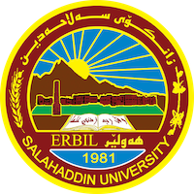
Academic Curriculum Vitae
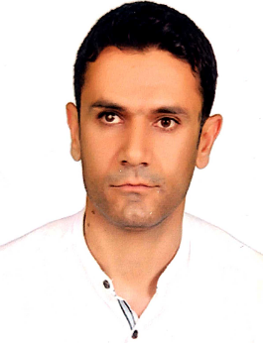
Personal Information:
Full Name: Beshroo Abdulkareem Othman
Academic Title: lecture
Email: (university email) beshroo.othman@su.edu.krd
Mobile: +9647504558317

Education:
- Bachelor degree, Animal Resourse department. , College Of Agriculture , Erbil -IRAQ
- Master degree , Animal-Breeding , Luhansk National Agrarian University , UKRAINE
Employment:
- Sulaimani Polytechnic University,Technical College of Applied science
- Salahaddin University, College of Education Shaqlawa, Biology Department.

Qualifications
- XL-state , Statistical Package for the Social Sciences (SPSS) program , Microsoft word
- Languages: Kurdish language , Arabic language , Russian language , English language

Teaching experience:
- Meat technology , Biostatistics , Invertebrate , Ecology and Pollution

Research and publications
-The Effect of High Doses of Fish Oil as A Source of (Omega-3) in The Production and Physiological Performance in Local Rabbits.
-Evaluate The Productive Performance of Two Varirties of Japanese Quail Brown and Black.
-Physical and Rheological Properties of Poly-floral Honey from the Iraqi Kurdistan Region and the Effect of Temperature on its Viscosity.

Conferences and courses attended
- Give details of any conferences you have attended, and those at which you have presented delivered poster presentations.

Professional memberships
- kurdistan agricultural engineers
Professional Social Network Accounts:

- List your profile links of ReserchGate, LinkedIn, etc.

It is also recommended to create an academic cover letter for your CV, for further information about the cover letter, please visit below link:
https://career-advice.jobs.ac.uk/cv-and-cover-letter-advice/academic-cover-letter/

