Niche and Organism:
In nature, many species occupy the same habitat but they perform different functions. The functional characteristics of a species in its habitat is referred to as "niche in that common habitat. Habitat of a species is like its 'address' (i.e. where it lives) whereas niche can be thought of as its "profession" (i.e. activities and responses specific to the species). The term niche means the sum of all the activities and relationships of a species by which it uses the resources in its habitat for its survival and reproduction.
Types of Niche
1. Habitat niche - where it lives .
2. Food niche-what is eats or decomposes& what species it competes with.
3. Reproductive niche - how and when it reproduces.
4. Physical & chemical niche - temperature, land shape, land slope, humidity & other requirement .
Adaptation:
Every organism is suited to live in its particular habitat. You know that the coconuts cannot grow in a desert while a camel cannot survive in an ocean. Each organism is adapted to its particular environment. An adaptation is thus, the appearance or behavior or structure or mode of life of an organism that allows it to survive in a particular environment".

Energy Flow in Ecosystems
All animals need energy to run, breath, and hunt, and they get this energy by consuming food. Food chains and food webs are similar to each other, but they are not the same

Major Concepts:
1.Ecosystems are energy-transforming machines that obey thermodynamic principles .
2. Primary production (PP) is energy assimilation and production of organic matter by photosynthesis .
3. Energy flows through food chains with only 5-20% passing to each higher trophic level. Energy pyramids result from this loss.
4. Energy losses limit the number of trophic levels in ecosystems.
6. Secondary production by consumers depends on NPP, efficiencies of transfer, and residence time. Secondary production - assimilated energy - respiration - excretion.

Gross primary productivity, or GPP, : is the rate at which solar energy is captured in sugar molecules during photosynthesis . Producers such as plants use some of this energy for metabolism/cellular respiration and some for growth (building tissues).
Net primary productivity, or NPP : it's the rate at which energy is stored as biomass by plants or other primary producers and made available to the consumers in the ecosystem.

food chain and food webs
A food chain shows a single, connected path of energy flow through an ecosystem.
Some animals only eat plants while some animals eat other animals. A food chain shows the different levels of eating within an ecosystem. The arrows show the flow of energy from one organism to the next. Most food chains begin with the sun at the bottom. Let's examine the example on the right.
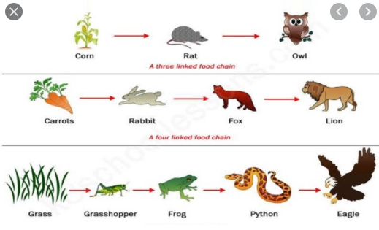

There are three types of organisms in a food chain: producers, consumers and decomposers.
1. Producers. These organisms absorb the sun's energy and convert the energy into food for themselves, allowing them to grow larger, make flowers and fruit, etc. An example of a producer is a plant.

2. Consumers. These organisms, mostly animals, can be split into a few categories:
●primary consumers only eat plants, so they are called herbivores. The primary consumers in the picture are the bee and grasshopper.
●Secondary consumers eat primary consumers. Many secondary consumers also eat plants, which makes them omnivores (meat and plant eaters ). the secondary consumers in the picture are the wasp and beetle .
●Tertiary consumers eat the secondary consumers and are usually carnivores (meat eaters). The tertiary consumers in the picture are the frog and snake.
●Quaternary consumers eat the tertiary consumers and are carnivores. The quaternary consumer in the picture is the hawk. In this picture, the food chain ends with the hawk, which claims the title as the top carnivore.

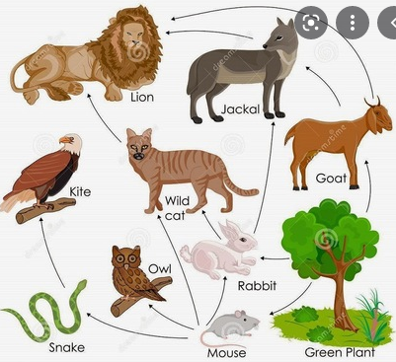
A food web is a network of all the food chains in an ecosystem. Food webs are very complex. Small disturbances to one population can affect all populations in a food web. Changes in populations of zooplankton, small marine animals that feed on algae, can affect all of the animals in the marine food web .
The same three types of organisms are in food webs:
producers, consumers and decomposers. Good food webs should also
include the sun as the initial source of energy In the picture to the right, there are multiple lines from one organism to another We see that the grass in the bottom right hand corner is eaten by more than just the grasshopper, it is also a food source for the rabbit and the deer. In this food web, we see that there are many top carnivores, not just one. We can identify three: the owl. the hawk and the fox We can also note the owl, the hawk, and the fox are shown as secondary and tertiary consumers in this food web. The deer is a primary consumer because it only feeds on plants, which makes it an herbivore. As you can see, food webs are more complex than food chains, but they represent what goes on in real life much better than a food chain!

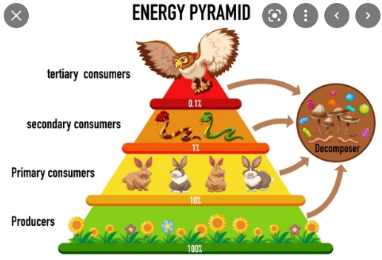
An energy pyramid shows how energy moves throughout an ecosystem. As you move up the pyramid levels, approximately 90% of the food's original energy is lost from level to level because animals must use their own energy to consume and digest food.
The consumers at the top of the pyramid do not have as much energy available to them because their food, another animal, is simply not very good at converting the food it eats into energy in its body .
In the picture above, we can see that energy (shown here as kilocalories" (kcal lost as we move up the pyramid from producer to tertiary consumer. This diagram also gives you an idea that it takes a lot of plants to support the predators at the top of the pyramid, such as this owl.
An ecological pyramid is a diagram that shows the relative amounts of energy or matter contained within each trophic level in a food chain or food web. Types of ccological pyramids are pyramids of energy, pyramids of biomass, and pyramids of numbers
Pyramids of energy show relative amounts of energy available at different trophic levels.
Pyramids of biomass show the total amount of living tissue at each trophic level.
À pyramid of numbers shows the relative numbers of organisms at different trophic levels.
