2. Freshwater Ecosystems:
A. Pond & Lakes (Continue):
depending on the amount of organic matter produced the Lakes are often classified as :_
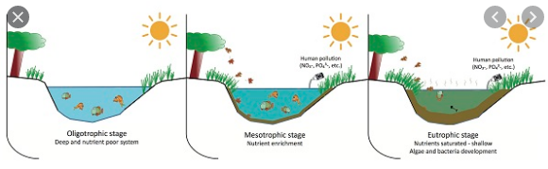
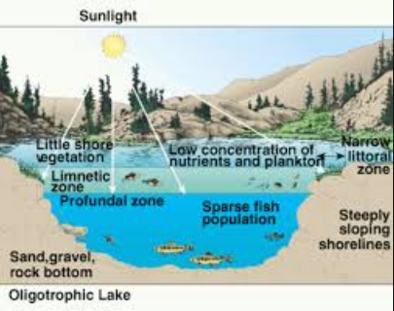
Ⅰ\Oligotrophic Lakes: defined as They are deep, nutrient-poor lakes in which the phytoplankton is not very productive and Very desirable fishery of large game fish. The water is usually clear and the profundal zone has a high oxygen concentration since little detritus is produced in the limnetic zone to be decomposed.
- Oligotrophic Lakes can change to Eutrophic lakes by:-
●They may develop into eutrophic lakes over time.
●Runoff from surrounding terrestrial habitats brings in mineral nutrients and sediments.
●Human activities increase the nutrient content of runoff due to lawn and agricultural fertilizers.
● Municipal wastes dumped into lakes dramatically enriches the nitrogen and phosphorus concentrations which increases phytoplankton and plant growth.
● Algal blooms and increased plant growth results in more detritus and can lead to oxygen depletion due to increased decomposition. • Clear water, low productivity .
Ⅱ\Mesotrophic Lakes: defined as
● Increased production.
● Accumulated organic matter.
● Occasional algal bloom.
Ⅲ\Eutrophic Lakes: defined as are usually shallow, nutrient-rich lakes with very productive phytoplankton and Rough fish common and The waters are usually murky due to large phytoplankton populations and The large amounts of detritus being decomposed may result in oxygen depletion in the profundal zone during the summer.
Lakes are natural bodies of water, where flow from one or several rivers is impounded by a natural obstacle. A lake differs from the incoming rivers simply by the fact that its flow is far weaker and no longer driven by gravity down a slope. Instead, currents in lakes are driven by surface winds and buoyancy forces.
A reservoir is an artificial lake created by a dam blocking a river. There are several reasons why people build reservoirs: Generation of hydro-electric power, flood control, freshwater supply (for households or irrigation), recreation, and control of water quality.
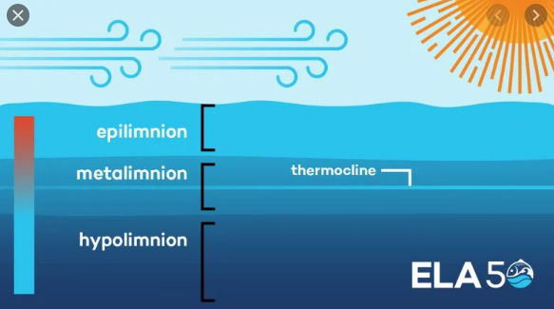
Summer: During the summer stratification, the thermocline may oscillate between the less dense epilimnion and the denser hypolimnion. The thermocline is the layer between the upper and lower layers in which there is a rapid drop of temperature with depth. These different layers can have very different nutrient and oxygen contents and, therefore, very different organisms in them. The metalimnion is the thermocline plus the waters immediately above and below the thermocline.
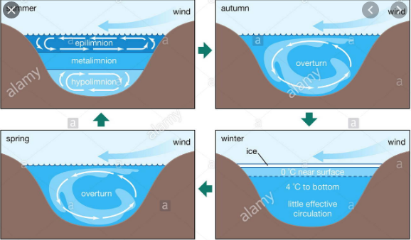
Late Fall: As winter approaches, the water begins to cool at the top where the water contacts the cooler air. As water cools to slightly above freezing (4 degrees Celsius), because water is most dense at that temperature, it sinks and forces the water that is less dense towards the surface. This less dense water then cools to 4 degrees and sinks, forcing more less-dense water to the surface. This continues, mixing the water in the lake. This is called the fall turnover or fall overturn.
Winter: When the water on the surface cools to zero degrees, ice may form and the cycle stops because there is a "cover" over the surface. This mixing of the water also mixes nutrients that were in the lower levels of the lake.
Spring: In the spring, the ice melts with the increasing air temperature and the water on the surface warms to 4 degrees Celsius and then sinks because it is more dense than the water below it. The cycle reverses in what is called the spring turnover or spring overturn. As the lake continues to warm the summer stratification levels occur.
