The energy of life
Energy is the capacity or ability to do work. In organisms, any biological work --such as growing, moving, reproducing, and maintaining and repairing damaged tissues—requires energy. Energy exists in several forms: chemical, radiant, thermal, mechanical, nuclear, and electrical. Chemical energy is energy stored in the bonds of molecules; for example, food contains chemical energy, and organisms use the energy released when chemical bonds are broken and new bonds form. Radiant energy is energy, such as radio waves, visible light, and X-rays, that is transmitted as electromagnetic waves (Figure 1). Solar energy is radiant energy from the sun; it includes ultraviolet radiation, visible light, and infrared radiation.
Thermal energy is heat that flows from an object with a higher temperature (the heat source) to an object with a lower temperature (the heat sink). Mechanical energy is energy involved in the movement of matter. Some of the matter contained in atomic nuclei can be converted into nuclear energy. Electrical energy is energy that flows as charged particles.
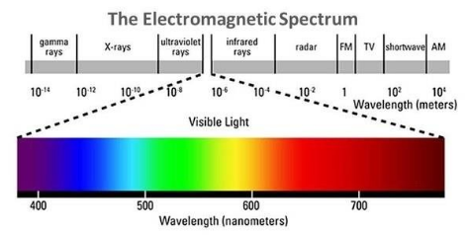
Figure 1: The electromagnetic spectrum. The shortest wavelengths are manute
longest are TV and radio waves. Visible light occurs between ultraviolet and infrared radiation.
The study of energy and its transformation is called thermodynamics .

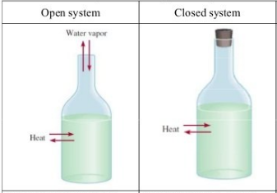
(a) Closed system.
Energy is not exchanged between a closed system and its surroundings. А thermos bottle is an approximation of a closed system. Closed systems are rare in nature.
(b) Open system.
Energy is exchanged between Open system and its surroundings. Earth is an open system because it receives energy from the sun, and this energy eventually escapes Earth as it dissipates into space.
The First Law of Thermodynamics
((Energy cannot be created or destroyed, although it can change from one form to another.))
According to the first law of thermodynamics, an organism may absorb energy from its surroundings, or it may give up some energy into its surroundings, but the total energy content of the organism and its surroundings is always the same. As far as we know, the energy present in the universe at its formation, approximately 15-20 billion years ago, equals the amount of energy present in the universe today. This is all the energy that will ever be present in the universe. Similarly, the energy of any system and its surroundings is constant A system may absorb energy from its surroundings, or it may give up some energy into its surroundings, but the total energy content of that system and its surroundings is always the same.
The first law of thermodynamics specifies that an organism cannot create the energy it requires to live. Instead, it must capture energy from the environment to use for biological work, a process involving the transformation of energy from one for to another. In photosynthesis, planes absorb the radiant energy of the sun and convert it into the chemical energy contained in the bonds of carbohydrate (sugar) molecules. Similarly, some of that chemical energy may later be transformed by an animal that eats the plant into the mechanical energy of muscle contraction, enabling the animal to walk, run, jump, slither, fly, or swim .

The Second Law of Thermodynamics
((When energy is converted from one form to another, some of it is degraded
into heat, a less usable form that disperses into the environment.))
As each energy transformation occurs, some energy is changed to heat that is released into the cooler surroundings. No other organism can ever reuse this energy for biological work; it is "lost" from the biological point of view. It is not really gone from a thermodynamic point of view because it still exists in the surrounding physical environment. Similarly, the use of food to enable us to walk or run does not destroy the chemical energy once present in the food molecules. After we have performed the task of walking or running, the energy still exists in the surroundings as heat. According to the second law of thermodynamics, the amount of usable energy available to do work in the universe decreases over time. The second law of thermodynamics is consistent with the first law; that is, the total amount of energy in the universe is not decreasing with time.

Photosynthesis and Cellular Respiration
Energy is stored in living things as carbon compounds. Photosynthesis is the biological process in which light energy from the sun is captured and transformed into the chemical energy of carbohydrate (sugar) molecules. Photosynthetic pigments such as chlorophyll, which gives plants their green color, absorb radiant energy. This energy is used to manufacture the carbohydrate glucose (C6 H12 O6) from carbon dioxide (CO2) and water (H2O), a process that also releases oxygen (O2).
6CO2 +12H2O + radiant energy → C6 H12O6 + 6H2O + 6O2
The chemical energy that plants store in carbohydrates and other molecules is released within the cells of plants, animals, or other organisms through cellular respiration. In aerobic cellular respiration, molecules such as glucose are broken down in the presence of oxygen and water into carbon dioxide and water, with the release of energy.

Aerobic cellular respiration:
C6H12O6 +6O2 +6H2O →6O2 +12H2O + energy
Cellular respiration makes the chemical energy stored in glucose and other food molecules available to the cell for biological work.
All organisms, including green plants, respire to obtain energy.
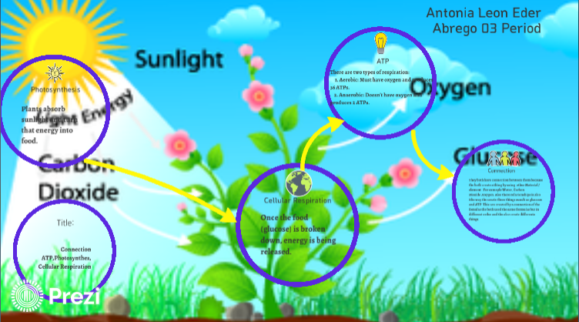
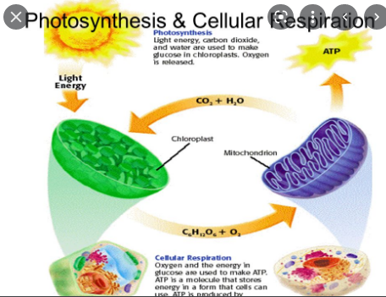
Some organisms do not use oxygen for this process. Anaerobic bacteria respire in the absence of oxygen.

