The Six Most Abundant Elements of Life CHNOPS:
Most biological molecules (Biomolecules) are made from covalent combinations of six important elements, whose chemical symbols are CHNOPS. Although more than 25 types of elements can be found in biomolecules, six elements (CHNOPS) are most common. The letters stand for the chemical abbreviations of carbon, hydrogen, nitrogen, oxygen, phosphorus, and sulfur. Each element has a characteristic valence that determines the number of covalent bonds it can form. A shared electron pair is called a covalent bond. The number of covalent bonds that each element can form is called its valence.
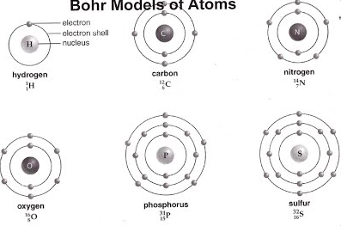
Biogeochemical Cycles:
1. The Water Cycle
Biological importance: Water is essential to all organisms, and its availability influences the rates of ecosystem processes, particularly primary production and decomposition in terrestrial ecosystems. Water percentage fluctuates from around 10% in plant seeds to 98% in some aquatic animals, whereas it is about 63% in the human body .
Forms available to life: All organisms are capable of exchanging water directly with their environment. Liquid water is the primary physical phase in which water is used, though some organisms can harvest water vapor.
Key processes: The main processes driving the water cycle are evaporation of liquid water by solar energy, condensation of water vapor into clouds, and precipitation Transpiration by terrestrial plants also moves large volumes of water into the atmosphere. Surface and groundwater flow can retum water to the oceans, completing the water cycle (Figure)

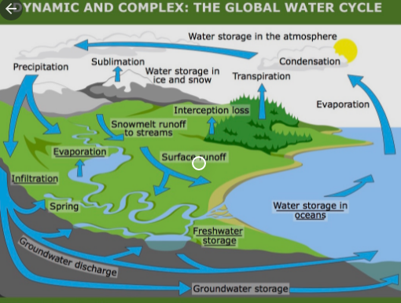

2.Nitrogen Cycle:
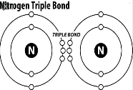
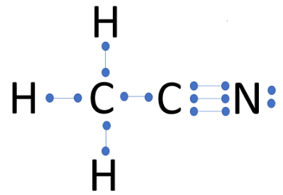
Nitrogen is a limiting nutrient because it is not always available in usable forms and because it is an essential component of proteins, nucleic acids, and chlorophyll. Because 78% of the Earth's atmosphere consists of nitrogen gas (N₂), it may seem that nitrogen should not be in short supply for organisms. However, N₂ molecules must be broken apart before nitrogen atoms are available to combine with other elements. Because of its triple bond, nitrogen gas is very stable and only certain bacteria and cyanobacteria can break it apart into usable forms. This process, called nitrogen fixation, is a critical component of the five-part nitrogen cycle, which also includes nitrification, assimilation, ammonification, and denitrification.
1. Atmospheric Nitrogen Fixation:
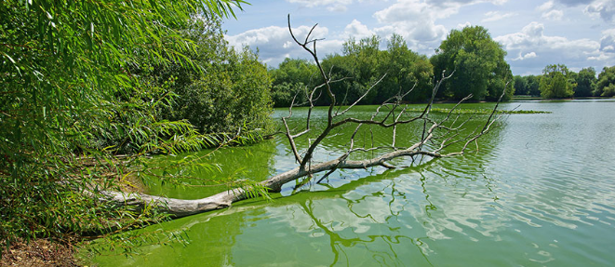
Only certain bacteria and a few cyanobacteria can accomplish nitrogen fixation, that is, convert atmospheric nitrogen to forms usable by other organisms. These organisms use the enzyme nitrogenase to break the nitrogen triple bond. The bacteria that fix nitrogen are fulfilling their own metabolic needs, but in the process, they release excess ammonia (NH3) or ammonium (NH4), which can be used by plants. The most important of these nitrogen-fixing bacteria in the soil are called Rhizobium, which live in nodules on the roots of legumes.
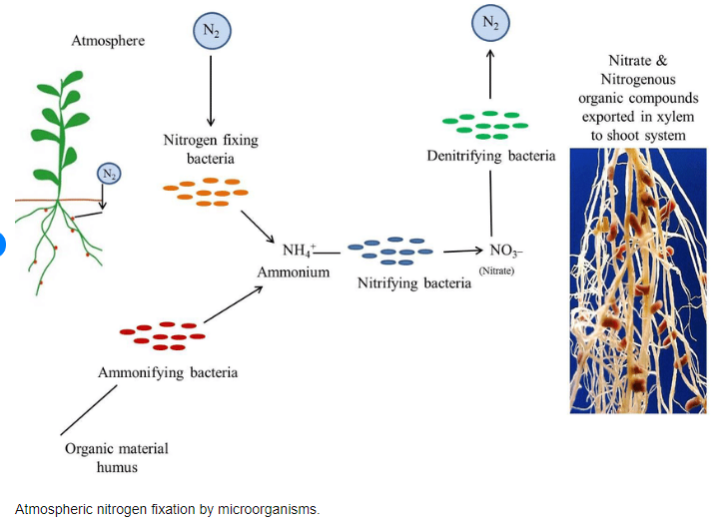
2. Nitrification:
In this process, soil bacteria convert NH3 or NH4+ to nitrate (NO₂), a form of nitrogen commonly used by plants. Bacteria in the genus Nitrosomonas and Nitrococcus first oxidize the forms of ammonia to nitrite (NO2), after which bacteria in the genus Nitrobacter convert NO2 to NO3. These bacteria commonly compete plants for ammonia.

3. Assimilation
is the process by which inorganic substances are incorporated into organic molecules. In the nitrogen cycle, organisms assimilate nitrogen by taking up ammonia and NO3 formed through nitrogen fixation and nitrification and incorporating them into other molecules. Plant roots take up these forms of nitrogen through their roots, and animals assimilate nitrogen from plant tissue.

4. Ammonification:
Ammonia can also be formed in the soil through the decomposition of plants and animals and the release of animal waste. Ammonification is the conversion of organic nitrogen to NH3 and NH4+. This process is carried out by bacteria and fungi. Because many soils lack nitrifying bacteria, ammonification is the most common pathway for nitrogen to enter the soil.

5. Denitrification
is the reduction of nitrate (NO3) to gaseous nitrogen (N₂). Denitrifying bacteria, in the genus Pseudomonas, which are anaerobic and use NO3 in their metabolism instead of oxygen, perform the reverse of their nitrogen-fixing counterparts by delivering nitrogen to the atmosphere. This process only delivers a relatively small amount of nitrogen to the atmosphere.
One problem with increased nitrogen deposition is that fertilizer runoff can cause eutrophication of rivers and lakes, and, as the resultant algae die, decomposition increases and the increased bacterial activity depletes the oxygen level of the water, resulting in fish die-offs.
Excess nitrates in surface or groundwater systems used for drinking water are also a health hazard, particularly for infants. In the body, nitrate is converted to nitrite, which then combines with hemoglobin to form methemoglobin, a type of hemoglobin that does not carry oxygen. In infants, the production of large amounts of nitrites can cause methemoglobinemia, a dangerous condition in which the level of oxygen carried through the body decreases.
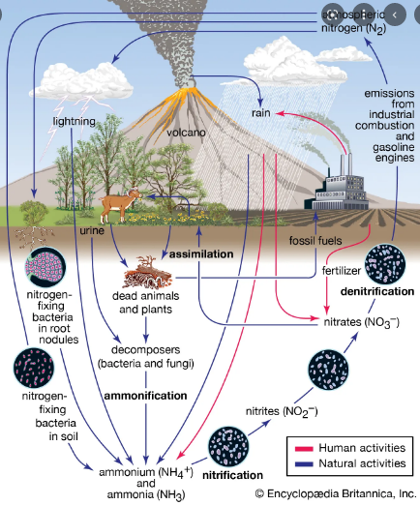
Figure 1. The nitrogen cycle. There are five main parts of the nitrogen cycle:
(1) nitrogen fixation, (2) nitrification, (3) assimilation, (4) ammonification, and (5)
denitrification. The recycling of nitrogen from dead plants and animals into the soil
and then back into plants is of paramount importance. Units are teragrams.
width of the arrows indicates the relative importance of each process.

