2.Phosphorus Cycle:
All living organisms require phosphorus, which becomes incorporated into ATP, the compound that provides energy for most metabolic processes. Phosphorus is also a key component of other biological molecules such as DNA and RNA and the phospholipid bilayer of cell membranes, and it is an essential mineral that in many animals helps. maintain a strong, healthy skeleton.
The phosphorus cycle is a relatively simple cycle (Figure 1 ). Phosphorus has no gaseous phase and thus no atmospheric component; that is, it is not moved by wind or rain. As a result, phosphorus tends to cycle only locally. The Earth's crust is the main storehouse for this element. Weathering and erosion of sedimentary rocks release phosphorus into the soil. Plants have the metabolic means to absorb dissolved ionized forms of phosphorus, the most important of which occurs as phosphate, HPO4 or H₂PO4. Herbivores obtain their phosphorus only from eating plants, and camivores obtain it by eating herbivores.
When plants and animals excrete wastes or die, the phosphorus becomes available to decomposers, which release it back to the soil. Leaching and runoff eventually wash much phosphate into aquatic systems, where plants and algae utilize it. In addition, rivers transport phosphorus to lakes or oceans where it is often quickly taken up by phytoplankton.
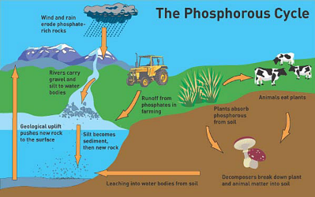
Phosphate that is not taken up into the food chain settles to the ocean floor or lake bottom, eventually forming sedimentary rock. Phosphorus can remain locked in sedimentary rock for millions of years, becoming available again through the geological process of uplift, which exposes the element to weathering.
3-Sulphur Cycle so4:
The Sulfur Cycle Is Both Sedimentary and Gaseous:
The sulfur cycle has both sedimentary and gaseous phases (Figure 2). In the long-term sedimentary phase, sulfur is tied up in organic and inorganic deposits, released by weathering and decomposition, and carried to terrestrial ecosystems in salt solution. The gaseous phase of the cycle permits sulfur circulation on a global scale.
Sulfur enters the atmosphere from several sources: the combustion of fossil fuels, volcanic, and gases released by decomposition. It enters the atmosphere initially as hydrogen sulfide (H₂S) which quickly interacts with oxygen to form sulfur dioxide (SO₂).
Atmospheric sulfur dioxide, soluble in water, is carried back to the surface in rainwater as weak sulfuric acid (H₂SO4). Whatever the source, sulfur in a soluble form is taken up by plants and incorporated through a series of metabolic processes, starting with photosynthesis, into sulfur-bearing amino acids (Methionine & cysteine).
From the primary producers, sulfur in amino acid is transferred to consumers. Excretion and death carry sulfur from living material back to the soil and to the bottom of ponds, lakes, and seas, where bacteria release it as hydrogen sulfite or hydrogen sulfate.
