Environmental Pollution:
Difference between Pollution and Contamination:
Contamination is simply the presence of a substance where it should not be or at concentrations above background level. Pollution is the introduction of contaminants into the natural environment (water, air and lands) that causes adverse change, making it less fit or unfit for life. Pollution can take the form of chemical substances or energy, such as noise, heat or light. Pollutants, the components of pollution, can be either foreign substances/energies or naturally occurring contaminants. Three factors determine the severity of a pollutant: its chemical nature, the concentration and the persistence. Pollution is often classed as point source or nonpoint source pollution.
All pollutants are contaminants, but not all contaminants are pollutants.
Environmental pollution is defined as "the contamination of the physical and biological components of the earth/atmosphere system to such an extent that normal environmental processes are adversely affected."
Pollutant | Contaminant
Pollutant is a harmful or poisonous  substance that pollutes something. | Contaminant is a foreign substance or  impurity that contaminates something.
Pollutants always create harmful effects. | Contaminants do not always create harmful effects.
Pollutants can be either foreign substances  or a component of the original substance  that has exceeded the harmless level. | Contaminants usually refer to foreign matter that are introduced from outside.

Pollutants:
Pollutants are the materials or factors, which cause adverse effect on the natural quality of any component of the environment.
For example, smoke from industries and automobiles, chemicals from factories, radioactive substances from nuclear plants, sewage of houses and discarded household wastes are the common pollutants.

Classifications of Pollutants
1According to the form in which they persist after release into the environment.
• Primary pollutant is an air pollutant emitted directly from a source,
•Secondary pollutant is not directly emitted as such, but forms when other pollutants (primary pollutants) react in the atmosphere.
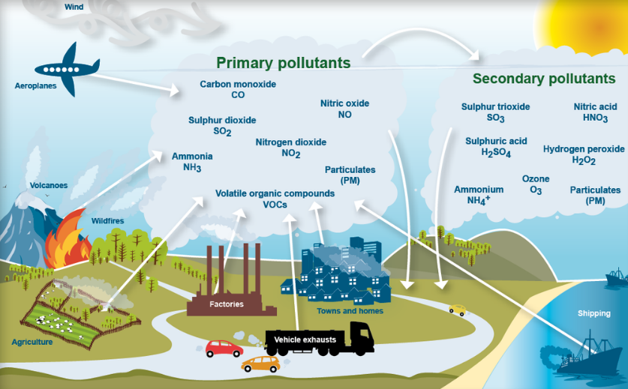
Examples of a secondary pollutant include NO2, which is formed as NO combines with oxygen in the air; and acid rain, which is formed when sulfur dioxide SO2 or nitrogen oxides NO2 react with water.
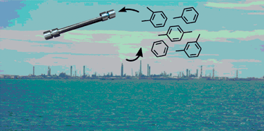
(2) According to their existence in nature.
Quantitative Pollutants: These occur in nature and become pollutant when their concentration reaches beyond a threshold level. E.g. carbon dioxide, nitrogen oxide.
Qualitative Pollutants: These do not occur in nature and are man-made. E.g. fungicides, herbicides, DDT etc.
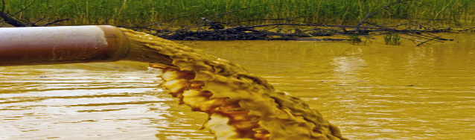
(3) According to their nature of disposal.
Biodegradable Pollutants: Waste products, which are degraded by microbial action. E.g. sewage.
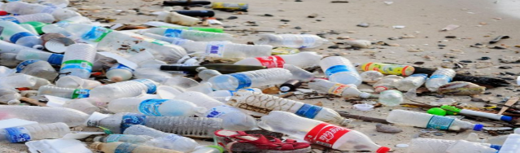
Non-biodegradable Pollutants: Pollutants, which are not decomposed by microbial action. E.g. plastics, glass, DDT, salts of heavy metals, radioactive substances etc..)
(4) According to origin
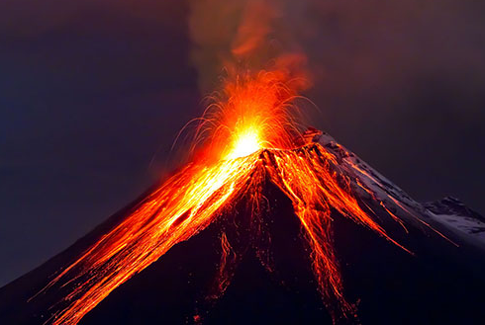
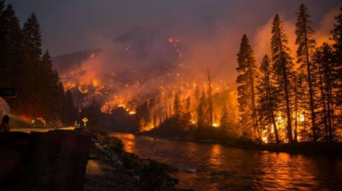
- Natural

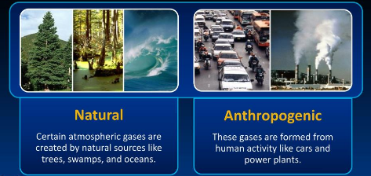
-Anthropogenic

