Ecological Footprints: Our Environmental Impacts
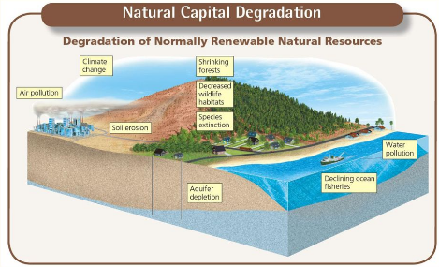
Many poor people in less-developed countries struggle to survive. Their individual use of resources and the resulting environmental impact is low and is devoted mostly to meeting their basic needs and living in makeshift housing. However, a large number of such people in a given area can have a large total environmental impact.
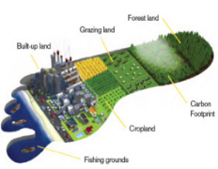
●By contrast, many individuals in more-developed nations enjoy affluence, or wealth, which allows them to consume large amounts of resources far beyond their basic needs and live in large homes.
Their environmental impact is more a product of their rates of resource use per person.
When people use renewable resources, it can result in natural capital degradation (Figure 1),
pollution, and wastes. This harmful environmental impact is an Ecological Footprint the amount of land and water needed to supply a person or an area with renewable resources such as food and water, and that are needed to absorb and recycle the wastes and pollution produced by such resource use.

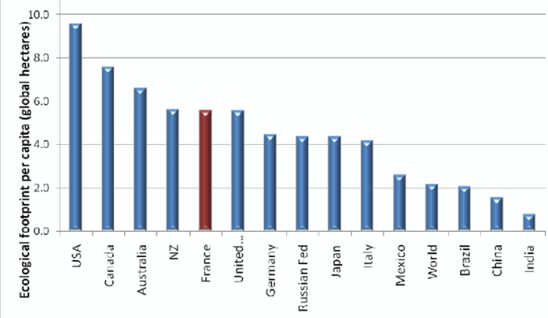
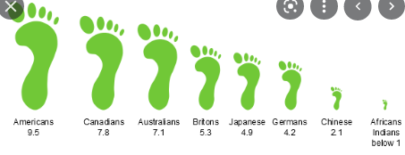
The per capita ecological footprint is the average ecological footprint of an individual in a given country or area. Figure 2 compares the total and per capita ecological footprints for selected countries. If the total ecological footprint for a city, a country, or the world is larger than its biological capacity to replenish (replace) its renewable resources and absorb the resulting wastes and pollution, it is said to have an ecological deficit . In other words, its people are living unsustainably by depleting their natural capital instead of living off the renewable supply of resources provided by such capital. Globally we are running up a huge ecological deficit (Figure 3).
Figure 3: People of some nations have much
larger ecological footprints than people of Figure 2: Natural capital use and degradation:
others. Shown are ecological footprints for These graphs show the total and per capita
average citizens of several nations, along with ecological footprints of selected countries.
the world's average per capita footprint of 9.5
hectares. One hectare (ha) = 2.47 acres.
Why Do We Have Environmental Problems?
Major causes of environmental problems are:
(1) population growth, (2) wasteful and unsustainable resource use, (3) poverty, (4) failure to include the harmful environmental costs of goods and services in their market prices, and (5) increasing isolation from nature (Figure 4).

The Human Population Is Growing at a Rapid Rate
Exponential growth occurs when a quantity such as the human population increases at a fixed percentage per unit of time, such as 1% or 2% per year. Exponential growth starts off slowly, but after only a few doublings, it grows to enormous numbers because each doubling is twice the total of all earlier growth.
The human population has been growing exponentially (Figure 5). There are now about 7.8 billion people on the earth with about 84 million more people added each year. There could be 9.6 billion of us by 2050.

(Figure 4)
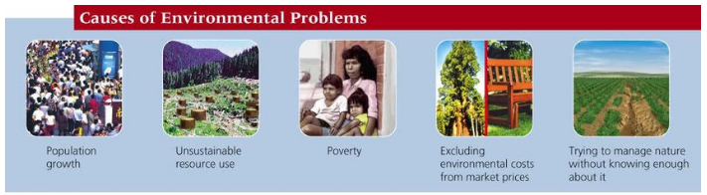
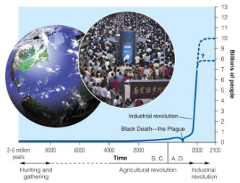
Figure5: Exponential growth

