Greenhouse effect ( Global warming )
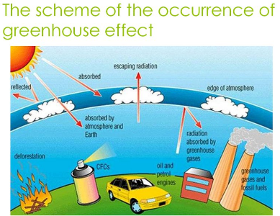
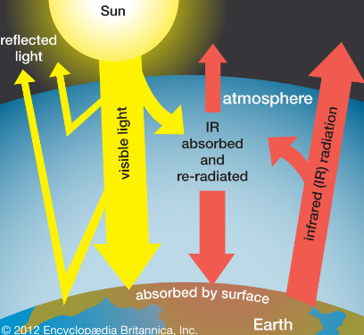
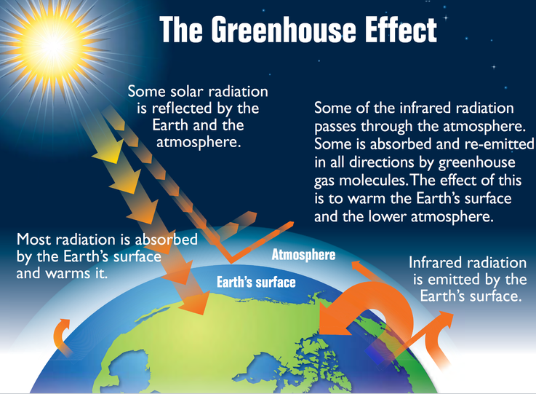
The earth is heated by sunlight and some of the heat that is absorbed by the earth is radiated back into space. However, some of the gases in the lower atmosphere, acting like glass in a greenhouse, while filtering the dangerous U.V. radiations , not allow the earth to re-radiate the heat into space. In order words, these gases in the atmosphere are transparent to the sun-light coming in but they strongly absorb the infra-red radiation, which the earth sends back as heat. A part of the heat so trapped in these atmospheric A part of the heat so trapped in these atmospheric gases is re-emitted to the earth's surface. The net result is the heating of the earth's surface by this phenomenon, called the "Greenhouse effect". The gases that are responsible for this Greenhouse effect are CO₂, water vapor, CH₄. Water vapor and CO₂ are strongly absorbs IR radiations.
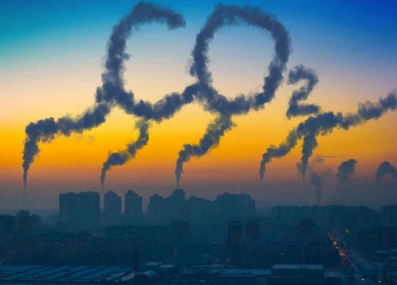
Carbon dioxide is released by volcanoes, oceans, decaying plants as well as human activities, such as deforestation and combustion of fossil fuels. Automobile exhausts account for 30% of CO₂ emissions in developed countries.

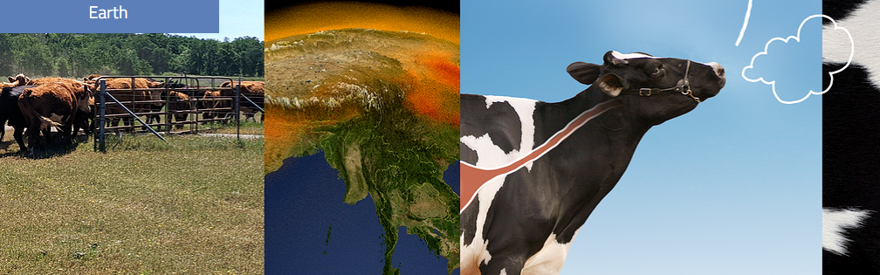
Methane (CH₄) is the second most important greenhouse gas accounting or 14 percent of our greenhouse output.
●Methane is produced when plant matter decays in oxygen-free conditions in the bottom of a wetland (where oxygen is abundant, decay produces mainly CO₂), and it is released from gas wells. the source of CH₄ are ruminant animals, such as cattle. In a cow's stomach which has little oxygen, digestion produces CH₄, which cows then burp into the atmosphere. A single cow can't produce much CH₄, but the global population of nearly 1 billion cattle produce enough methane to double the concentration naturally present in the atmosphere.

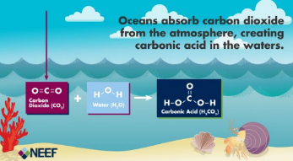
Oceans and bio-mass are the major sinks for the atmospheric CO₂. Oceans convert CO₂ into soluble bicarbonates. The photosynthetic activity in the green plants increases with increase in CO₂ level in the atmosphere. Forests are the places where lot of photo-synthetic activity occurs. They also act as vast reservoirs of fixed but readily oxidizable carbon in the form of vegetation, wood and humus. Hence, forests maintain a balance in the atmospheric CO₂ level. Therefore, deforestation definitely upsets this balance and increases the atmospheric CO₂ level.
It is estimated that the atmospheric CO₂, content has increased by 25% during the last two centuries. This is mostly attributed to the industrial revolution over these two centuries. This is one of the reasons for the slight increase in the global temperature (about 0.5°C). Since the concentrations of the Greenhouse gases have been continuously increasing because of deforestation, industrialization, increased burning of fossil fuels, mining, exhausts from increasing number of automobiles and other anthropogenic activities, there is an increasing concern about the possible "Global warming". This will increase the evaporation of surface waters, which may influence climatic changes.

Depletion of Ozone in the stratosphere
Ozone is an important chemical species present in the atmosphere.
Ozone is formed in the stratosphere by photochemical reaction :
O₂ + hv ( 242nm ) → O + O
O + O₂ + M (third body , such as N₂ ) → O₃ + M

Ozone, in the stratosphere, is found to be destroyed by man-made chloroflourocarbons (CFC's), which are used as coolants in refrigerators, air-conditioners, such as "Styrofoam".

Too much ultra-violet light can result in:
●Skin cancer
●Eye damage such as cataracts
●Immune system damage
●Damage to the DNA in various life-forms.

Protection
●Sunglasses with 100% UV block
●Eye protection for children
●Hats
●Protect the skin against the solar radiation using skin creams with SPF

