Atmospheric Structure
The Atmosphere, which extends up to about 500 km above the earth's surface, can be broadly divided into four major regions
(1) Troposphere.
This is the region nearest to the earth's surface and extends up to an altitude of 11 km. The temperature of air in the troposphere decreases fairly steadily with increasing altitude, it can be seen from Fig. 1 that the temperature-altitude curve changes its slope (i.e., the temperature starts increasing with increasing altitude) rather suddenly in a narrow transitional layer at the top of the troposphere, known as the "Tropopause".
which is usually at an altitude of 10 kun to 20 km. The change of temperature with height is called the "lapse rate" The decrease of temperature with increasing altitude in the troposphere is called positive lapse rate.
The transition from positive lapse rate to negative lapse rate at the tropopause marks what is called the Temperature inversion .
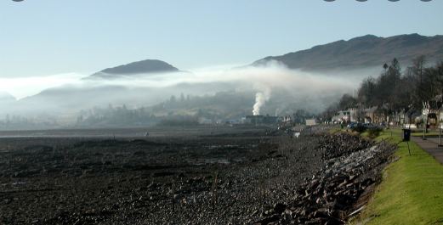
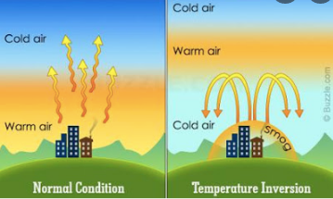

The earth continuously receives energy from the sun, a part of which is absorbed, while the remaining emitted back into space. The sun radiates energy, like a black body at 6000K. Out of the solar radiation reaching the earth, 92% consists of radiations in the range 315 to 1400 mm, 45% of this is in the visible region (400 to 700 nm). The earth absorbs radiations mainly in the visible region.
The circulation of air in the atmosphere usually keeps air pollution from reaching dangerous levels. During the day, the sun heats the surface of the Earth and the air near the Earth. On a clear summer day, the air near the earth's surface gets heated rapidly. It is under such conditions when the atmospheric pollutants are rapidly dispersed due to considerable vertical mixing of air. Inversion occurs in the atmosphere mainly due to radiation inversion Such a situation occurs when the air near the earth's surface gets cooled because of the loss of heat by the earth at night by emitting long wave radiations. The air near the ground is denser than the air above and hence very little mixing takes place.
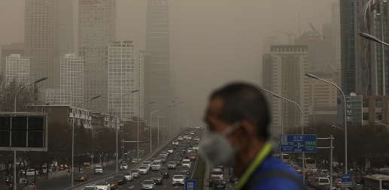
* Inversion is generally destroyed by the best morning due to the solar heating of the ground and the buildings which enable and current of the warmed air. But simultaneous occurrence of mist or fog may prolong the duration of inversion by reducing The sunlight reaching the ground. The problem of air pollution assumes serious dimensions under conditions of inversion and other meteorological conditions which are adverse to the effective dispersion of pollutants. Inversion is responsible for many air-pollution episodes in the world. The notorious London smog of 1952 that lasted for five days killing four thousand people is an example.
Sometimes, however, pollution is trapped near the Earth's surface by a temperature inversion. Usually, air
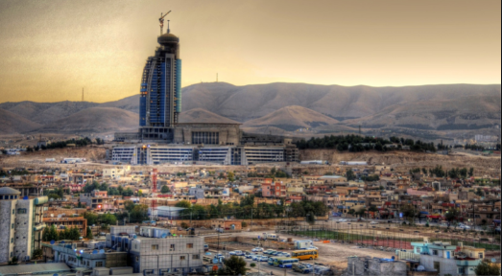
temperatures decrease with height, but in an area with air above is warmer than the air below. Figure below: shows how a temperature inversion traps pollutants near the Earth's surface. The warmer air above keeps the cooler air at the surface from moving upward. So, pollutants are trapped below with the cooler air. If a city is located in a valley, the city has a greater chance of experiencing temp. inversions. Slemani city, which is surrounded on three sides by mountains, often has temperature inversions that trap smog in the city.
(2) Stratosphere.
(3) Mesosphere.
(4) Thermosphere.

