Environmental Chemistry
Environmental Chemistry deals with the study of the various chemical phenomena taking place in the environment. It comprises of the study of the chemical species existing in the various segments of the environment, their sources, pathways, reactions and their consequences on the activities of human beings and other life-foms.
The great increase in industrial activity during the last few decades on one hand and deforestation and population explosion on the other, are threatening the very existence of life. This situation can improve only if people from all walks of life realize the importance of environmental protection. Hence, environmental education (which includes basic concepts of environmental chemistry) at all levels of non-formal and formal education, is of paramount importance .

Environmental Segments
The environment may broadly be considered to comprise of the following four segments:
(1) Lithosphere
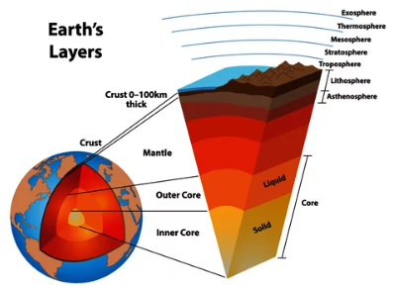
The mantle of rocks constituting the earth's crust is called lithosphere. The soil mainly consists of complex mixture of inorganic and organic matter and water. The inorganic mineral constituents include complex mixture of silicates of Na, K, Ca, Al and Fe; oxides of Fe, Mn and Ti; and carbonates of Ca and Mg. The organic matter, which constitutes not more than about 5% of the soil, mainly determines the productivity of the soil.

(2) Hydrosphere
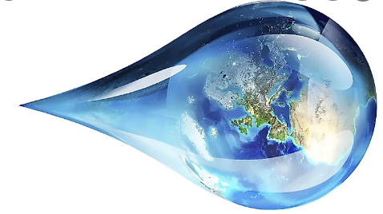
This includes all the surface and ground water resources (oceans, seas, rivers, streams, lakes, reservoirs, glaciers, polar ice caps, ground-water, the water locked in rock-crevices and minerals lying deep below the carth's crust Earth is called the blue planet, however, about 97% of the earth's water resources are locked-up in the oceans and seas, which is too saline to drink and for the direct use for agricultural and industrial purposes. About 2.4% is trapped in giant glaciers and polar ice-caps. Thus not even 1% of the total world's water resources is available for exploitation by man for domestic, agricultural and industrial purposes.
(3) Biosphere
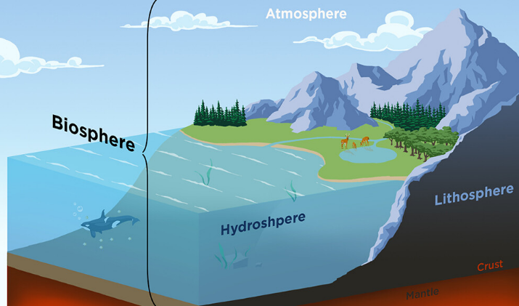
This is the region of the earth where life exists and includes a global girdle extending from about 10,000 m below sea-level to 6,000 m above sea-level. Thus, the biosphere covers the entire realm of living organisms and their interactions with the other segments of the environment, namely the lithosphere, the hydrosphere and the atmosphere.
(4) Atmosphere
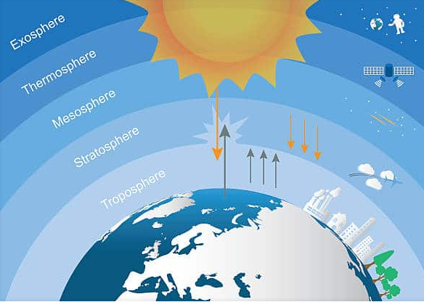
The atmosphere comprises of a mixture of gases (N. 03. Ar, etc) and it extends up to about 500 kms above the surface of the earth.
The atmospheric temperature, it varies with altitude ( - 100°C to +1200 °C).
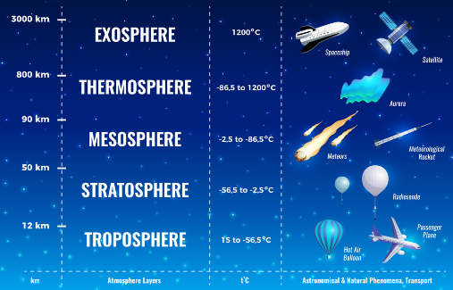
The atmosphere has four distinct zones of contrasting temperature, due to differences in absorption of solar energy. The layer of air immediately adjacent to the earth's surface is called the troposphere. Within the troposphere, air circulates in great vertical and horizontal convection currents, constantly redistributing heat and moisture around the globe. The depth of the troposphere ranges from about 18 km over the equator to about 8 km over the poles, where air is cold and dense.
Because gravity holds most air molecules close to the earth's surface, the troposphere is much more dense than the other layers: It contains about 75 percent of the total mass of the atmosphere. Air temperature drops rapidly with increasing altitude in this layer, reaching about -60°C at the top of the troposphere.
The stratosphere extends from the tropopause up to about 50 km. It is vastly more dilute than the troposphere, but it it has almost no water vapor and more ozone (O3).
Near the earth's surface Ozone is a pollutant, but in the stratosphere it serves a very important function. Stratospheric ozone absorbs certain wavelengths of ultraviolet solar radiation, known as UV-B (290–330 m). This absorbed energy makes the atmosphere warmer toward the top of the stratosphere. Because UV radiation damages living tissues, causing skin cancer, genetic mutations, crop failures, this UV absorption in the stratosphere also protects life on the earth's surface. ((A number of air pollutants, including Freon once used in refrigerators deplete stratospheric ozone, especially over Antarctica, and are allowing increased amounts of UV radiation to reach the earth's surface. Unlike the troposphere, the stratosphere is relatively calm. There is so little mixing in the stratosphere that volcanic ash or human caused contaminants can remain in suspension there for many years. Above the stratosphere, the temperature diminishes again, creating the mesosphere, or middle layer.
The atmosphere screens the dangerous U.V radiations (< 300 nm) from the sun but transmits only the radiations in the range 300 nm to 2500 mm, comprising of near ultra-violet, visible and near infra-red radiations and radio-waves.
* Atmospheric Composition, anthropogenic activities, lead to disastrous consequences or may even endanger the very survival of life on the earth.

(a)Major components | %v/v | ppm | (b)Minor components | %v/v | ppm
Nitrogen(N2) | 78.09 | 780900 | Argon(Ar) | 0.934 | 9340
Oxygen(O2) | 20.94 | 209400 | Carbon dioxide(CO2) | 0.032 | 320

(c)Trace components | %v/v | ppm
Neon (Ne) | 0.00182 | 18.2
Helium (He) | 0.000524 | 5.24
Methane (CH4) | 0.00018 | 1.8
Krypton (Kr) | 0.00011 | 1.1
Nitrous oxide (N2O) | 0.000025 | 0.25
Hydrogen (H2) | 0.00005 | 0.5
Xenon (Xe) | 0.0000087 | 0.087

