The questions style:-
Q1: Define the following terms:
1- Cathepsins 2- Collagen 3- Meat 4- Aging
Answer:
1- Cathepsins: Meat contains the protease enzymes, and these are responsible for the increased tenderness of meat during ageing. The enzymes slowly brea down the connective tissues.
Q2 : /Fill the following blanks with suitable words or phrase.
The meat sausages selection lean/fat ratio varies, depending----- and ------.
A. The meat sausages selection lean / fat ratio varies, depending on depending on cultural preferences and consumer expectations.
Q3: A/ Write briefly on the following statements: for example (Spices)?
Answer\ Spices add characteristic flavours to the meats. Some spices can have added preservative effects (However, the quantities of spice needed to achieve these effects may be well beyond the reasonable quantities of use.
Q4 \ Known these products of meat? How do you express your palatability for these products (factors)? And write about juiciness?
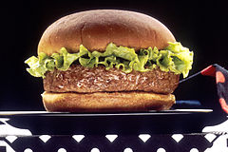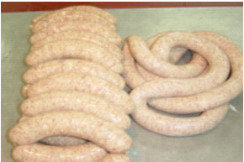
Hamburger sausage
Factors: 1- Tenderness 2- Juiciness 3- Flavor and aroma: 4- Color 5- Texture.
Juiciness: Is the feeling of moisture during chewing meat or meat products produced Juiciness of fat and water in the muscles. During the cooking fat with liquid water (soup) is liberated from within the meat during chewing. This liquid is given unfettered feeling of moisture in the mouth In addition, this fluid helps stimulate the secretion of saliva from the mouth and thus improve meat Juiciness

