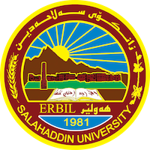
Academic Curriculum Vitae
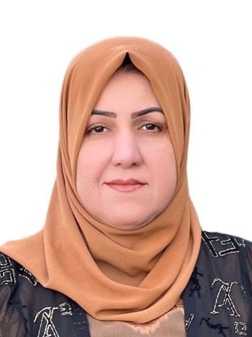

Personal Information:
Full Name: Bekhal Samad Sedeeq
Academic Title: Assist. Prof
Email: ( Bikhal.sedeeq@su.edu.krd )
Mobile: 07504542040

Education:
- Salahaddin University - College of Administration and Economics (1994-1998)
Bachelor of Science in Statistics (B.Sc.)

- Salahaddin University - College of Administration and Economics (2000-2002)
Master of Science in Statistics (M.Sc.)
- Salahaddin University - College of Administration and Economics (2008)
Doctoral of Science in Statistics(Ph.D)
Employment:
- Assistant research in1999: College of Administration and Economic
- Assistant lecturer in 2002: College of Administration and Economic/Statistics department
- Lecturer in 2008: College of Administration and Economic/Statistics department
- Assistant Prof. in 2018: College of Administration and Economic/Statistics department

Qualifications
- Teaching qualifications
- IT qualifications
- Language qualification

Teaching experience:
- Principles of Mathematics
- General Mathematics
- Advance Mathematics
- Mathematical Statistics
- Mathematics
- SPSS
- Differential Equation
- Sampling theory
- Applied Statistics
- Principles of Statistics
- Operation research
- Quality Control
- Regression
- Reliability
- Decision Theory
- Stochastic Process

Research and publications

- Copulas as a Measure of Dependence in Skewed Portfolios of Risk/simulation study on Financial Losses.
- Use quality control panels to control the ratio of calcium in distilled water
- The Use of Tobit and Logistic Regression Models to Study Factors that Affect Blood Pressure in Cardiac Patients.

Conferences and courses attended
- The Second International Conference on Administrative and financial Science in Cihan University Erbil Kurdistan Region (CIC-ADFIS' 1) held in 27-28/ June/2018)
- $3^{rd}$ International Conference on Accounting, Business, Economics and Politics (ICABEP 2021) which was held on June 29-30, 2021, Erbil, KRI by Faculty of Administrative Sciences and Economics, Tishk International University, Salahaddin University- Erbil and University of Szczecin, Poland.
- “The First International Conference On Administrative And Legal Sciences And Prospects For Renewal And Innovation” Organized by the Colleges of (Administrative and Financial Sciences and Law) at Knowledge University on (7-8/5/2022).
Professional memberships
- Kurdistan Economists' Syndicate since 2006

Professional Social Network Accounts:
- https://www.researchgate.net/profile/Bikhal-Sedeeq
- https://scholar.google.com/citations?hl=en&user=1RYwpasAAAAJ

