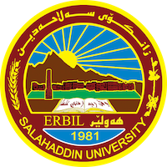
Academic Curriculum Vitae
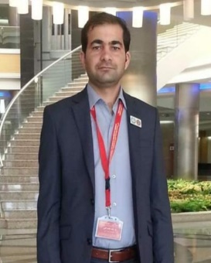
Personal Information:
Full Name: Blnd Najat Ali
Academic Title: Lecturer
Email: blnd.ali@su.edu.krd
Mobile: 009647504669796

Education:
- Bachelor in Physical Education / Salahaddin University – Erbil 2004.
- Master degree in Physical Education / Salahaddin University – Erbil 2009.
- Ph.D. degree in Physical Education / Salahaddin University – Erbil 2019.

Employment:
- Employed in Physical Education / Salahaddin University – Erbil 2004 until present.
- Department coordinator from 2013 until 2015.

Qualifications
- Teaching method qualification at Salahaddin University in 2011.
- English language qualification at Salahaddin University language center (pre-intermediate) level 2019.

Teaching experience:
- Taught the following undergraduate courses (scouting- first grade) and (handball – second grade).

Research and publications
- The effect of direct mental training timing in learning some basic skills in volleyball. Journal of Sports Education Sciences. Volume(3), issue (16),2023.
- The effect of direct mental training exercises on visual sensory preference to perform some basic technical skills in volleyball. CONFERENCE CIHAN UNIVERSITY-ERBIL.

Conferences and courses attended
- Physical Education and Sport Science conference ……….2019.
- CONFERENCE CIHAN UNIVERSITY-ERBIL. THE3RDINTERNATIONAL CONFERENCE ON LANGUAGE AND EDUCATION “EMERGING HORIZONS IN LINGUISTICS, LITERATURE, EDUCATION,AND TRANSLATION STUDIES”(CIC-LANGEDU2023)

Professional Social Network Accounts:

- ORCID: https://orcid.org/my-orcid?orcid=0009-0008-9154-333X.
- GOOGLE SCHOLAR: https://scholar.google.com/citations?hl=en&view_op=list_works&authuser=5&gmla=AHoSzlVL0ABLXiyT9hCXw92rVzEQBNNrmZx7HaIV7B5Yxj40qEUZy9dYeD5yeEj4rbQTYTET-QzRXdn51pFxww&user=Bx7F5jYAAAAJ.
- Research Gate: https://www.researchgate.net/profile/Blnd-Ali-2.

