Lab 1 Practical Molecular Biology
(SOLATION OF PLASMID DNA)
prepared by
Blnd Ibrahim Mohammed
2022-2023

Plasmid
Plasmids are extra chromosomal DNA that replicate independently of the bacterial chromosome. They are normally covalently closed, circular, super-coiled molecules. They carry genes encoding functions (such as antibiotic resistance) which may be useful to the cell but are not essential for normal cellular activities.
Type of plasmid
- Regarding their ability to be transferred to other bacteria:
- Conjugative: the sexual transfer of plasmids to another bacterium through a pilus. those plasmids possess the 25 genes required for transfer.
- Non-conjugative: this type of plasmids doesn’t initiate conjugation. They can only be transferred with the help of conjugative plasmids.

- Regarding function:
- Fertility-(F) plasmids: they are capable of conjugation (they contains the genes for the pili).
- Resistance-(R) plasmids: contain gene (s) that can build resistance against one or several antibiotics or poisons.
- Col-plasmids: contain genes coding for colicines, proteins that can kill other bacteria.
- Degradative plasmids: able to digest unusual substances, e.g., toluene or salicylic acid.
- Virulence plasmids, turn a bacterium into a pathogen.

- Copy number
- High copy number = 10-100 copies / cell ◊ generally Non conjugative.
- Low copy number = 1-4 copies / cell ◊ generally conjugative.

Plasmid in Biotechnology
In the recombinant DNA technology plasmid DNA are used as vectors for carrying any foreign DNA. They can replicate with in host cell and possess phenotypic traits by which they can be detected. Genetic engineering makes use of recombinant DNA technology to fuse genes with plasmid vectors and clone them in the host cells. This way large number of isolated genes and their products can be synthesized and used for industrial, therapeutic and agricultural purposes.
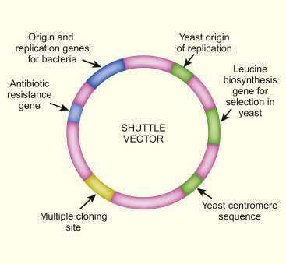

Requirements for Plasmid isolations

- coli cells (DH5α) (provided)
- Plasmid DNA Isolation Kit (Sigma) (provided)
- Luria Bertani medium
- Autoclaved Sigma water

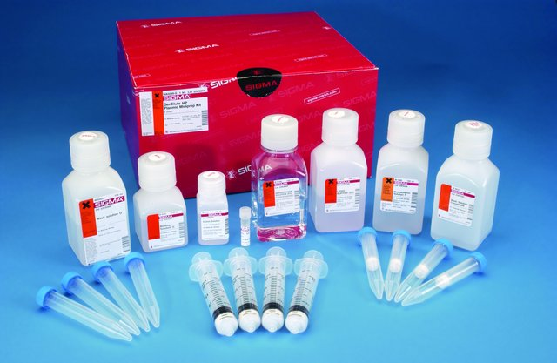

Procedure
- Preparation of bacterial sample: inoculate 50 ml of bacterial cells (E. coli, DH5α) from frozen glycerol stock (or pick up one colony from Petri plate using sterile tooth pick) to 5ml LB medium. Allow the cells to grow overnight at 37°C at 200 rpm.
- Harvest and Lysis of bacteria: Transfer 1.5 ml of broth containing cells into 1.5 ml centrifuge tubes and centrifuge the cells at 13000 rpm for 1 min, discard supernatant. Resuspend the cells in 200 μl of resuspension solution. Add 200 μl of Lysis Solution. Invert gently to mix, let it for about 5 min.
- Preparation of clear lysate: Add 350 μl of Neutralization solution. Invert 4-6 times to mix. Centrifuge at 13,000 rpm for 10 mins, discard supernatant.
- Preparation of binding column: Add 500 μl Column Preparation Solution to binding column in a collection tube. Spin at 13,000rpm for 1 min, discard flow through.
- Binding plasmid DNA to column: Transfer the cleared lysate to the binding column Centrifuge at 13,000 rpm for 1 min, discard the flow through.
- Wash to remove contaminants: Add 750 μl Wash solution to column. Spin for 1 min. Discard flow through. Spin for 1 min to dry the column (dry by speed vacuum), allow at room temperature for 2-5 min.
- Elution of purified Plasmid DNA: Add 70 μl of Elution Solution (or sterile sigma water). Spin for 1 min at 13,000 rpm. Store the plasmid DNA at - 20°C.

