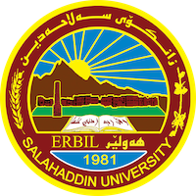
Academic Curriculum Vitae

Personal Information: 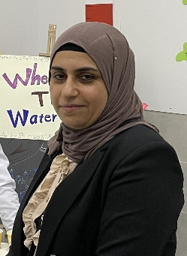
Full Name: Bnar Khalid Bakr
Academic Title: Lecturer
Email: (university email): bnar.bakr@su.edu.krd
Mobile:07504782200

Education:
- BSc in Biology: 2005
- MSc in in Plant Taxonomy: 2011, thesis about: Morphological-Systematic study of two genera Smyrenium and Scandix of Family Umbelliferae (Apiaceae) in Kurdistan Region of Iraq.
Employment:
- I graduated from Salahaddin University in 2005(Ranked 2nd in collage ).
- I got master degree in 2011 in Plant taxonomy.
- I change Academic Title from Assistant lecturer to lecturer in 2017.

Qualifications
- Teaching method course.
- IT
- Language qualifications such as TOEFL, IELTS or any equivalent
- Any professional qualification
- You could put any professional courses you have attended

Teaching experience:
- Laboratory teaching experience : plant anatomy, plant taxonomy, General botany, academic debate.

Research and publications
- Comparative Study of Laticiferouse Canals in Five Genera of Plants.
- A chemotaxonomical Study of Four Species Belonging the Genus Arabis L. Cruciferae (Brassicacae) in Iraq.
- Anatomical and Palynological studies of three species of Gladiolus L. of Family Iridaceae.
- Chemotaxonomical study of two genera Scandix and Smyrnium of family Apiaceae in Kurdistan region of Iraq.

Conferences and courses attended
- Give details of any conferences you have attended, and those at which you have presented delivered poster presentations.

Funding and academic awards
- List any bursaries, scholarships, travel grants or other sources of funding that you were awarded for research projects or to attend meetings or conferences.

Professional memberships
- Kurdistan Biology Syndicate/ Hawler
- Kurdistan Teacher Syndicate/ Hawler.

Professional Social Network Accounts:
- https://www.researchgate.net/profile/Bnar-Bakr.
- https://scholar.google.com/citations?user=l3X8LOEAAAAJ&hl=en.
- https://www.linkedin.com/feed/.
- https://orcid.org/my-orcid?orcid=0009-0009-3945-1398.

It is also recommended to create an academic cover letter for your CV, for further information about the cover letter, please visit below link:
https://career-advice.jobs.ac.uk/cv-and-cover-letter-advice/academic-cover-letter/

