The impact of cryptocurrency on traditional banking services

Research Project
Submitted to the department of (Finance and Banking) in partial fulfilment of the Requirements for the degree of BSc. in
(Finance and Banking)

Prepared By:
Kaiwan Omer Hassan
Mohammed Ali Esmail
Sawsan Maqsud Salim

Supervised By:
L. Bnar Karim Darwish

2024

Chapter 1
- Introduction
Today's financial climate requires studying how virtual currency affects traditional banking. This study is essential and dynamic since cryptocurrency is becoming more popular. There are several reasons to study how cryptocurrencies affect payment processing, loan and deposit interest, and government control. Cryptocurrencies have garnered attention and investment. Crypto assets may impact the monetary system. Regulators and policymakers must comprehend their impact on traditional banking to ensure financial stability. Alternative payment and transaction systems include Bitcoin and Ethereum, the influence of the payment ecosystem on conventional bank's payment services must be assessed to understand its evolution. Digital payments are rising, making this vital. Peer-to-peer and other decentralised lending enabled by cryptocurrency have disrupted banks.
How well traditional banks analyse the impact on their lending operations will determine how well they adapt. Some people and corporations are investing or protecting their capital using bitcoin and other digital assets. Financial institutions may require bitcoin custodial services to compete. Traditional banks must adapt to bitcoin regulations. Compliance and risk management must understand bitcoin's impact on banking rules. The study examines how cryptocurrencies impact payment systems by changing transaction volumes and user preferences. Learn how bitcoin innovations like decentralised lending platforms and peer-to-peer lending are revolutionising finance. Examine how traditional financial institutions manage bitcoin holdings. To examine how cryptocurrency regulation affects traditional banking organisations. To illuminate how traditional financial institutions may adapt to bitcoin. This study examines how cryptocurrencies influence traditional banking in a region or set of countries. Within its mandate, it will examine transaction frequency, lending conditions, and new legislation.
Acknowledging the regional focus on the Kurdistan Regional Government, this research will delve into a select group of traditional banks operating within the KRG. The study will utilize a mixed-methods approach, combining quantitative surveys and qualitative interviews, to capture the unique interplay between traditional banking practices and the adoption of cryptocurrencies in the specific context of the Kurdistan region. Therefore, the following research questions are formatted:

1.1 Research questions:
- What is the current state of cryptocurrencies in the financial landscape?
- How have cryptocurrencies affected traditional banking practices and
services?
- What are the potential long-term implications of this influence?

  - Research importance:
Understanding the impact of cryptocurrencies on traditional banking services is vital for several reasons:
- Regulatory Challenges: Research helps in developing effective regulatory
frameworks, ensuring consumer protection, and maintaining financial stability in the face of evolving technologies.

- Risk Management: Banks must assess risks associated with cryptocurrency integration, including cybersecurity threats and compliance with regulations, to safeguard their operations.

- Research guides traditional banks in innovating and adapting to the changing financial landscape, allowing them to leverage blockchain technology and cryptocurrencies to enhance services.

- Consumer Behavior: Studying the impact of cryptocurrencies helps banks comprehend changing consumer preferences and behaviors, enabling them to tailor offerings to meet evolving demands.

1.3 Research objectives:
  - To examine the influence of cryptocurrencies on conventional banking.
  - To identify key drivers and challenges related to this influence.

  - Research Methodology
This research employs a mixed-methods approach, combining both quantitative and qualitative methods to provide a comprehensive understanding of the impact of cryptocurrency on traditional banking services. This design allows for a nuanced exploration of the topic by leveraging the strengths of both quantitative data for broader trends and qualitative insights for depth of understanding.
1.4.1 Quantitative Phase:
a. Survey Design:
- Developing a structured survey questionnaire to collect quantitative data.
- Including questions addressing the adoption of cryptocurrencies by traditional banks, customer preferences, and perceived challenges and opportunities.
- Utilizing a Likert scale for some questions to quantify attitudes and opinions.
b. Sampling Strategy:
- Randomly selecting a representative sample of traditional banks across different geographical regions.
- Identifying a sample of cryptocurrency users and non-users among bank customers.
c. Data Analysis:
- Employing statistical techniques, such as regression analysis, to examine the correlation between cryptocurrency adoption and changes in traditional banking services.
- Utilizing descriptive statistics to present an overview of trends in cryptocurrency adoption.

1.4.2 Qualitative Phase:
a. Interviews:
- Conducting semi-structured interviews with key stakeholders, including banking executives, regulators, and technology experts.
- Exploring in-depth perspectives on the challenges faced by traditional banks in adapting to cryptocurrencies and the strategies employed.
b. Document Analysis:
- Analyzing publicly available financial reports, policy documents, via literature review
- Extract qualitative insights into the impact of cryptocurrency on traditional banking services.
1.4.3 Research hypotheses:
H0: Cryptocurrencies will not impact traditional banking practices and services.
H1: Cryptocurrencies will impact traditional banking practices and services.

This mixed-methods research design provides a robust framework for investigating the multifaceted impact of cryptocurrency on traditional banking services. The integration of both quantitative and qualitative data will allow for a more nuanced and comprehensive understanding of the evolving dynamics within the financial sector.

Chapter 2
Literature Review
2.1 The history of financial services and cryptocurrencies.
Financial services have ancient roots. Beginning before 2000 BCE in ancient Mesopotamia, banks were created. Temples stored grain and other valuables throughout this time. As lenders, the priests loaned these resources to local farmers and merchants. Ancient Greek banking developed alongside moneylenders and private depositories. Traditional financial services are centralised, transparent, and efficient. Centralization the gradual accumulation of power and decision-making into a single authority is shown by the bank. This improves financial transaction oversight. Conventional banking services depend on timely and accurate account and transaction information. This technique ensures client information and openness. This fosters financial sector trust and certainty. Efficiency is key to traditional banking. Banks provide internet banking, mobile banking, and ATMs to serve consumers efficiently and reliably. Innovation is important with conventional banking services. Financial organisations are continually looking for ways to enhance their services and provide new solutions. Online banking has transformed the banking business, making financial administration easier for clients. Traditional banking services are affected by laws and regulations. Central banks supervise and manage the financial system by ensuring banks follow the law. Central banks often prioritise price stability and robust banking and payment systems. Legislation must provide the central bank with the tools and authority it needs to succeed. (Der Spek & Leeuwen, 2018, pp. 17-22)
A distributed network of computers supports cryptocurrency, an electronic payment system that authenticates transactions using cryptography. The year 2009 marked the inception of Bitcoin, a digital currency conceptualised and introduced by Satoshi Nakamoto, perhaps regarded as the pioneering cryptocurrency. Bitcoin, the first kind of cryptocurrency, is widely recognised and esteemed as a prominent digital currency. The rise of Bitcoin has led to the widespread acceptance of other cryptocurrencies, which are now used for many purposes. Before Bitcoin, established banks and payment methods dominated financial transactions. These systems had centralised control maintained by authority entities. The above systems have long transaction times, high fees, and restricted accessibility. Several digital currencies have addressed these difficulties. B-Money and Bit Gold, which included secure ledgers, were proposed but never completed, resulting in low acceptance. The 2009 invention of Bitcoin brought decentralised digital money to finance. This innovative work was credited to Satoshi Nakamoto, whose actual identity is unknown. Bitcoin created the blockchain, a decentralised and immutable record technology that supports many cryptocurrencies, revolutionising banking. Early Bitcoin supporters spotted its promise and started mining and trading, accelerating its adoption. (Okpala, 2020, pp. 3-6) (Khadka, 2020, pp. 7-10)
2.2 The significance of cryptocurrency on the financial sectors.
Recent years have seen Bitcoin and other cryptocurrencies acquire popularity and global recognition. All bitcoin transactions are recorded using blockchain technology. Blockchain technology allows direct transactions via decentralisation. Blockchain technology's openness lets everyone exchange information. Increased system accountability and fraud reduction result from this feature. Cryptocurrencies offer rapid, affordable, bankless international transactions. Most countries are establishing legislation in this field; however, others are behind due to different factors. Under the new statute, the Securities and Exchange Commission (SEC) and Commodity Future Trading Commission (CFTC) have power. There is not much cryptocurrency law in the UK. Unlike legal cash, cryptocurrencies are assets in the UK. So, bitcoin exchangers must register with the UK FCA. Cryptocurrency regulations should decrease risks and promote innovation. Taxes, Anti-Money Laundering (AML), and Know Your Customer (KYC) are examples of regulations. Criminals utilising cryptocurrency worry governments. Regulators and central banks promote innovation, consumer protection, and financial stability to achieve balance. Cryptocurrency regulations should reduce risks and encourage innovation. (Vu, 2022, pp. 29-32) (Wang, 2018, pp. 2-4)
Cryptocurrencies' volatility, large gains, diversity, and financial democratisation appeal to retail investors. Institutional investors handle significant financial assets for pension funds, hedge funds, banks, insurers, and endowments. Technology companies sell software, hardware, internet services, cloud computing, AI, and blockchain. Central banks are considering digital currency. CBDCs also protect the legal tender status and the regulation and supervision of traditional fiat currencies. Financial phenomena like cryptocurrencies may impact monetary systems and society. Growing as an asset class, cryptocurrencies need further research and development. (Crypto Assets and Central Bank Digital Currencies: Potential Implications for Developing Countries, 2023, pp. 21:27)

2.3 The relevance of studying cryptocurrencies impacts on the traditional banking.
Today's financial climate requires studying how virtual currency affects traditional banking. This study is essential and dynamic since cryptocurrency is becoming more popular. There are several reasons to study how cryptocurrencies affect payment processing, loan and deposit interest, and government control. Cryptocurrencies have garnered attention and investment.
Digital payments are rising, making this vital. Peer-to-peer and other decentralised lending enabled by cryptocurrency have disrupted banks. How well traditional banks analyse the impact on their lending operations will determine how well they adapt. Some people and corporations are investing or protecting their capital using bitcoin and other digital assets. Financial institutions may require bitcoin custodial services to compete. Traditional banks must adapt to bitcoin regulations. Compliance and risk management must understand bitcoin's impact on banking rules. The study examines how cryptocurrencies impact payment systems by changing transaction volumes and user preferences. To examine how cryptocurrency regulation affects traditional banking organisations. To illuminate how traditional financial institutions may adapt to bitcoin. This study examines how cryptocurrencies influence traditional banking in a region or set of countries. Within its mandate, it will examine transaction frequency, lending conditions, and new legislation. We'll also examine cryptocurrency and traditional banking consumer and investor attitudes and behaviours.

2.4 Overview of cryptocurrency technology and its evolution.
Asymmetric cryptography safeguards block chains. The keys of asymmetric encryption are public and private. Public-key cryptography protects account transactions using digital signatures. The encrypted private key can be manually exported and decoded to sign transactions.
An attacker can steal private data from the desktop bitcoin wallet's Remote Procedure Call (RPC) interface. Asymmetric encryption safeguards participants' integrity and privacy. A Distributed Ledger Technology (DLT) system's shared consensus mechanism lets non-malicious nodes reach consensus on an unchangeable transaction ledger. The same as bank transfers, ledger transactions allow digital asset transfers to approved users. (Carvalho et al., 2021, pp. 483-484) (Wang, 2018, pp. 4-5)
Figure 1: Types of Blockchain (Wang, 2018, pp. 8)
The most popular ledger, the public ledger, provides transparency for all users due to its anonymity. Therefore, those in this category are at higher risk of assault. Blockchain transaction instructions are secured by a decentralised consensus method, removing the requirement for participant trust. Cryptocurrency protocol incentives are considered. Public blockchain ecosystem security and viability depend on bitcoin exchange market incentive misalignments. (Nikam, 2018, pp. 157) (Yu et al., 2022, pp. 4-5)
After the remarkable success of Bitcoin, other competing cryptocurrencies, often known as "Altcoins" quickly emerged. By the second quarter of 2020, there will be over 7,000 different cryptocurrencies, together valued at over 300 billion dollars, in the market. The development and adoption of numerous cryptocurrency types are indicators of the industry's significant expansion. The cryptocurrencies that are widely recognised and acknowledged include:
- Bitcoin (BTC):
Introduced by Satoshi Nakamoto in 2009, it is a decentralised digital currency that uses blockchain technology to document transactions and achieve fundamental encryption and consensus. With a circulation cap of 21 million tokens, it stands as the first most widely used cryptocurrency as of September 2021.
- Ethereum (ETH):
A different kind of digital currency operates on a blockchain network that can be programmed and is designed as a platform for decentralised applications (DApps). Ether (ETH) serves as the intrinsic currency and was created as a medium of exchange on the Ethereum network. Ethereum ranked as the second most widely adopted cryptocurrency, behind Bitcoin, in September 2021.
- Cardano (ADA):
A blockchain platform of the third generation employs proof-of-stake (PoS) as a means to remove the requirement for intricate proof-of-work calculations. Cardano seeks to create a decentralised application (DApp) platform that incorporates a multi-asset ledger and validates smart contracts, taking inspiration from Ada Lovelace, a mathematician from the 19th century. The development process consists of five steps that utilise a research-based methodology and incorporate peer-reviewed findings.
- Binance Coin (BNB):
Created by Binance, it is a utility coin that enables traders to obtain savings on trading expenses. It is currently employed for many functions, such as payments, flight ticket reservations, entertainment, internet services, and financial services.
- Solana (SOL):
Is a blockchain platform that generates the Sol cryptocurrency, which has made notable advancements in decentralised finance. Utilising contract technology, it has introduced the non-fungible token (NFT) called "Degenerate APE Academy."

- Ripple (XRP):
Developed by Ripple Labs, Inc., it is a digital currency used for investment, cryptocurrency trading, and financing Ripple transactions. XRP differs from Bitcoin in that it does not depend on a complex blockchain-based digital verification process.
- Dogecoin (DOGE):
Which garnered immense popularity after its 2013 introduction, was designed to imitate Bitcoin. This cryptocurrency is built on blockchain technology and uses proof-of-work (PoW) for its mining process. As of September 2021, Dogecoin has a market capitalization of 21 million and is associated with significant cryptocurrency events. It’s worth around 24 cents.
- Polkadot (DOT):
The Main Relay Network and the Parallel Network are two blockchain technologies that Gavin Wood, one of the co-founders of Ethereum, has incorporated into Polkadot in an effort to improve the capabilities of a blockchain network. The primary relay network is utilised for enduring transactions; however, the parallel network is employed for user-generated blockchains, referred to as "parachains." Polkadot differentiates itself from other cryptocurrencies by focusing on the development of blockchain bridges to address interoperability issues.
- USD Tether (USDT):
The inaugural stablecoin is pegged to the value of the US dollar and provides clarity, reliability, and minimal transaction expenses. Nevertheless, Tether Ltd. does not provide a guarantee for the redemption of its currency, and it is not possible to exchange it for US dollars. To summarise, cryptocurrencies provide a diverse range of uses and are always developing to cater to the requirements of their users.
- USD Coin (USDC):
Ethereum is the backbone of the blockchain-based stablecoin known as USD Coin (USDC). It maintains a fixed exchange rate with the US dollar, resulting in efficient and cost-effective transactions. Given that Grant Thornton, LLC, is in charge of overseeing its reserves, investors have faith in USDC due to its stability and transparency. In March 2021, Visa declared its acceptance of USDC, and by June 20, 2021, the total amount of USDC in circulation had reached 24.1 billion.
(Adaobi & A, 2023, pp. 13-24)
Figure 2: Current state market size. (Blake & Propson, 2022, pp. 14)
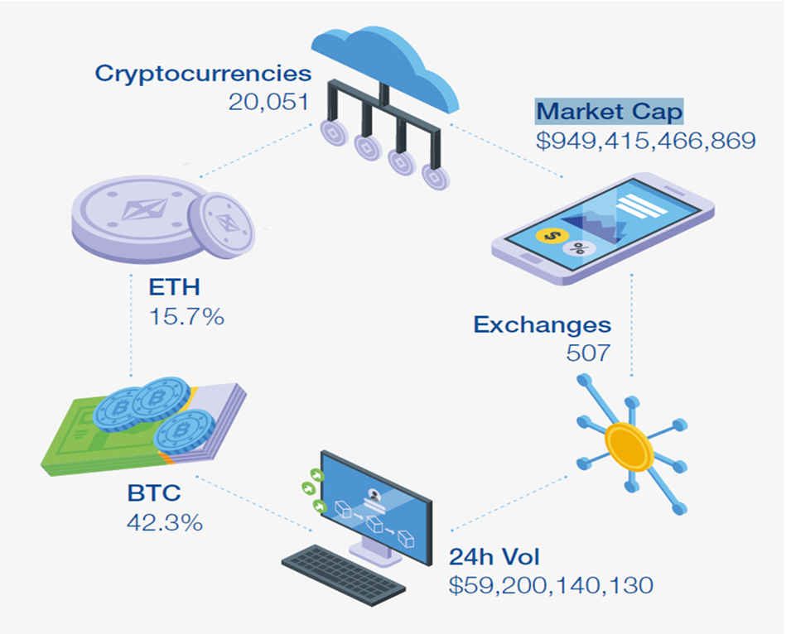
A stablecoin is a type of digital currency that is specifically created to provide a steady and unchanging value in relation to a chosen item or group of assets, which might be a traditional currency, gold, or a combination of several cryptocurrencies. Stablecoins are employed to alleviate the volatility inherent in the cryptocurrency market and are frequently used for trading, easing transactions, and safeguarding value.
Conventional financial institutions have also adopted reserve-backed stablecoins, which are often referred to as tokenized deposits, in addition to public blockchains. Institutional stablecoins are used in restricted networks for Digital Ledger Transactions (DLTs), facilitating efficient wholesale transactions between financial institutions and their consumers. (Liao, 2022, pp. 1-5)
Figure 3:
Circulating supply of USD-pegged public stablecoins. (Liao, 2022, pp. 3)
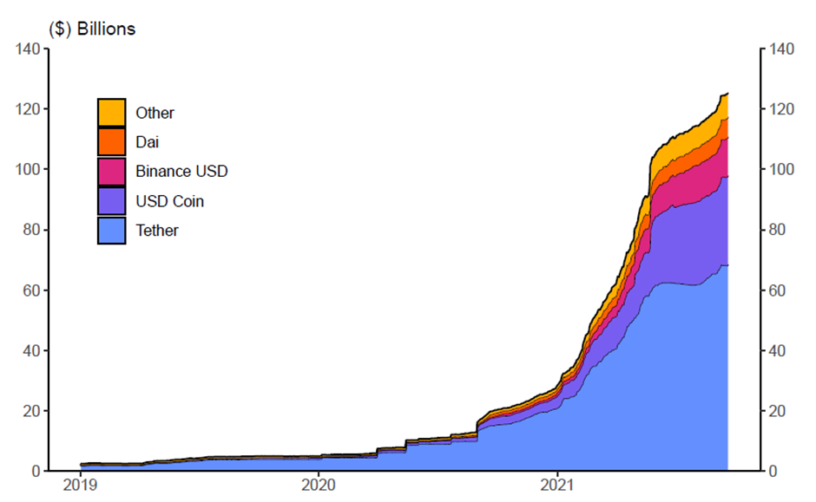

2.5 Previous studies on the relationship between cryptocurrency and traditional banking.
Bitcoin-based companies could replace traditional financial institutions payment services, complicating the relationship between banks and cryptocurrencies. In order to resolve this problem, financial institutions can form partnerships with bitcoin enterprises to streamline payment services. Financial institutions have the ability to possess cryptocurrencies, promote their use, provide loans backed by cryptocurrency assets, facilitate the settlement of cryptocurrency derivative trades, extend loans to cryptocurrency enterprises, support initial coin offerings (ICOs), and offer secure storage wallets or trading platforms. Banks generate currency, allocate credit, and facilitate the transmission of monetary policy, thereby presenting novel risks to the financial system. Banks could potentially engage in cryptocurrency-related activities by leveraging recent advancements in bitcoin scalability. Financial institutions have the option to implement cryptocurrencies that cater specifically to retail customers or utilise settlement tokens for the purpose of clearing and settling financial obligations.

2.6 Analysis of regulatory approaches and policies related to cryptocurrencies.
- Regulatory landscape in European Union (EU):
The European Banking Authority (EBA) and other members of supervisory colleges are responsible for the oversight of significant stablecoin issuers in the European Union (EU). MiCA guarantees the standardisation of regulations across the European Union, in contrast to EU directives that necessitate national adoption, potentially leading to regulatory discrepancies and obstacles to market entry. These regulations mandate the maintenance of a capital buffer and the requirement of 100% collateralization for their creation. MiCA's objective is to mitigate stablecoin runs that occur when issuers are unable to promptly meet substantial redemption requests, specifically focusing on global stablecoins. (Ostercamp, 2022, pp. 16-22)
For example, the most popular crypto-friendly banks in EU are:
Amina Bank: previously known as SEBA Bank, is a Swiss financial institution that specialises in cryptocurrency transactions and provides a broad variety of services to businesses and individuals, including custody, trading, lending, and payment processing.
Sygnum Bank: shares AMINA Bank's dedication to supporting cryptocurrencies and provides similar services, including custody, trading, lending, asset management, and tokenization.
Fidor Bank: is a highly accommodating bank in Europe that offers a diverse array of services and products tailored specifically for bitcoin consumers.
Xapo Bank: is a private bank under Gibraltar-Spain regulations that offers both Bitcoin and US dollar accounts, with a designated account manager to help customers maximise the bank's offerings.
N26: is a German neobank established in 2013 that offers mobile banking services and virtual or real cards for convenient transactions. Its standard package does not require a monthly fee, but premium options range from €4.90 to €16.90. N26's connection with Bitpanda allows clients in Austria, Germany, Switzerland, Belgium, Portugal, and Ireland to purchase and trade over 200 cryptocurrencies directly within the N26 app. (Murphy, 2023) (Nielsen, 2023) (Rotkiewicz, 2023)
- Regulatory landscape in United Kingdom (UK):
The UK government is proposing pilot regime legislation to allow distributed ledger-based financial market infrastructures to settle e-money token payments. This idea might boost stablecoin innovation and institutional acceptance. The UK aims to regulate most stablecoins and stablecoin arrangements by classifying them as financial services. The Electronic Money Regulations of 2011, Payment Services Regulations of 2017, Banking Act of 2009, and Financial Services (Banking Reform) Act of 2013 must be followed for this categorization. Governments recommend "stable tokens" to reduce risk since they are connected to fiat money or other assets. The goal of these regulatory frameworks is to make stablecoins as trustworthy as bank money. The Bank of England is considering adjustments to establish stablecoins supported by a single fiat currency (Ostercamp, 2022, pp. 23-30)
For example, the most popular crypto-friendly banks in UK are:
Revolut, Monzo, Royal Bank of Scotland, NationWide, and Barclays are all banks that support cryptocurrency transactions.
Revolut: allows users to easily engage in exchanges and manage their financial matters within a single application.
Monzo: is a bank that supports cryptocurrency, allowing users to engage in buying and selling activities on cryptocurrency exchanges using their accounts.
The Royal Bank of Scotland (RBS): its subsidiary NatWest have a favourable stance towards cryptocurrencies and trade, allowing users to purchase and sell cryptocurrency with either a debit or credit card.

- Regulatory landscape in United States (US):
The US stablecoin regulatory structure is contentious, with certain issuers and service providers conforming to federal and state regulations. Stablecoins were intended to be classified as deposits under the STABLE Act, which would have restricted their distribution to insured depository institutions beginning in December of 2020. Stablecoins might fall under the umbrella of securities, commodities, or derivatives that are subject to government regulation. The Basel standard requires issuers to have a liquidity coverage of one hundred percent, and high-quality liquid assets (HQLAs) must be readily accessible for conversion into cash. (Ostercamp, 2022, pp. 31-36)
Most of the cryptocurrency market consists of stablecoins, which maintain a value relative to a fiat currency or other asset, and volatile cryptocurrencies like Bitcoin and Ethereum. The federal government protected uninsured depositors and implemented a contingency lending policy for banks in reaction to bank failures that threatened the US banking system. (Wilmarth, 2023, pp. 243-299)
Implementing this approach would ensure these firms follow regulations. This policy will protect investors, the banking system, and the financial system against bitcoin market disruptions. Establishing strong prudential boundaries between the bitcoin market and banks is crucial. (Wilmarth, 2023, pp. 299-312)
For example, the most popular crypto-friendly banks in US are:
Simple Bank: a financial technology firm, is known for its crypto-friendly approach and seamless connection with several cryptocurrency exchanges.
BankProv: a Massachusetts-based bank, is supportive of cryptocurrencies and provides a wide range of specialised services for businesses and individuals entering the bitcoin industry. It stands out due to its commitment to regulatory compliance, with FDIC insurance protecting client deposits up to $250,000.
Mercury, a US-based banking platform, provides a wide range of financial services for digital enterprises, including custody, trading, and payment processing. (Andriyenko, 2023) (Lawrence, 2023) (Murphy, 2023) (Nielsen, 2023)

Table 1. International community vision of cryptocurrencies status:
(Atiyah et al., 2023, pp. 6-7)
Rank Friendly What cryptocurrencies Unfriendly What cryptocurrencies
Jurisdiction Status Jurisdictions Status

1 USA Convertible cryptocurrencies are under China Ban all trading exchanges for
study for ETF admission. Cryptocurrencies.
(CFTC) classified Bitcoin as a commodity.
The (SEC) had considered Bitcoin and
Ethereum as commodities, but classified
other cryptocurrencies as a security.

2 UK Considered cryptocurrencies as foreign Nigeria Banned All cryptocurrencies.
currency and put them under study to be
applied to the bank to improve its
monetary system.

3 Japan Deemed a payment method. Bolivia Banned treating with
cryptocurrency, not issued via
government.

4 Germany Private currency. Colombia Banned cryptocurrencies.

5 Australia Considered cryptocurrencies as property, Thailand Banned cryptocurrencies.
Australian citizens can use them for
purchases in a shop as barter.

6 El Salvador According to Article 7 of El Salvadoös Ecuador Trading cryptocurrencies is not Bitcoin Law, which considered Bitcoin as prohibited, but the government legal tender, where all people must announced that it accept Bitcoin as a means of payment. is not an authorised means of payment that can be utilised in Ecuador.

7 Central The legislators in the parliament had voted Turkey The Central Bank banned African unanimously to pass a bill legalising the utilising Bitcoin and other Republic adoption of cryptocurrencies. Cryptocurrencies to purchase goods or services.
- Regulatory landscape in United Arab Emirates (UAE):
Financial-free zones with separate administrations, tribunals, and legal frameworks affect cryptocurrency law in the UAE. The UAE Central Bank, which regulates financial institutions, does not ban Bitcoin, other cryptocurrencies, currency exchanges, or blockchain technology. The Central Bank is evaluating cryptocurrencies and developing new laws if needed.
The Dubai Virtual Assets Regulatory Authority (DVARA) regulates crypto assets and non-fungible tokens in Dubai's free zones and special development regions autonomously. Crypto.com, Kraken, and Binance are licenced to conduct financial services in this jurisdiction. (Atiyah et al., 2023, pp. 10-14)
The United Arab Emirates (UAE) financial system is highly modern and interconnected, providing a wide range of services to merchants, businesses, retail outlets, and multinational enterprises.
Directly crypto-friendly banks:
Emirates NBD: NDB offers qualified institutional investors crypto custody and trading services through their blockchain platform, "e24." However, Emirates NBD does not allow individual cryptocurrency purchases or sales. RAKBANK: They were one of the first UAE banks to announce cryptocurrency services; however, their products are still being developed. They're working with Binance to provide bitcoin traders with complete banking alternatives.
Indirectly crypto-friendly banks:
Abu Dhabi Commercial Bank (ADCB): ADCB, which does not directly provide cryptocurrency services, lets consumers transfer funds to UAE-licenced cryptocurrency exchanges.
First Abu Dhabi Bank (FAB): FAB allows consumers to transfer cash to authorised exchanges but does not offer cryptocurrency services.
Mashreq Bank: Mashreq Bank does not provide bitcoin trading online or on mobile. (Murphy, 2023) (Das, 2023)
- Regulatory landscape in Iraq (IQ):
Since cryptocurrencies are not addressed in Iraqi law, one must go to Iraqi Electronic Signature and Electronic Transactions Law No. 78 of 2012 for guidance. The primary goal of enacting this regulation was to remove barriers to electronic transactions, such as online payments. But there were no limitations in the aforementioned provisions. But the Iraqi Central Bank has control over all things related to electronic money transfers, including payment methods, according to Article 27 of the country's law on electronic signatures and transactions. Article 27,67 of the regulatory framework states that the directives and decisions of the Central Bank of Iraq must be followed by any cryptocurrency activity. In 2017, the Central Bank issued a warning about Bitcoin. The cautionary tale paints Bitcoin as virtual money that doesn't exist in the real world. This method makes it easier to purchase online and can be turned into conventional currency. Consequently, there is a chance of electronic fraud and piracy when these commodities are distributed. Because of the Central Bank's ruling, anyone who uses cryptocurrencies is now potentially in violation of regulations, including the Anti-Money Laundering and Terrorist Financing Law No. 39 of 2015. The tally comes to 68. But when cryptocurrency gained traction in Iraq, several Iraqis and Arabs created their own versions that met their specific needs. These individuals took advantage of the fact that these cultures didn't fully understand or use this new technology.
Muhammad Al-Arab, an Iraqi journalist from Bahrain, created one of these currencies and named it HZM. The proprietor of HZM targeted al-Anbar and Abu Ghraib with video advertising on Facebook, Telegram, and Twitter. A lot of people were interested in these ads. The individual claimed that HZMcoin will have applications in investment, online commerce, and other digital spaces. Many Iraqis were enticed to invest in the HZM cryptocurrency, which led to its proliferation. Local authorities in Ramadi have faced challenges despite warnings from the Central Bank and Mayor Ibrahim al-Awsaj against bitcoin commerce. The lack of legislation in Iraq criminalising or prohibiting bitcoin transactions might be the reason for this. According to crypto specialists, the proprietor of the HZM currency deceived investors by guaranteeing a $1,000 return on a $1 investment. Among Iraq's most egregious forgeries, this one stands out. Investors suffered heavy losses when the HZM coin plummeted in value compared to the US dollar due to the owner's massive selling of the asset.
In response to severe economic setbacks, Iraq's central bank released a detailed proposal covering all cryptocurrencies on November 11, 2021. The Central Bank of Iraq will regulate marketplaces that deal in cryptocurrencies. The lack of a legislative, legal, or technological framework in the nation allowed these digital currencies to function, leading to this verdict. Cryptocurrencies are quite unpredictable, so the Central Bank says you shouldn't use them. The Central Bank does not guarantee either the stability of cryptocurrency prices or the safety of cryptocurrency users. No cryptocurrency has been authorised by the Central Bank. In light of the information provided, the Iraqi government has decided to strictly enforce the Anti-Money Laundering Law No. 39 of 2015 and maintain its prohibition on cryptocurrency trading and transactions. The legislative function of the bank is unaffected by this limitation. Unless expressly forbid by law, cryptocurrency transactions are still legal in Iraq. Money laundering laws encompass a wide variety of financial assets when they define "money" in Article 1, Section 5. This includes both domestic and international currencies, savings and checking accounts, investments, digital or electronic monies, precious metals, and more. The idea encompasses both Iraqi and international property and assets. Cryptocurrencies such as Bitcoin may be legally traded as they are tradable assets. Should Article 2, Sections 1, 2, and 3, characterise these transactions as money laundering, then they do not constitute money laundering. Transferring, hiding, or acquiring funds with the intent to hide their illicit origins is known as money laundering. It is not money laundering to buy or send cryptocurrency if the intention is not to conceal its origin. (Atiyah et al., 2023, pp. 14-15)
Summary of literature review
The rise of cryptocurrencies presents both opportunities and challenges for traditional banking services. Regarding Iraqi financial transfers to electronic ones, including payment methods, according to Article 27 of the country’s law on electronic signatures and transactions, the Central Bank of Iraq has control over everything. Research in this area is essential for informed decision-making, regulatory clarity, and the development of strategies to navigate the evolving financial landscape. Understanding the gaps in existing literature allows researchers to address critical questions and contribute valuable insights to the ongoing discourse surrounding the intersection of cryptocurrencies and traditional banking services.

References
Adaobi, C. C., & A, A. M. (2023, June). Understanding Cryptocurrency and Blockchain Technology. ResearchGate. https://www.researchgate.net/publication/371785743
Ahluwalia, S., Mahto, R. V., & Guerrero, M. (2020, February). Blockchain technology and startup financing: A transaction cost economics perspective. Technological Forecasting and Social Change. https://doi.org/10.1016/j.techfore.2019.119854
Andriyenko, I. (2023, July). Best Crypto-Friendly Banks You Should Know 2024. Traders Union. Retrieved January 1, 2024, from https://tradersunion.com/ratings/digital-banks/common/best-crypto-friendly-banks/
Atiyah, G. A., Manap, N. A., & Aziz, S. N. A. (2023, February). Legal Status of Cryptocurrency Circulation in Iraq: Lessons from the United Arab Emirates and the United States. Hasanuddin Law Review. https://doi.org/10.20956/halrev.v9i1.3867
Blake, & Propson. (2022, July). Head of Technology and Innovation in Financial Services. Retrieved November 29, 2023, from https://www3.weforum.org/docs/WEF_The_Macroeconomic_Impact_of_Cryptocurrency_and_Stablecoins_2022.pdf
Böhme, R., Christin, N., Edelman, B., & Moore, T. (2015, May). Bitcoin: Economics, Technology, and Governance. Journal of Economic Perspectives. https://doi.org/10.1257/jep.29.2.213
Carvalho, C. E., Pires, D. A., Artioli, M., & De Oliveira, G. C. (2021, July). Cryptocurrencies: technology, initiatives of banks and central banks, and regulatory challenges. Economia E Sociedade. https://doi.org/10.1590/1982-3533.2021v30n2art08
Crypto Assets and Central Bank Digital Currencies: Potential Implications for Developing Countries. (2023, April). https://doi.org/10.18356/9789210026178
Das, D. C. (2023, September). Reason Why UAE is One of The Most Crypto Friendly Countries in 2023 - Das Crypto. Das Crypto. Retrieved January 1, 2024, from https://dascrypto.in/uae-the-crypto-friendly-country/#3-access-to-banking-services
der Spek, & Leeuwen. (2018, January). MONEY, CURRENCY AND CRISIS IN SEARCH OF TRUST, 2000 BC TO AD 2000. books.google.nl. Retrieved November 2023, from https://books.google.nl/books?id=3E9bDwAAQBAJ&printsec=frontcover&source=gbs_ViewAPI&output=embed&redir_esc=y#%257B%2522showLinkChrome%2522%253Afalse%257D
Khadka, R. (2020, October). The impact of blockchain technology in banking: How can blockchain revolutionize the banking industry? Theseus. https://www.theseus.fi/handle/10024/346030
Krishnan, R. H., Saketh, Y. S., & Vaibhav, M. V. T. (2015, January). Cryptocurrency Mining – Transition to Cloud. International Journal of Advanced Computer Science and Applications. https://doi.org/10.14569/ijacsa.2015.060915
Lawrence, D. (2023, October). How Top 10 Crypto-Friendly Banks in Europe Can Help Push Massive Crypto Adoption. Cryptopolitan. Retrieved January 1, 2024, from https://www.cryptopolitan.com/crypto-friendly-banks-europe-crypto-adoption/
Lewis, I. (2023, November). 6 Crypto-Friendly Banks UK Compared (2024 Reviews). CompareBanks. Retrieved January 1, 2024, from https://www.comparebanks.co.uk/banking/crypto-friendly-banks-in-the-uk/
Liao, G. Y. (2022, January). Stablecoins: Growth Potential and Impact on Banking. https://doi.org/10.17016/IFDP.2022.1334
Murphy. (2023, March). Crypto Banking Report 2023. CoinCub. Retrieved January 1, 2024, from https://coincub.com/ranking/report-crypto-friendly-banks-in-2023/#sp_h_29002
Nabilou, H. (2019, July). Central Banks and Regulation of Cryptocurrencies. https://papers.ssrn.com/sol3/papers.cfm?abstract_id=3421417
Nielsen, J. (2023, June). The 10 Best Crypto-Friendly Banks in 2023 | CoinCodex. CoinCodex. https://coincodex.com/article/29182/crypto-friendly-banks/
Ochilov, R., Alikulov, M., Jumaniyozov, B., & Tursunov, K. (2023, January). The Regulation and Differences between Cryptocurrency, Stablecoin, Central Bank Digital Currency, e-Money, Virtual Currency, and In-Game Currency. Social Science Research Network. https://doi.org/10.2139/ssrn.4391265
Okpala, B. (2020, January). Disrupting the Banking System with Blockchain Technology: The Case of Bitcoin. Social Science Research Network. https://doi.org/10.2139/ssrn.3751178
Ostercamp, P. (2022, January). Stablecoin Regulation: EU, UK and US Perspectives. Social Science Research Network. https://doi.org/10.2139/ssrn.4038843
Rotkiewicz, K. (2023, December). The Best Crypto-Friendly Banks Worldwide. ULAM LABS. Retrieved January 1, 2024, from https://www.ulam.io/blog/the-best-crypto-friendly-banks-worldwide
Vu, T. N. N. (2022, April). The impact of cryptocurrency on traditional financial market. Theseus. https://www.theseus.fi/handle/10024/753871
Wang, J. (2018, November). An Introduction to Blockchain, Cryptocurrency and Initial Coin Offerings. https://ssrn.com/abstract=3288059
Wilmarth, A. E. (2023, January). We Must Protect Investors and Our Banking System from the Crypto Industry. Social Science Research Network. https://doi.org/10.2139/ssrn.4360175

