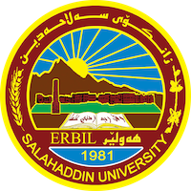
Academic Curriculum Vitae

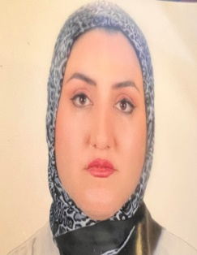
Personal Information:
Full Name: Bnar Sardar Mustafa Saaed
Academic Title: Assistant Lecturer
Email: bnar.mustafa@su.edu.krd
Mobile: +9647504710813

Education:
- B.SC: University of Salahaddin College of Agriculture (2011-2012). Field crops.
- M.SC: Salahaddin University-Erbil. College of Agriculture. Field crops–forage crops.

Employment:
- Permanent employment at the College of Agricultural Engineering Sciences/Salahaddin University – Erbil (since 2012 unit now).
- Currently l work as an academic staff of Salahaddin University – Erbil.

Qualifications
- Teaching qualifications (forage crop, Agricultural engineering practices ,technology of forage crop ,range management and grazing)
- IT qualifications
- Microsoft Office Word
- Microsoft Office Excel
- IBM – SPPS – Statistics
- Microsoft Office PowerPoint

- Language qualifications
- IELTS
- Language Writing Speaking Comprehension
Kurdish very good very good very good
Arabic very good very good very good
- Academic writing courses/ Language and Translation Centre – Salahaddin University-Erbil

Teaching experience:
- Undergraduate:
- Technology of forage ,Two-stage students
- Agricultural engineering practices, Third-stage students
- Range management, Fourth-stage students

Research and publications
- 1ST ICAS2019.

Conferences and courses attended

Funding and academic awards

Professional memberships

Professional Social Network Accounts:

https://orcid.org/0009-0000-5193-8013
https://scholar.google.com/citations?hl=en&hl=en&user=OSGDf_sAAAAJ
https://www.morressier.com/profile/64392bb0e052700012688ec1

