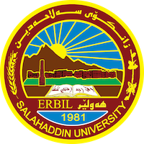
Academic Curriculum Vitae
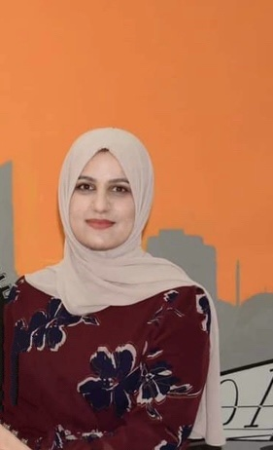
Personal Information:
Full Name: Bruska Sardar Mamand
Academic Title: Assistant Lecturer
Email: (university email) bruska.mamand@su.edu.krd
Mobile: 0750 420 36 44

Education:
- Bachelor of Science: Dams & water resources – 2010 Salahaddin University, Erbil.
- Master of Science: Engineering Hydraulic Structures – 2017 Salahaddin University, Erbil.

Employment:
- Engineer (assistant of teacher in class- معيدة): 04/2011 to 01/2014
- Assistant Lecturer: 2018 – 2023
- Water resources department Coordinator (مقرر القسم): 02/2021 to 05/2022

Qualifications
- Teaching qualifications:
General engineering subjects: Academic debate and critical thinking, engineering drawing and AutoCAD, engineering statistics and Engineering Analysis.

Specialization engineering subjects: Soil mechanics lab., Fluid mechanics, Engineering Hydraulics, Construction methods and estimation.

- IT qualifications:
Microsoft word, excel, AutoCAD, Matlab, SPSS statistics, ANSYS-FLUENT and GIS.

- Language qualifications: IELTS

Teaching experience:
- Method of teachings
- Computer programing course

Research and publications

- Estimating Seepage Quantity through Homogenous Earth-Fill Dam with Horizontal Drainage Using Different Methods – ZANCO Journal of Pure and Applied Sciences - 2020

- Use of Isotope Technique in Groundwater Investigation around Erbil City- Northern Iraq- ZANCO Journal of Pure and Applied Sciences - 2021

- Applying mass balance dilution technique for wastewater disposal to Greater-Zab River in Erbil, Kurdistan Region-Iraq – Recycling and Sustainable Development journal -2021

- Flow simulation over semicircular labyrinth weir using ANSYS -fluent – Tikrit Journal of Engineering Sciences - 2022

Professional Social Network Accounts:

- https://www.researchgate.net/profile/Bruska-Mamand
- https://scholar.google.com/citations?hl=en&user=rtEvexcAAAAJ

