Kurdistan Regional Government
Ministry of Higher Education and Scientific Research
Salaheddin University-Erbil
College of Engineering
Department of Mechanical Eng. & Mechatronics

The Effect of Exhaust Gas Temperature on the Emissions Removal Efficiency of a Catalytic Converter of the SI Engine

A project submitted to the college of engineering, department of mechanical engineering and mechatronics as a partial fulfilment
for the degree of
B.Sc
in mechanical engineering

Prepared by:
Abdulhadi Kawa Maulud

Supervisor:
Dr. Buland I. Dizayi

May 2023

Dedication

My deep gratitude to Dr. Buland I. Dizayi. His guidance and invaluable suggestions significantly refined the project during the limited time devoted for the project.
I appreciate my parents for their encouragement, support, and assistance during the past years. Eventually, their sacrifices were coronated by making me a degree holder in Mechanical Engineering. I wouldn’t have done it without them.
Thanks to the teaching staff of the Mechanical Engineering and Mechatronics Department, technicians, and my classmates.

Contents
Dedication 1
Abbreviations 4
List of figures 5
List of tables 6
Chapter One 7
Introduction 7
1.1 Introduction 7
1.2 Aims and objectives. 7
Chapter Two 9
Literature Survey 9
2.1 The Regulated Emissions and their Environmental Impacts 9
2.1.1 Nitrogen Oxides 9
2.1.2 Hydrocarbons 10
2.1.3 Carbon monoxide (CO) 11
2.1.4 Particulate matter 11
2.2 Emissions Formation within the Engine 12
2.2.1 Nitrogen Oxides 12
2.2.2 Hydrocarbons 12
2.2.3 Carbon monoxide 13
2.2.4 Particulate matter 13
2.3 Emission mitigation 15
2.3.1 Mitigation within the engine 15
2.3.2 Mitigation by after treatment facilities 15
2.3.3 Selective catalytic reduction 15
2.3.4 Exhaust Gas Recirculation 17
2.3.5 Particulate Filters 18
2.3.6 Catalytic Converters for Vehicles 20
2.3.7 The structure of the catalytic converter 20
2.3.8 The longevity of catalytic converters 21
Chapter Three 22
Experimental Apparatus and the Procedure 22
3.1 The Apparatus 22
3.1.1. Engine Test Rig 22
3.1.2. The Exhaust Gas Calorimeter 24
3.1.3. The Gas Analyzer 24
3.1.4. The Gas Circuit 28
3.2 The Test Procedure 30
3.2.1. Preparing the exhaust gas analyzer 30
3.2.2. The temperature sensor 30
3.2.3. SI Engine Constant-Speed Test 30
Chapter Four 35
Analyses and Discussions 35
Chapter Five 36
Conclusions 36
References 37

Abbreviations
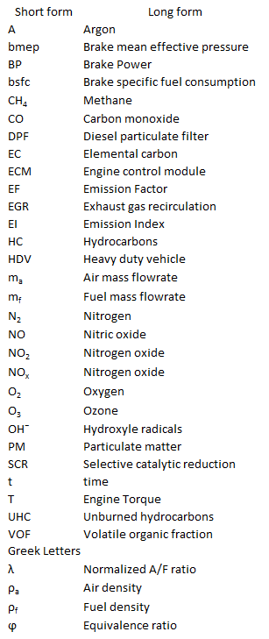

Chapter One

Introduction

Introduction
The ever-increasing demand for internal combustion engines for the transportation sector and power generation increased the burdens on the assimilative capacity of the environment. New techniques were developed by the engine industry to mitigate the emissions to the standard levels specified by the environmental bodies. These solutions comprise new engine designs, sophisticated after treatment facilities, highly refined synthetic fuels and surrogates for the petroleum fuels, biofuels, and electrification. Most of these solutions need a great deal of changes in the infrastructure which are considered as expensive, and difficult to implement.
Scientists set the end of 2030 as the deadline to accomplish all the mandates taken by the government around the globe during COP 26 and the all the obligations suggested by UNCCC program.
Recently, a great deal of efforts and resources where utilized at the research centers around the globe to find new material for coating the monoliths which are characterized by high efficiency, fast response, working at low temperatures, long life, and inexpensive. In that context, understanding the behavior of catalytic converters is utterly important to pave the way for the development and improvements in the new generations of these catalytic converters.

Aims and objectives.
This project aims to improve the operational conditions of the mandatory aftertreatment facilities installed on the exhaust system of the internal combustion engine. Engine-out temperature, the rate exhaust gas cooling, and the sequential position of the treatment elements play a key role on the efficiency and rate of the chemical reactions taking place in these facilities. In the course of this work, controlling the exhaust gas temperature is taken as one of the primary inputs along with other engine operational parameters to inspect the environmental performance of these aftertreatment facilities.

