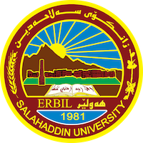
Academic Curriculum Vitae
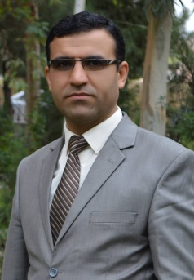
Personal Information:
Full Name: Burhan Hatam Othman
Academic Title: lecturer
Email: burhan.othman@su.edu.krd
Mobile:07504567189
Education:
- Erbil, Iraq. Bachelor in History -2006- Salahaddin University.

- Erbil, Iraq. Master in the Modern History (V. good grade) 2011 -Salahaddin University.
- Erbil, Iraq. Doctorate in Modern and Contemporary History (2019).Salahaddin University.

- Employment:
- Sallahadin University College of arts.
Qualifications
- Word, power point.
- I have 4.5 in IELTS examination, and language English certificate, Computer certificate.
Teaching experience:
- I teached in first stage, second stage third stage and four stage of college of arts in salahaddin University.

Research and publications
- Saleh Al-Haidari 1922-2001 His political and cultural role. (2012)

- Introduction to the philosophy of history Translate from
Arabic to Kurdish(2015)

- Christianity and the sword /Translate from Arabic to Kurdish(2015)

- The spread of Islam in Kurdistan. /Translate from Arabic to Kurdish (2016)

- Summary of scientific messages and theses of modern and
Contemporary history (under publication) (2018)
- Abstract of the Philosophy of History. (2019)
- New and Contemporary American History. /Translate from Arabic to Kurdish (2022).
- Mustafa Barzani in Secret Documents of the Iraqi Government 1947-1970- (2022).
Conferences and courses attended
- I attended of conference about Erbil in Historcal Sources – Read and evaluate 2019/4/ 10 – 11 . 4rd Student Research Projects & Idea Grant Conference, 2nd February 2023.The Genocide of faily Kurds, May 2-4 th 2023. Centenary of the Treaty of Lausanne, January 22 nd 2023.

Professional memberships
- I membership in komallay roshenbiry mezhuey.

Professional Social Network Accounts:
-https://scholar.google.com/citations
- https://www.researchgate.net/profile/Burhan-Hatam
- https://www.linkedin.com/in/burhan-hatam-182024278/

