Q 1) A- Define and classify Benthic algae.
B- Equipment used for collection of Planktonic or floating microalgae.

Q 2) Write the differences between:
- Chroococcus and Gloeocapsa
- Chlamedomonas and Chlorella

Q 3) Write the function of the following: heterocysts, akinetes, sheath and formalin solution.

Q 4) Identify and classify this Genus.
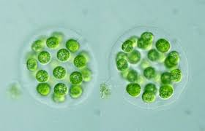

Q5) How we Storage and preservation of algal sample

Q 6) Identify this Genus and mention number of cells
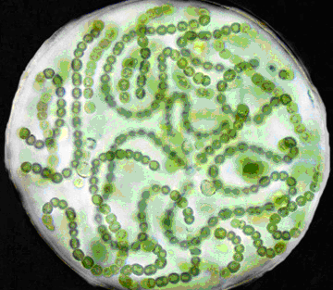

Q 7) Write the general characteristics of Charophyta and Euglenophyta.

Q 8) Write the function of the following: eye spot, sheath and formalin solution.

Q 9) Write the general characteristics of Cyanophyta and Chlorophyta in the following:
- Chlorophyll content 4-Food reserve
- Cell wall 5-Flagella
- Reproduction 6-Habitats

Q 10) Write number of cell in Scenedesmus, Sorastrum, Eudorina and Hydrodictyon

Q11) Write Basic parts of the microscope with its function.

Q12) Write type of chloroplast with example

Q13) Write forms of algal cell with clear example.

Q 14) Complete this table:
Genus | Chloroplast shape | Chloroplast number | Habitat
Ulothrix
Oedogonium
Zygnema
Spirogyra

Q15) How Chara and Nitella are Classified?

Q16) Identify this Genus and mention shape of cell
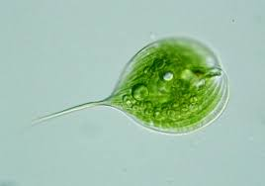

Q17) Write the structure cell of Chara.

Q18) Write the differences between heterocysts and akinetes

Q19) Write general characteristics of Bacillariophyceae (Golden brown algae)

Q20) What are the differences between Pennales and Centrales

