Q1) A/ write the name and uses of these equipment?

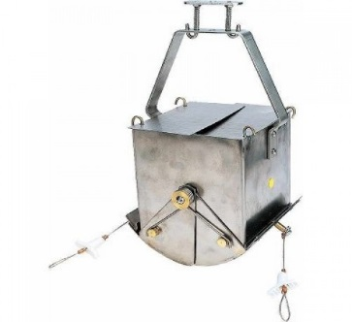

A

Q2) Answer by True or False:
- Pitfall trapping is glass, metal or plastic container sunk into the ground so that the mouth is level with soil surface.
- Any animal which is hunted and killed by another animal for food is Predator.
- Carbonate is the main influence on the pH of clean water.
- Population organisms that mate and produce offspring like themselves.
- Water affected by acid rain will have a high pH.

Q 3 ) Choose suitable answers for the following sentences:
- Is comprises all types of water resources oceans, seas, lakes, rivers, streams, polar icecaps, glaciers, and ground water……………………………..
a. Hydrosphere b. Lithosphere c. Biosphere
3- The pH value of natural surface waters usually ranged from……………….
- (7.5-8.5) b. (6.5-8.5) c. (6-8)

Q4) Enumerate Levels of studying Ecology.

Q5) Enumerate Types of sample?
Q 6) Where we take sample?
Q7 ) Measurement of pH
Q8) Write the differences between Population and Community?

Q9) If we have distilled water, H₂SO₄ solution and NaOH solution write the location of PH of each of them on pH scale?

Q10) A/ Write name of this Scale …………………………….
B/ Is used for …………….……….
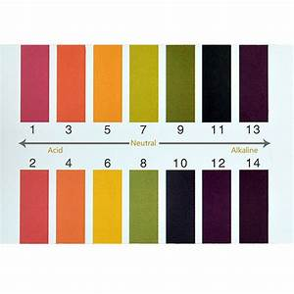

Q11) What are the effects of pH.

Q12) Answer by True or False:
- In some cases, there are only a few of one type of animal left in the wild these animals are endangered.
- Ecosystem: is the interaction of living and nonliving things in an environment.
- Grab sample: include a group of samples that take from one position in different time.
- Types of rock is the main influence on the pH of clean water.
- Community is a group organisms of the same species that live in the same place at the same time.
Q13) what are the relationship between Low carbon dioxide and pH
Q14) Why Conductivity (EC) is an important?
Q15) Why determination of acidity is important?

Q16) Write the equation of Total Dissolved Solids (TDS) with its unit.

Q17) What are Causes of turbidity

Q18) Discus Sources of alkalinity

Q19) Write method of measurement of the following parameters.
- Turbidity 2- Electrical conductivity 3- Alkalinity 4- TDS

Q20) Why do we care about conductivity?

