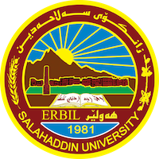
Academic Curriculum Vitae
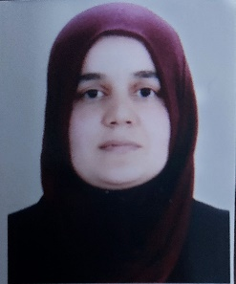
Personal Information:
Full Name: chiman ali yaba
Academic Title: assist lecturer
Email: (chiman.yaba@su.edu.krd)
Mobile:07504918455
Education:
- Bachelor degree at historical department { salahadin university college of arts} in 2008
- Master of history in middle century { salahadin university college of arts} in 2016
Employment:
- Sallahadin university college of arts
Qualifications
- Word , excel ,access, power point.
- Ihave 4 in IELTS xaminaton, and language English certificate, Computer certificate .
Teaching experience:
- I teached in first stage, second stage and thiard stage of college of arts in salahaddin uneversity.

Research and publications
(Agriculture in the regions of Khorasan and the countries of the river in the fifth and sixth centuries AH),

Conferences and courses attended
- I attended of conference about Erbil in Historcal Sources – Read and evaluate 2019/4/ 10 – 11 . 3rd Student Research Projects & Idea Grant Conference, 2nd February 2023

Professional memberships
- I membership in komallay mezhunusan. IFAD group.

Professional Social Network Accounts:

https://scholar.google.com/citations?hl=en

