Q1. Fill in the blanks
3. The CEC increases when pH increase.
CEC determination comprise of three stages :-
1- Saturation with a cation.
2- Washing.
3- Replacement or extraction of an indicator cation.
Methods of analysis
- Dry combustion method.
- Wet digestion method.
- Loss on ignition method.
Points taken into consideration with sampling
- Uniformity of samples in weight or volume.
- Must be avoiding samples from.
  - Wet soils.
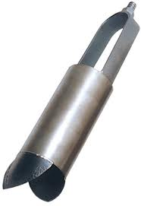
  - Near roads.
  - The storage of fertilizer in the field.
  - Top of hills or valleys.

Q2. what is the EC of a soil with the following ion concentrations?
Ion | Ca²⁺ | Mg²⁺ | K⁺ | Na⁺ | HCO₃⁻ | CO₃⁼ | Cl⁻ | SO₄⁼
Conc, meq/L | 1 | 2 | 1 | 0.5 | 2 | 1 | 1 | 0.5

A1.
∑cation or anion meq/L
EC (dSm⁻¹) =
10
= (1+2+1+0.5)/10
=4.5/10
=0.45 dS/m
Q3. What is the EC of a soil at 25c, if its EC at room temperature (21c) was 3.1 dS/m
EC will increase 2% with increase of each Celsius degree
The difference of temperature is 25-21=4C
EC at 25c = EC + (EC * 4*2/100) = 3.1+(3.1*4*2/100)
= 3.1+0.248
= 3.348 dS/m

