Solving System of Linear Equation (Cont……)

2- Gaussian Elimination Method
In linear algebra, Gaussian elimination is an algorithm for solving systems of linear equations.
Elementary row operations are used to reduce a matrix to what is called triangular form. Gaussian elimination is a method of solving a linear system Ax=b (consisting of m equations in n unknowns) by bringing the augmented matrix
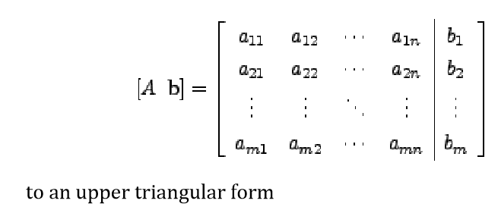
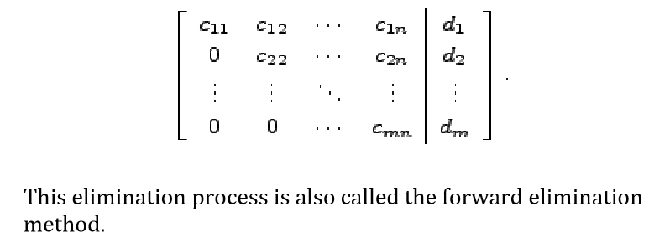

Example: Solve the linear system by Gauss elimination method.
y+z=2
2x+3z=5
x+y+z=3
Solution: In this case, the augmented matrix is
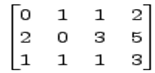

The method proceeds along the following steps.
1. Interchange 1st and 2nd equation .
2. Divide the 1st equation by 2 (or R1*(1/2) ).

3. Add -1 times the 1st equation to the 3rd equation (or R1*(-1) +R3).

4. Add -1 times 2nd equation to the 3rd equation (or R2*(-1)+R3 ).

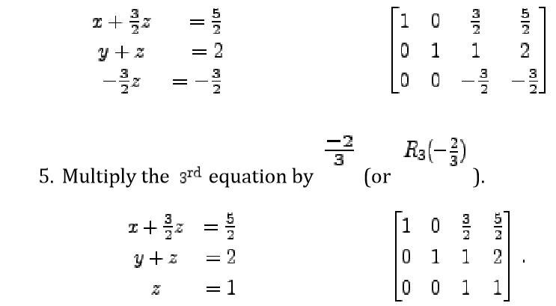

The last equation gives z=1 the second equation now gives y=1 Finally the first equation gives x=1 .

Example
Let's solve the following system of equations:
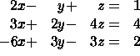
In augmented matrix form we have
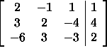
We now use the method of Gaussian Elimination:
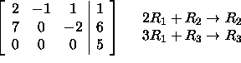
We could proceed to try and replace the first element of row 2 with a zero, but we can actaully stop. To see why, convert back to a system of equations:
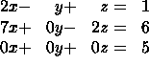
Notice the last equation: 0=5. This is not possible. So the system has no solutions; it is not possible to find values x, y, and z that satisfy all three equations simultaneously.

Example: Solve
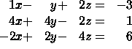
In matrix form:
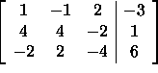
Using Gaussian Elimination:
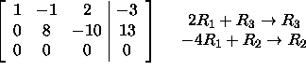
Converting back to a system of equations:
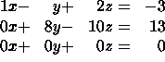
Notice the last equation: 0=0 (this resulted from equation 3 being a linear combination of the other two equations). This is always true. And, we can solve the first two equations to get x and y as functions of z alone. Solving the second equation we get
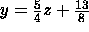
And for the first equation
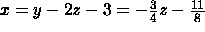
The variable z in this problem is called a parameter since there are no constraints on what values z may take on. Thus, there are an infinite number of solutions - one for each value of z. Examples of solutions are (-11/8,13/8,0) and (-17/8,23/8,1) which come from setting z=0 and z=1, respectively. We may concisely write all solutions as triples of the form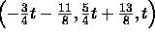 where t is any real number.
H.W: solve the system linear using Gaussian Elimination Method.
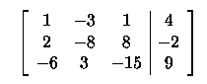

3-Gaussian Jordan Elimination.
This method is a variation of Gaussian elimination method. In this method, the elements above and below the diagonal are simultaneously made zero. That is a given system is reduced to an equivalent diagonal form using elementary transformations. Then the solution of the resulting diagonal system is obtained.
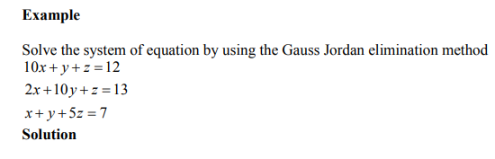
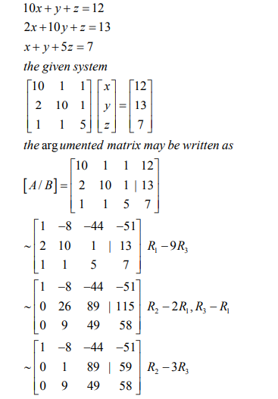
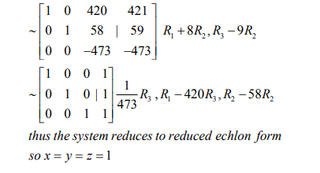

- Iterative methods for solving system of linear Equation

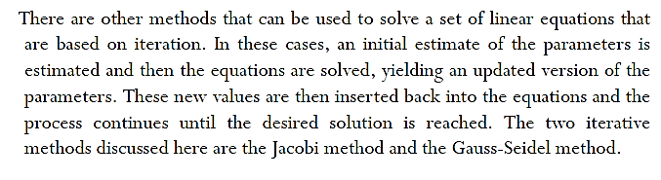

1-Jacobi Iteration Method
