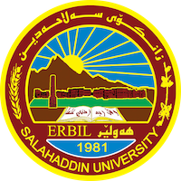
Academic Curriculum Vitae

Personal Information: 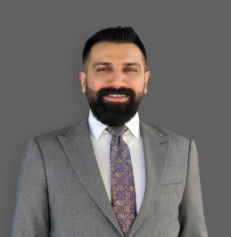
Full Name: Dana Salahaddin Shareef
Academic Title: Assistant Lecturer
Email: dana.shareef@su.edu.krd
Mobile: +964 750 4832043

Education:
Sept 2022- October2007 Institute of Fine Arts Erbil
Sept 2007 - October 2011 Salahaddin University- College of Fine Art/Erbil (Fine Art, Bachelor of Ceramics)
Sept 2019-Sept 2021 Selcuk University
- College of Fine Art/ Turkey (MA Fine Art, Master of Ceramics)

Employment:
- Salahaddin University – College of Fine Arts, Plastic Arts Department

Qualifications
- 2020 pedagogical Teaching Methods Course, Salahaddin University
- IELTS-4.5
- UK English Center Corse (intermediate)

Teaching experience:
• Salahaddin University\ College of Fine Arts, Erbil (Academic Staff) Courses; pottery,mural,chemical glazing, Ceramic techniques and restoration, Ceramic sculpture, Kiln and glaze, Pottery material
Research and publications
https://avesis.anadolu.edu.tr/yasar_uslu/indir?languageCode=tr
Professional memberships
- Kurdistan Artist Syndicate
- Iraq Artist Syndicate

Professional Social Network Accounts:

(2) Dana Salahaddin Shareef (researchgate.net)
Dana Salahaddin Shareef - Google Scholar‬‬‬‬‬‬‬
Dana Salahaddin Shareef (0000-0002-2552-4703) (orcid.org)

