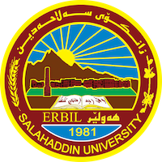
Academic Curriculum Vitae

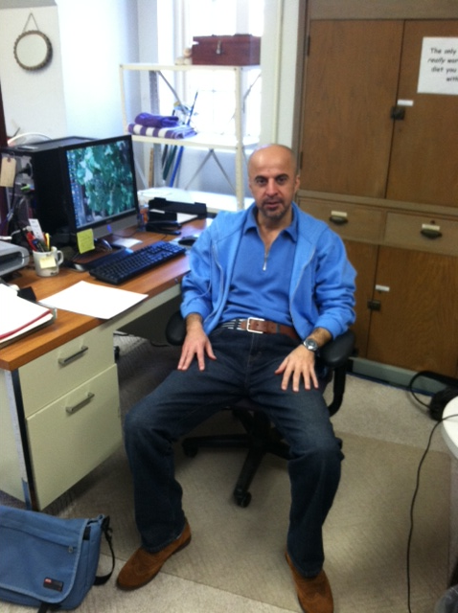
Personal Information
Full Name : Dara Musheer Ibrahim
Academic Title: lecturer
Email: dara.ibrahim@su.edu.krd
Mobile: (07504848780)

Education:
1- Post Doctoral Program Certificate from University of Connecticut, Connecticut, Storrs ,
U.S.A, 2012 - 2013.
2- Ph.D. in Educational Psychology (Personality) from Salahaddin University, College of
Education, Erbil, Northern Iraq, 2005 – 2008.
3- M.Sc. degree in Educational Psychology, Salahaddin University, College of Education ,
Erbil, Northern Iraq, 1995 – 2000.
4- B.A. in Psychology from AL – Mustansiriya University, College of Arts, Baghdad, Iraq,
1986-1995
Employment: Staff Member in the Department of Special Education- College of
Education- Salahaddin University- Erbil, Northern Iraq

Qualifications :
1- Giving lectures for graduates in pre- teaching level.
2- Giving lectures for those who are in administrative positions in the schools.
3- worked as Member of the Curriculum Development Council of Salahaddin University.
4- Worked as Translator/Interpreter in:
- The safe children fund (SCF), UK based Ngo, Erbil governorate office.
- International Republic Institute (IRI), USA based, Erbil governorate office).
5- Knowledge of computer and internet skills.

Teaching experience:
1- Giving lectures.
2- Supervising researches of undergraduate students.
3- Evaluation of teaching practices of undergraduate students.
Research and publications:
1- Conducting research with other colleagues financed by (UNESCO) about Standardization
of Raven's Intelligence Test.
2- Dara M. Ibrahim, Ronald P. Rohner, Rhiannon L. Smith, Kaitlin M. Flannery (2015). Adults’
Remembrances of Parental Acceptance–Rejection in Childhood Predict Current
Rejection Sensitivity in Adulthood. Volume 44, Issue1, Pages 51-62.
3- Ronald P. Rohner, Diane L. Putnick, Alex D. Molaver, Sumbleen Ali, M. Mussaffa Butt, Dara M. Ibrahim,
Cecilia Aurino, Marjolijn J. M. Blom, Fatima H. Darwesh, Stefania Auricchio, Araz H. Radha, Maria C.
Miranda, Kari Adamsons, and Vincenzo Paolo Senese (2020) . Psychological maladjustment mediates the
link between remembrances of parental rejection in childhood and loneliness in adulthood: A cross-cultural
comparative study. International Journal of Psychology, Vol. 55, No. 4, 590–600, DOI: 10.1002/ijop.12621

Conferences and courses attended;
1- Workshop related to Educational Packages –Jordan.
2- Third international congress on Parental Acceptance – Rejection in Padua University-
Italy.
3- المؤتمر العلمي الدولي الثاني: قضايا التعليم وتحدياته في ظل التطورات المعرفية والتكنولوجنة المتسارعة. نقابة الاكاديميين العراقيين مركز التطوير الاستراتيجي الاكاديمي - بالتعاون مع عمادة كلية التربيةالأساس/ جامعة صلاح (2020) . العـلاقة بين الحاجة إلى المعرفة والذكـاء المتعدد وفقاَ لنظرية كـاردنر لدى طلبة جـامعة صلاح الدين.
4- 1st Moodle Platform workshop-EDU(2020). College of Education.
Funding and academic awards : ---------
Professional memberships : -------------
Professional Social Network Accounts: https://scholar.google.com/citations?hl=en&user=gmS04bQAAAAJ

