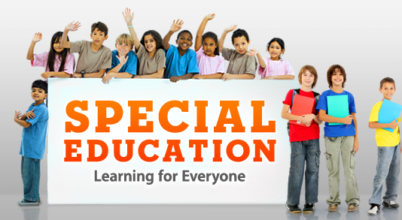
Text 1
What is Special Education?

Purposes of Special education
1- Special Education aims at to ensure that students with disabilities are provided with the
environment that allows them to be educated effectively.
2- Disabilities that qualify for Special Education include all types of physical, mental
and behavioral disabilities.

Special Education Definitions

1- Special Education is composed of a range of teaching practices speciﬁcally designed for

the needs of individuals with disabilities, who have special learning needs, that are

implemented by well-trained special education teachers and not normally seen or used

by untrained teachers in a regular classroom.

Inclusion and Special Education
2- Special Education means specially designed instructions that meet the unusual needs of the
exceptional students.
3-Special Education or Special Needs Education is the form of education planned for the
students with special needs in a way that addresses the students (1) individual differences and (2) needs.
4-Special Education is instruction based program that is specially designed to meet the
special needs of the children with disabilities .
5- Special Education is a form of learning provided to the students with exceptional needs ,
such as students with learning disabilities or mental abnormalities .

Objectives of Special Education
1- To provide appropriate educational program, related services to each child with a
disability requiring special education, from age three through twenty-one years.
2- To provide activities that foster social development and adjustment into the regular
school and community activities.
3- To identify disability among preschool children.

4- To provide opportunity to participate in an approved preschool program within a
reasonable distance from the child’s home.
5- To provide a coordinated and comprehensive instructional program from kindergarten
through high school.
6- To provide appropriate related services to the students with disabilities according to their
needs.
7- To encourage parental involvement and understanding of Special Education Programs.
8- To provide appropriate Vocational Services to the students with disabilities.
9- To provide Healthy and Friendly Environment in and outside the school for each
student with disability.

