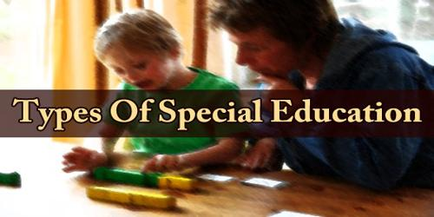

Text 2
Types of Special Education

Special education is a very broad field and has many different specialties.Those who specialize in working with students who have extra challenges may find themselves in a number of different scenarios, depending on the school district or type of school that they are working in. There are six main types of special education within most public-school settings.

1- Push-in Services
This type of services is provided to students with disabilities who require minimal intervention. The services happen in the general education classroom. The general education teacher, special education teacher, and others (like speech therapists or occupational therapists) work collaboratively.

2- Pull-out Services
This type of services is provided to students who need a bit more focused help from a speech- language therapist, occupational therapist, or another specialist, and may be pulled out of the classroom for work in a one-on-one or small group in a resource rooms.

3- Inclusive Classroom
This type have a mix of children of varying abilities (For example, gifted students, auditory learners, visual learners and students with disabilities such as ADHD, students who are in wheelchairs), and co-teachers remaining in a traditional classroom setting. Often, some of the students within the classroom may receive some pull-out services in addition to their assisted learning.

4- Exclusive Education
Some students benefit from being placed in a smaller classroom of students who have similar educational needs. They may remain within a traditional school setting. Education for the gifted is a type of exclusive education.

5- Specialty Schools
Students have severe cognitive challenges and certain physical disabilities, can receive not only occupational, speech, and cognitive services but also will take advantage of other therapies to help improve their quality of life and prepare them for adulthood.

6- Residential Programs
Students who require around the clock care, often have medical needs beyond what can be managed at home or in even a specialty school that come before their educational needs. Students in these types of programs will often be transitioned into adult assisted living or residential care facilities as they mature out of the program.

