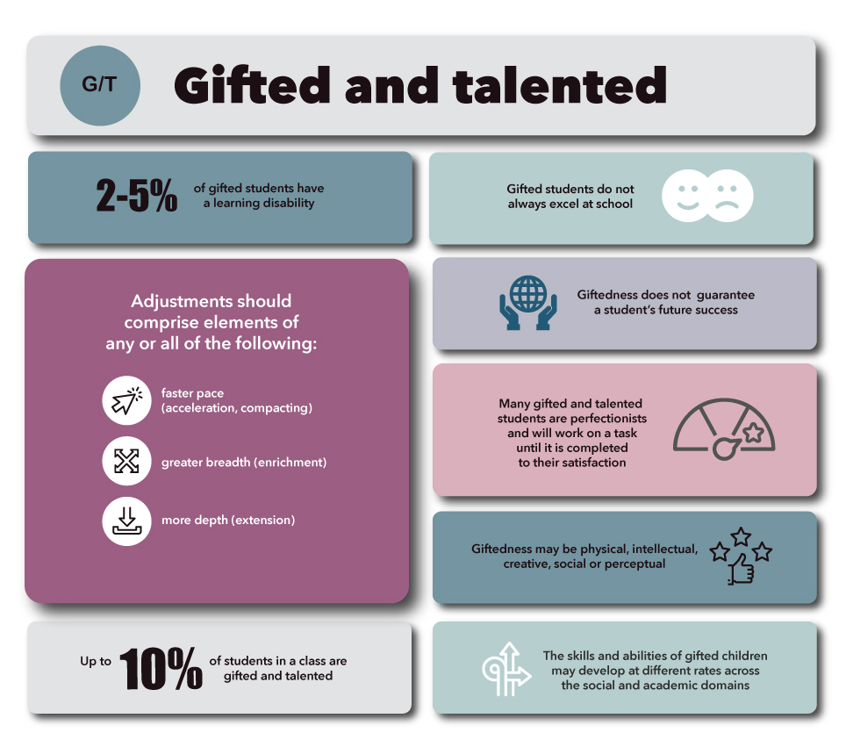
Text 5
Activities to Try in Your Gifted Classroom

1- Flexible and In-depth Learning
You can make use of certain credible online applications like Google Arts and Culture. Let the kids enrich their knowledge through engaging virtual tours. It is also a good idea to give them a chance to share their findings with other students.
2- Activities like ‘Volley of Questions’
These gifted learners also love resolving open-ended questions. So, you engage them with an extra set of questions after the completion of the topic. Try to keep these open-ended. And let them suggest multiple answers for these scenarios/questions.

3- Complex Problem Solving
Let them tackle complex problems and come up with credible solutions. You can give them real-world problems and allow independent research time to suggest solutions, and you can make this learning more relevant to the child’s age and intelligence type.
4- Extra Study Options
Encourage for additional courses. Online courses are beneficial , and this option can be great for them, because online schooling platforms now offer more and better course options than any regular school. Support the child in selecting the most appropriate courses as per their career aspirations and likings.
5- Challenge Them Enough
Your gifted student can develop numerous mental health issues and a sense of guilt if he/she underperforms. And this happens when these kids are not challenged enough in regular educational settings. Try to raise the bar for them. And allow them to explore the topics that are already covered in the class, because it will spark their interest and pacify their curious minds will.
6- Collaborative Learning
Since these learners are superlative, it is perfect to group them with other students in the class. It will motivate others to work harder to reach the level of these learners. This strategy will also make it easy for regular learners to understand complex problems and resolve them better, esides collaborative learning is also beneficial for gifted students, because this heterogeneous mix of students makes way for better learning and inculcates soft skills like ‘teamwork’ in them.
7- Keep the Student’s Personality in Mind
Try to understand their personality types. And observe their behavior carefully. There is a possibility that some of these students get excessively passionate about their learning. All this might hinder their mind’s functioning and they tend to be become overly focused only on one thing. This kind of obsession is harmful, because the student might at times go to the extent of exerting pressure on his/her mental faculties. Try to intervene and stop any such practices.. and teach them the importance of joyous and happy realistic learning.

