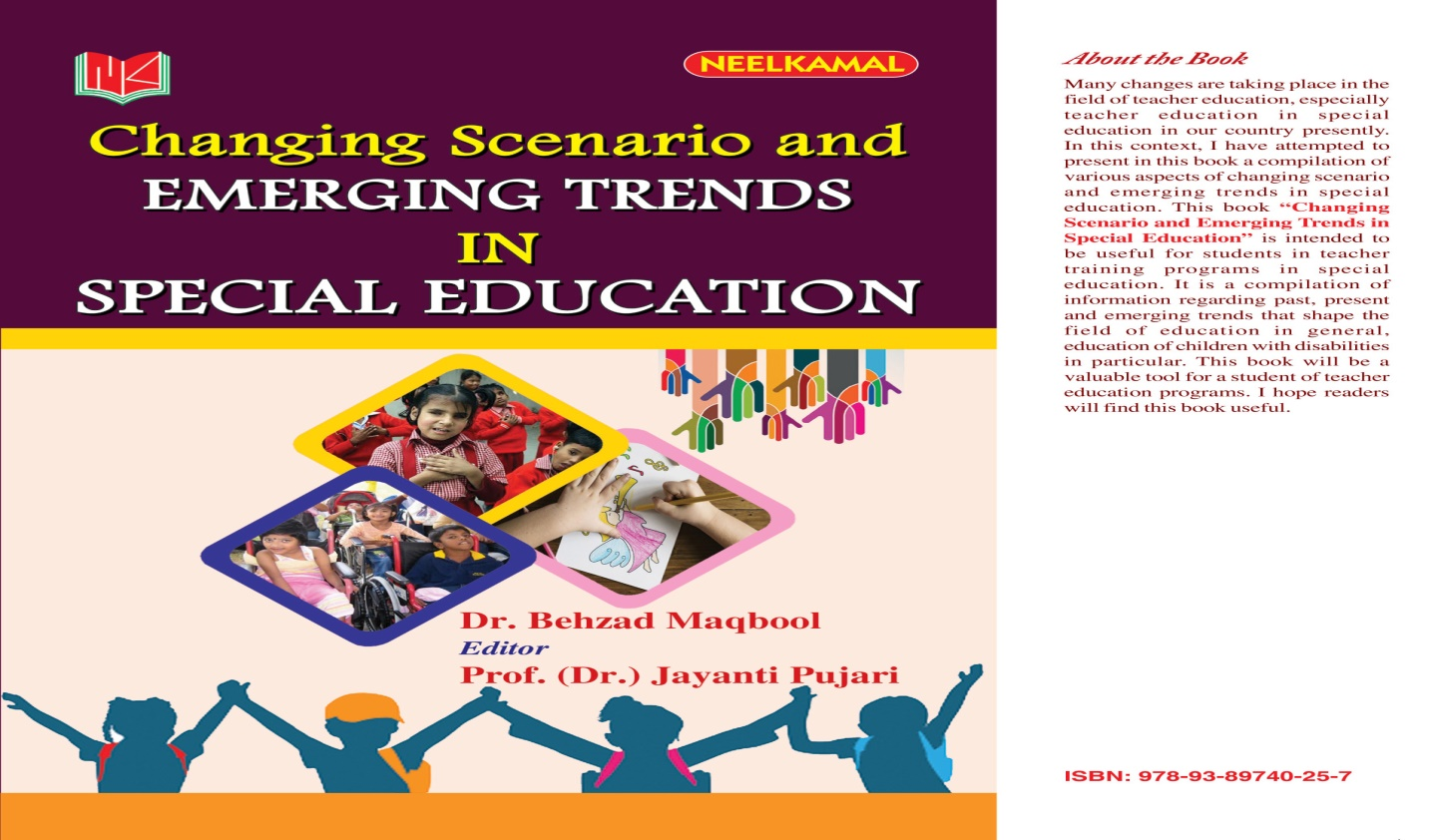
Text 7
Expected Trends in the Future of Special Education Systems

1- Technology
Technological advances greatly increase educators’ abilities to personalize learning. For example, virtual reality applications are particularly useful for allowing children with autism to practice navigating real-world challenges.
2- trauma-screening resources
Today’s students are coping with traumas that impact learning. Natural disasters, socio-economic shifts and the loss of loved ones can all impact how students perform in school. Educators will need to rely increasingly on trauma-screening resources to identify their students’ individual needs and intervene as soon as possible. Providing trauma-informed support will also entail changes to how educators approach discipline in special education. Reports indicate that exclusionary and punitive school discipline policies, such as suspensions and expulsions, increase the likelihood of student absences, repeated grades and school dropouts. Historically underserved student groups, such as students with disabilities, disproportionately experience these types of disciplinary actions compared to their peers.
3- Educator Preparation
With the increasing use of technology in the special education classroom, teachers are also likely to need training in the tools and techniques available to them. There is also a trend toward alternative teacher preparation pathways to encourage a more diverse range of expertise and skills in special education. By encouraging people from various backgrounds and experiences to enter education, schools can diversify their faculty and more effectively reflect the diversity of their students.
4- Data Collection and Reporting
To best understand the needs of students, it is imperative to have accurate, transparent information. Data collection is vital to understanding population makeup, community needs, income trends and other factors influencing student lives.
5- Familial Support
With increasing evidence of the power of parental involvement in special education, many schools are finding new ways to connect with parents and work together as a team to support students. As a result, future initiatives are likely to rely more on community mindsets that involve the family in supporting student learning inside and outside the special education classroom.

