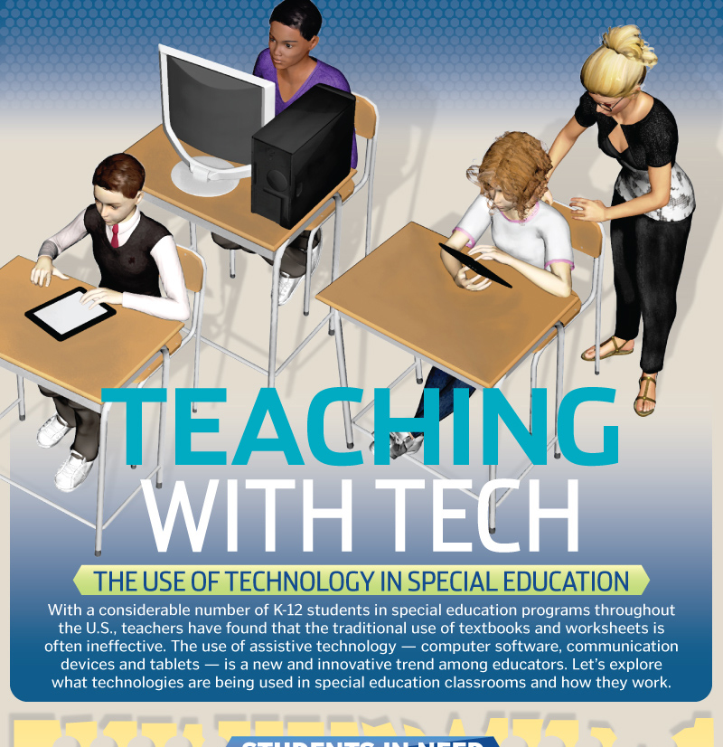
Text 8
Types of Technology for Special Education

Technology for students with special needs comes in many different shapes and forms. Here are some exciting examples of the technologies available for special needs students:
1- Text-to-Speech Technology
Students who have difficulty reading—whether from dyslexia, visual impairment, or some other learning disability—can now utilize Text-to-Speech (TTS) technology. (TTS) takes written text and transforms it into audio, allowing student to process text aurally.
2- Voice-recognition software
Voice recognition provides a compelling alternative to a keyboard for students with special needs. In the past, voice-recognition was often a standalone software solution that schools had to purchase. While these specialized solutions still exist today, they have been almost entirely eclipsed by the native voice-recognition tools in nearly every smartphone, tablet, and computer (e.g. Siri, Alexa, Google Assistant).
3. Sip-and-Puff Systems
Sip-and-puff devices from companies such as Orin are especially beneficial for students that do not have the use of their hands. By sipping or puffing into a tube, students send an air pressure signal to a sensor that is used to control a wide variety of devices, such as motorized wheelchairs and computers. This technology has opened up a whole new world of possibilities for students.
4- Virtual reality technology
Virtual and augmented reality tools now allow students to learn through visual experiences. Systems like InclusiveVR offer VR/AR tools to immerse students in 360-degree visual experiences, where they can learn and explore the world in new and compelling ways. These tools also let teachers personalize experiences to meet any student’s special needs.
5- Assistive Technology for Writing
Students with dyslexia or other learning disabilities can benefit from assistive technology like Ghotit, which helps them eliminate the frustration that can often be associated with reading and writing. Tools include predictive typing, proofreading, read-aloud capabilities, and much more to help reduce errors in writing, as well as the frustration that can be caused by a learning disability.

6- Math Learning Tools
There is an especially innovative wave of new solutions for learning math. For example, MathTalk lets students use voice commands for completing math work. Tools like Snowflake let students interactive visually with math on interactive touchscreen panels. Teachers can also use Snowflake to create customized, interactive lessons for their students.
7- Touchscreen Technology
From tablets to smartphones to interactive touchscreen panels, touchscreen technology is especially useful in today’s classrooms, as it allows all students to interact with classroom instruction through touch. We are especially passionate about our touch screen panels, which opens the door to countless possibilities for teaching and learning. Useful accessories also enable further learning and accessibility. For example, table-top mounts allow students in wheelchairs to more easily access the panel.

