Chapter One
Introduction

Importance of psychology
Psychology is important to understand other people, the basics of society and human nature and all the things we do without thought.

The origin of the term “Psychology”
Psychology is a word deriving from ancient Greek :
Psyche – “soul” or “mind”
logos – “study”

* German physician Wilhelm Wundt (1832 – 1920) is one of the founding figures of modern psychology. He founded the first psychological
Laboratory (1879) , at Leipzig University.
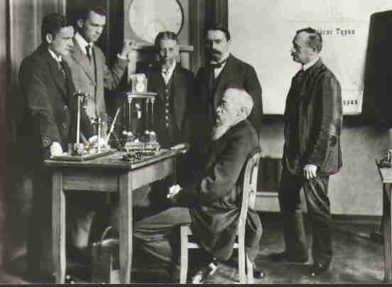
Psychology in the modern science
Psychology is The science of behavior and mental Processes .

Goals of Psychology
- Description ( What is happening? )
- Explanation ( Why is it happening? )
- Prediction ( Will it happen again? )
- Control ( How can it be changed? )

GENERAL PSYCHOLOGY (Definition)
General Psychology is the study of the basic principles, problems and methods that underlie the science of psychology, Includes human development, emotions, motivation, learning, senses, perception, thinking, memory, intelligence and processing.

