Chapter Two
Approaches to the Science of Psychology

1- Evolutionary Approach: Emphasizes the ways in which behavior and mental
processes are adaptive for survival.
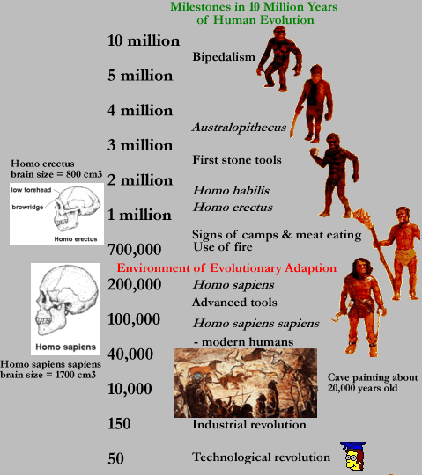

2- Biological Approach: Emphasizes on the contributions of the nervous system,
hormones , and genetics to the explanations of behavior .

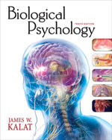

3- Psychoanalysis Approach: Emphasizes on the internal conflicts, mostly
unconscious, which usually sexual or aggressive instincts against environmental
obstacles to their expression, and Childhood experiences.
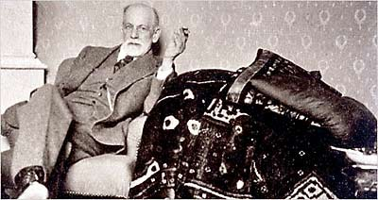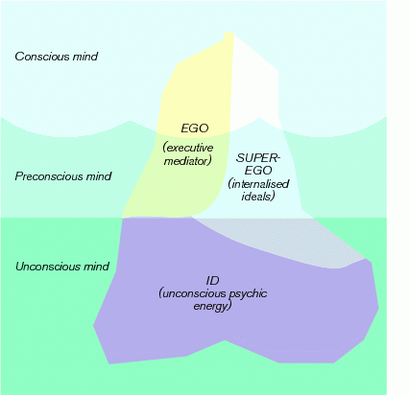

4- Behavioral Approach: Emphasizes on learning, especially each person’s experience
with rewards and punishments.
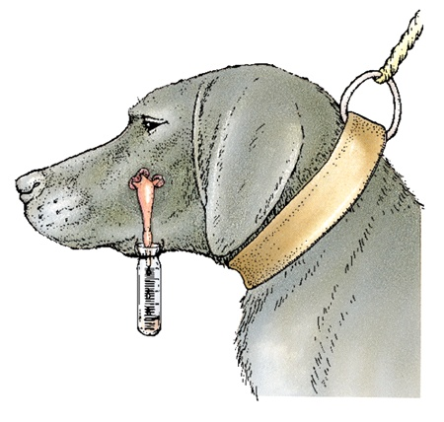
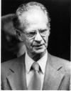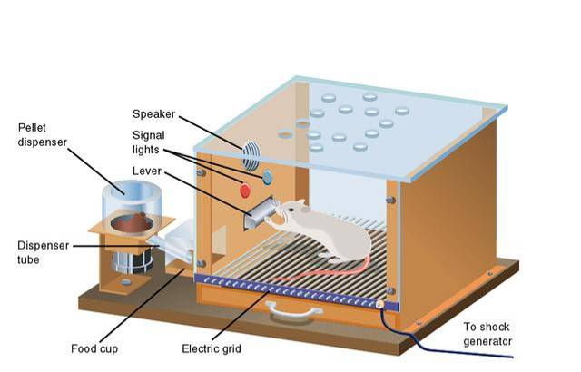
5- Cognitive Approach: Emphasizes on the mechanisms through which people
receive, store, retrieve, and otherwise process information.
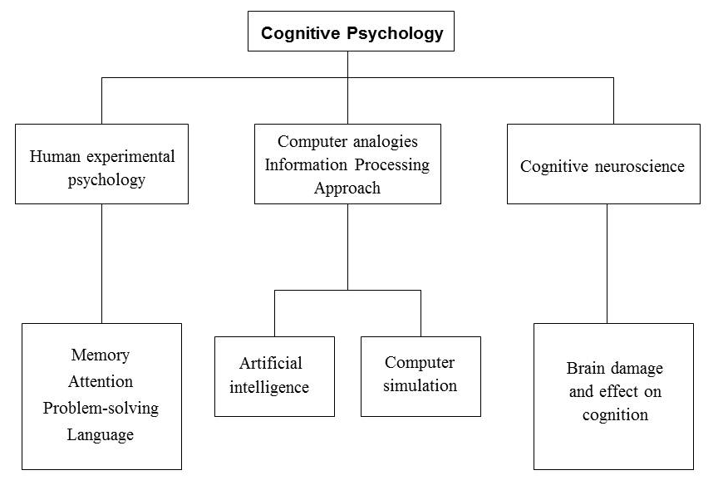

6- Humanistic Approach: Emphasizes individual potential for growth (for example,
self-actualization).
Maslow’s Hierarchy of Needs
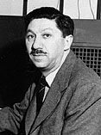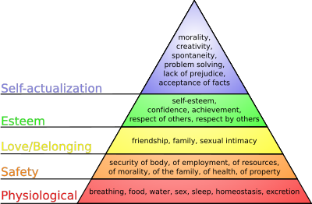

7- Cross-Cultural Approach: Emphasizes on the psychological differences among
people living in different cultural groups.

