Chapter Four
Sensation

Chapter Four
Sensation

Sensation (definition): is the process of receiving , converting ,
and transmitting information from the outside world to the brain .

Sensory Systems

1- Vision: Visual receptor cells located on retina (rods for night
vision and cones for color vision). The eye captures light and
focuses it on the visual receptors, which convert light energy
to neural impulses sent to the brain.
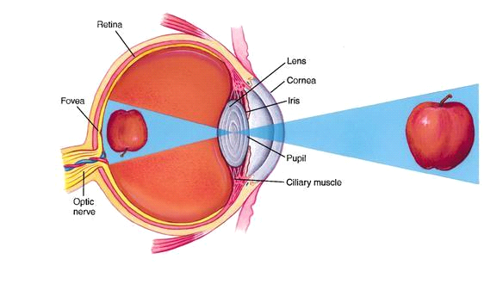
2- Hearing (Audition): occurs via sound waves, which result from
rapid changes in air pressure caused by vibrating objects.
Receptors located in the inner ear (cochlea) which are tiny hair
cells that convert sound energy to neural impulses sent to brain.
The Cochlea
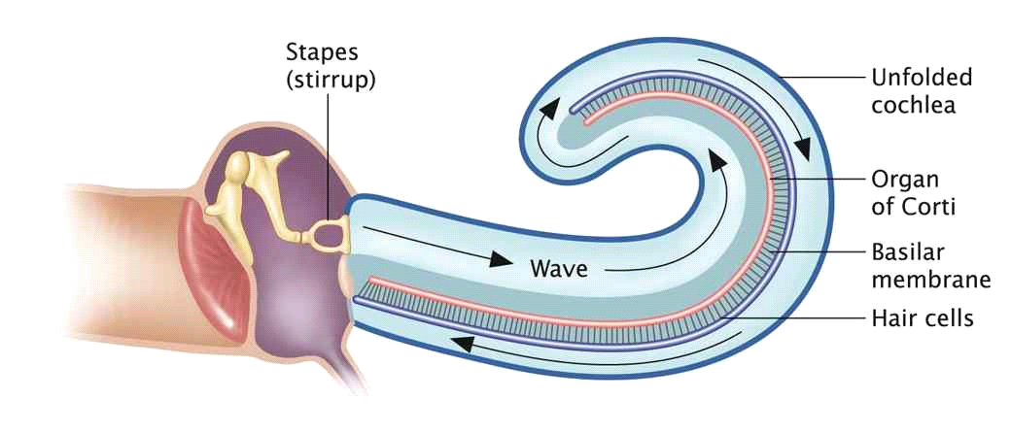
3- Smell (olfaction): receptors are located at top of nasal cavity.

4- Taste (gustation): receptors are taste buds on tongue. There are
four basic tastes ( sweet, salty, sour and bitter).
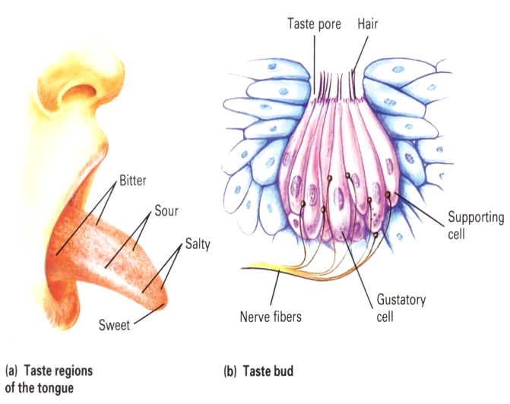

5- Touch: skin senses detect touch (pressure, temperature and pain).

6- Vestibular sense (balance): results from receptors in inner ear.
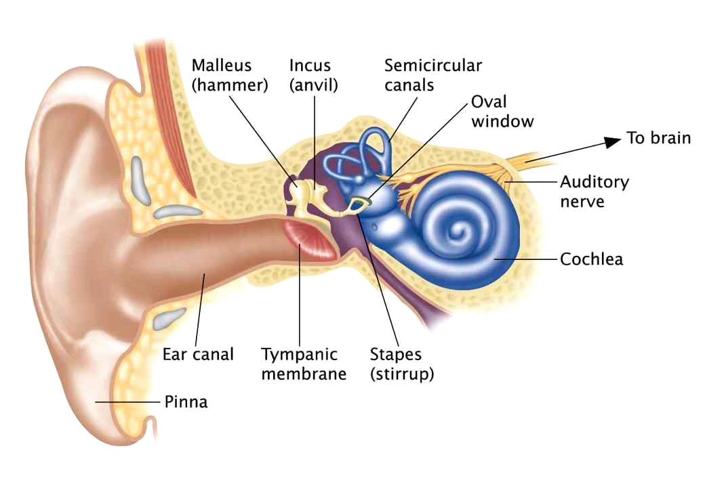
7- Kinesthesis: (body posture, orientation, and body movement)
Results from receptors in muscles, joint and tendons.
