Chapter Five
Attention
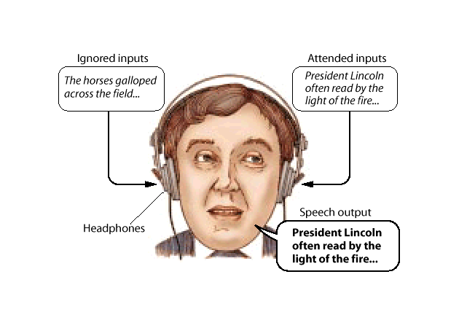Attention: the process by which the mind chooses from among the various
stimuli that strike the senses at any given moment.
Theories on Attention
1-Filter Theories: Early Selection
Attentional filter operates after sensory processing but prior to
meaningful semantic processing.
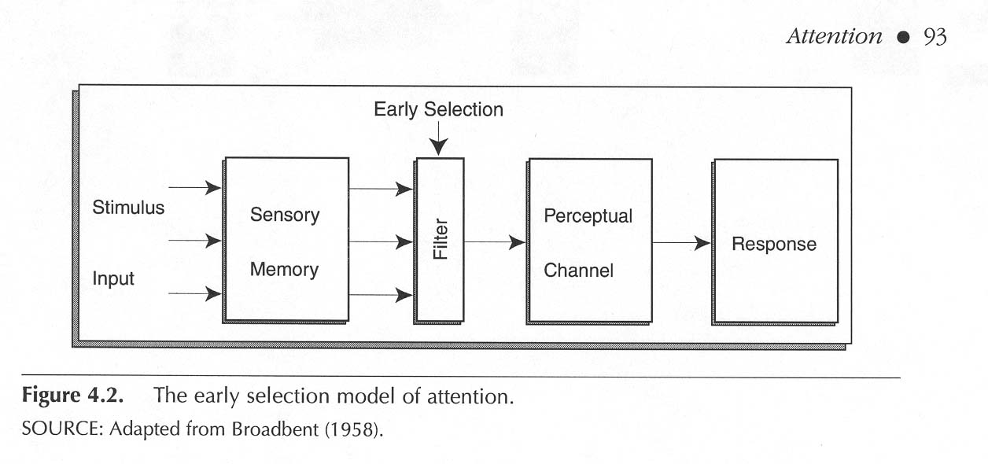
2- Filter Theories: Attenuation
An attenuation filter lowers the strength of the sensory signal in the
ignored message, making it less likely to be perceived. Important stimuli
such as one’s name pass through the filter without attenuation.
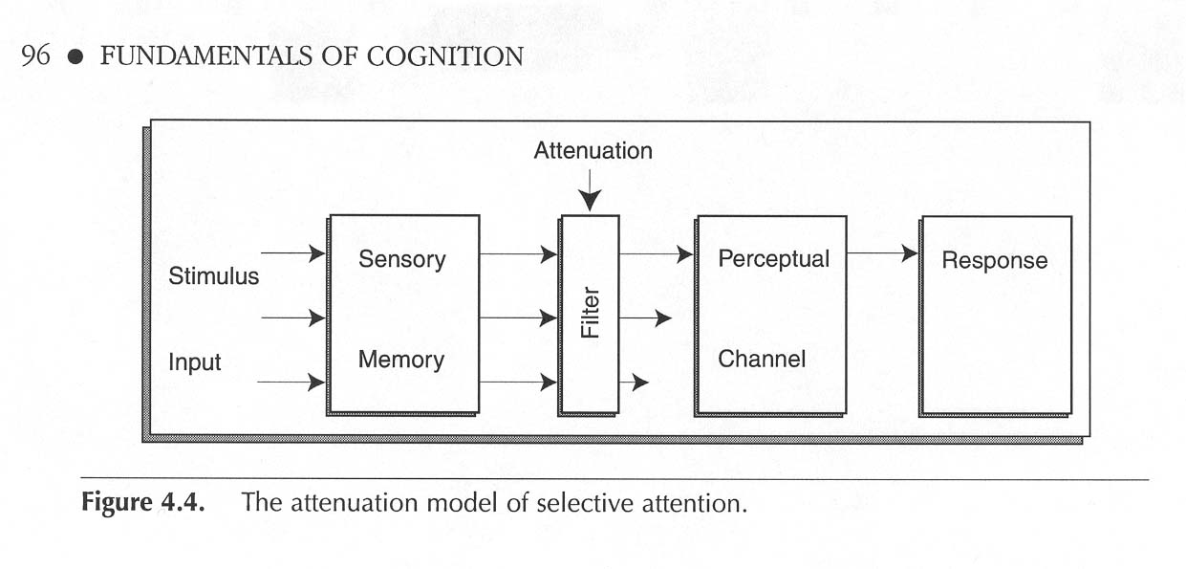
3- Filter Theories: Late Selection
Late selection filter occurs after sensory and semantic analysis but before
response selection.
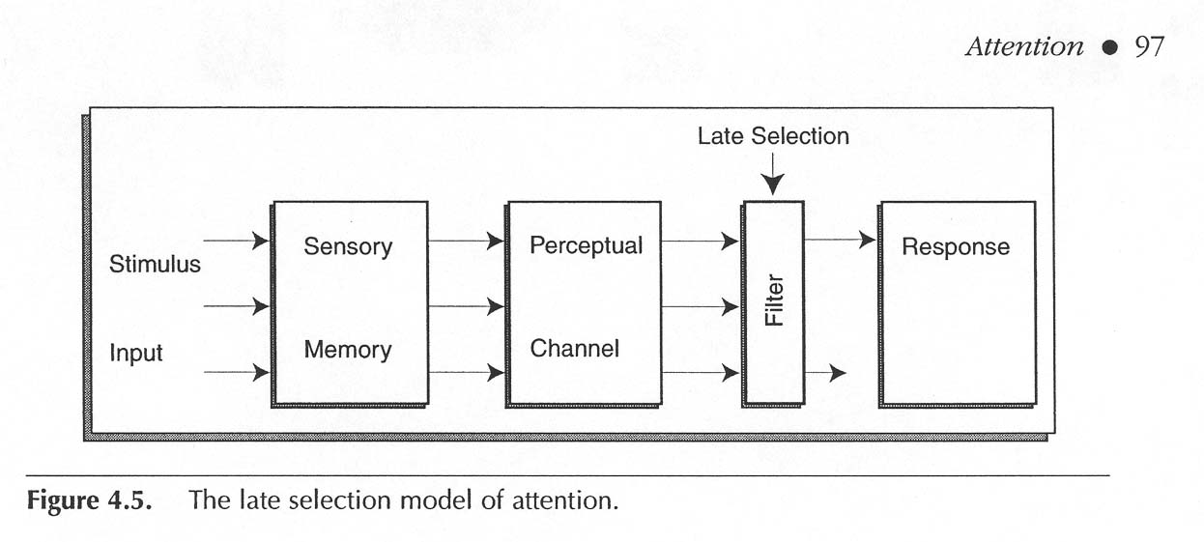
4- Capacity Theories :When a particular task demands lots of rocessing
resources, then other tasks get fewer resources.

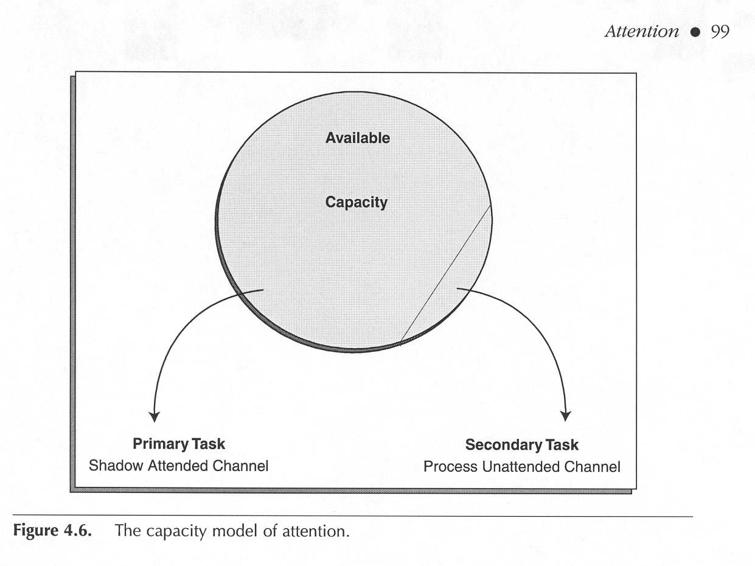
5- Feature Integration Theory: Attention is required to put the
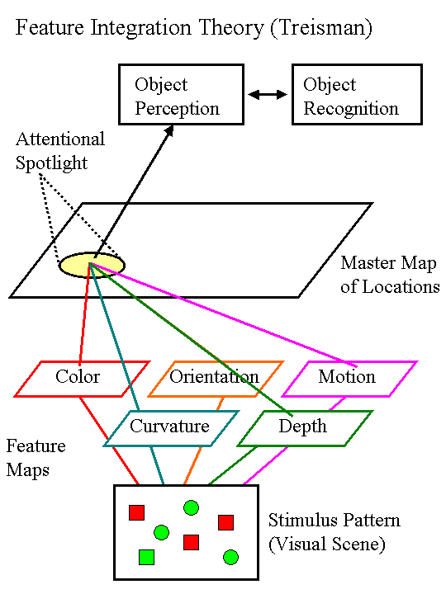
pieces together (to combine features into objects).

