**Chapter Six**

**Perception**

**Perception:** the process by which sensory information is actively organized and interpreted by the brain.

**Top-Down Processing:** We perceive Based on our experiences and schemas. If you see many old men in glasses, you are more apt to process a picture of an old man.

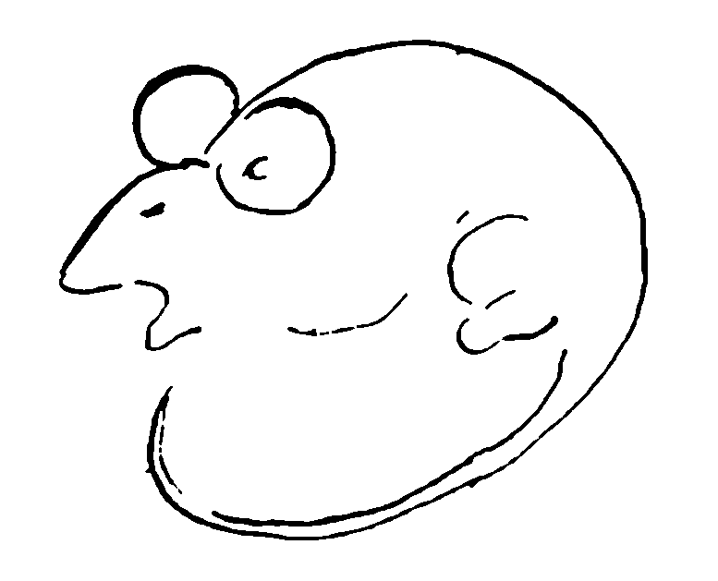

**Bottom-Up Processing:** Also called feature analysis. We use the features on the object itself to build a perception.

**Perceptual organization:** It is the process by which we group outside stimuli into recognizable and identifiable patterns and whole objects. Certain factors may contribute to this process and they are : -

**A- Figure ground:** The tendency to distinguish and focus on a stimulus that is

classified as figure as opposed to background.



**B- Perceptual grouping:** Our tendency to group several individual stimuli into a

meaningful and recognizable pattern. Some factors

underlying grouping are:-

**1- Similarity**: occurs when objects look similar to one another. People

often perceive them as a group or pattern.

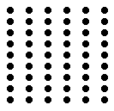

**2-Proximity:**  occurs when elements are placed close together. They tend to be

perceived as a group.



**3- Closure:**  Tendency to fill in gaps of holes in incomplete images.

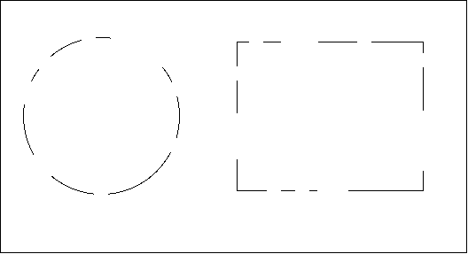

**4-Continuation:** the preference for continuous figures. We perceive the figure as

two crossed lines instead of 4 lines meeting at the center.

