Chapter Eight
Emotion
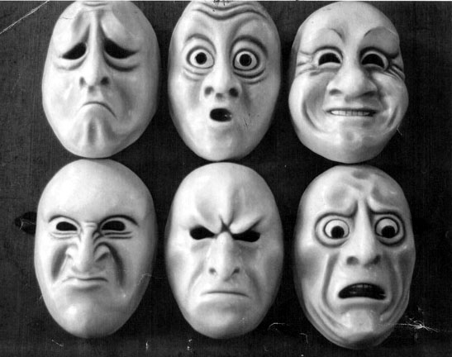
*Emotion: the “feeling” aspect of consciousness, characterized by a certain physical
arousal, a certain behavior that reveals the emotion to the outside world, and an
inner awareness of feelings.

Theories of Emotion

- Common Sense Theory of Emotion: a stimulus leads to an emotion, which then

leads to bodily arousal.

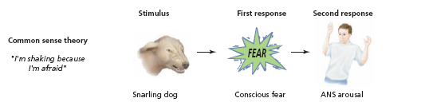

- James-Lange theory of emotion: physiological reaction leads to the labeling of an
emotion.

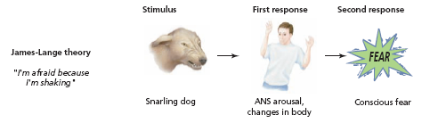

- Cannon-Bard theory of emotion: physiological reaction and the emotion are
assumed to occur at the same time.

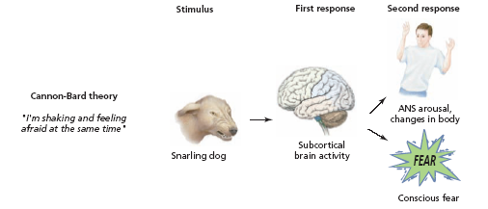
- Cognitive arousal theory: both the physical arousal and the labeling of that arousal based on cues from the environment must occur before the emotion is experienced.

