Chapter Nine

Thinking

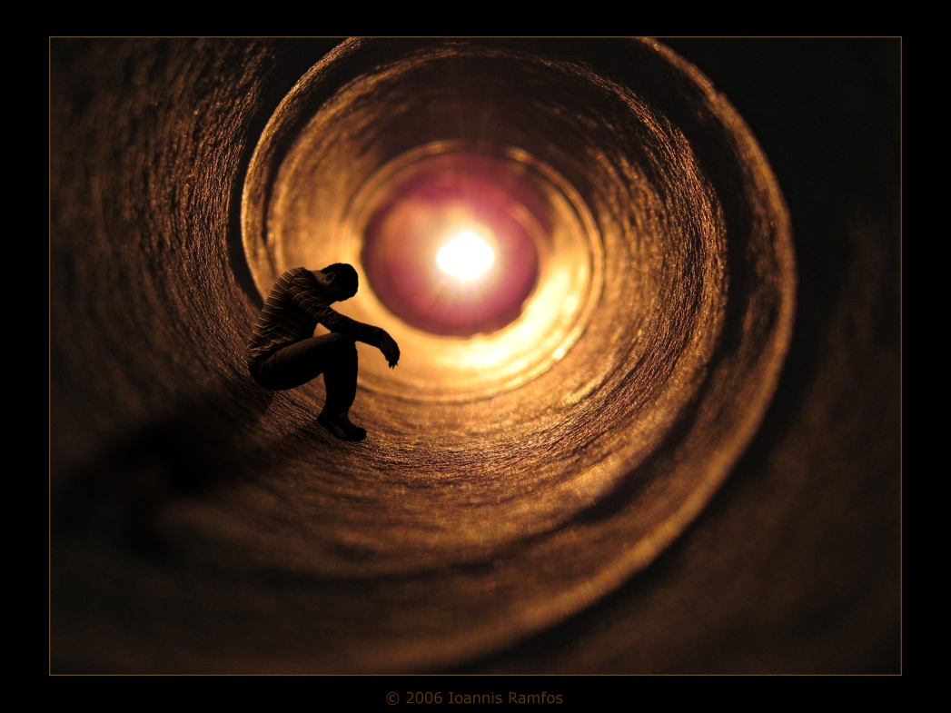

* Definitions on thinking
1- Thinking: The action of using your mind to produce ideas,
decisions, memories, ……..etc.
2- Thinking: The processing of information to solve problems and
make judgments and decisions.
3- Thinking: The way that the mind makes sense of the world.

*Thinking skills

- Foundation Skills: Recall & Perception
- Basic Skills: Analysis, Comparison, Classification, Evaluation,
Prediction, Interpretation and Inference.
- Synthesis
- Higher Order Skills: Problem Solving, Decision Making, Creative
Thinking and Critical Thinking.

* Types of thinking
1- Creative Thinking: A way of thinking that generates something new or different .
2- Critical Thinking: A way of thinking that assesses the worth
and validity of something inexistent.

3- Analytical Thinking: The abstract separation of a whole into its
constituent parts in order to study the parts and
their relations .

4-Deductive Thinking: This type of reasoning moves from the whole to its
Parts, from generalizations to examples .
5- Inductive Thinking: This is the process of reasoning from parts to the
whole, from examples to generalizations

