Chapter Eleven
Intelligence

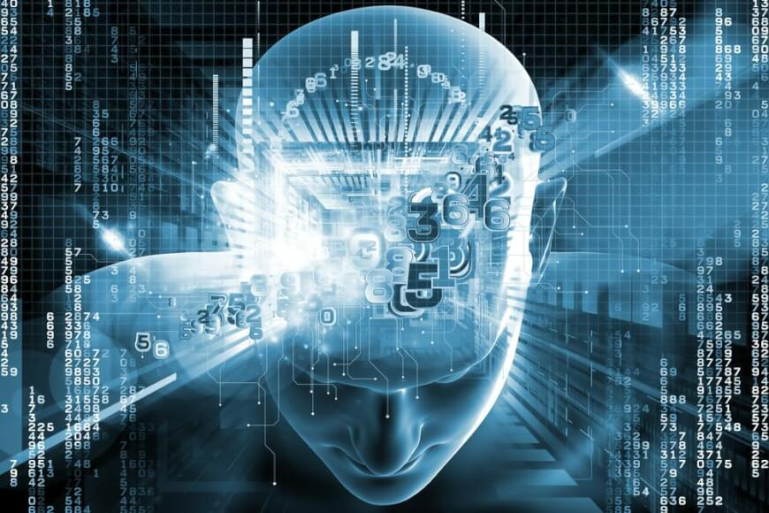

Intelligence (definition): the ability to learn from experience, solve problems, and use our knowledge to adapt to new situations.

Theories of Intelligence
1- Charles Spearman – “two-factor” theory of intelligence: general and
special abilities (1920s)

2- Louis Leon Thurstone – 7 “primary mental abilities” (1930s):
  - Word fluency
  - Verbal comprehension
  - Spatial ability
  - Perceptual speed
  - Numerical ability
  - Inductive reasoning
  - Memory

3- Raymond Cattell – fluid and crystallized intelligence (1960s)
Fluid Intelligence:
- Non-verbal & culture-free form of intelligence
- Related to a person’s inherent capacity to learn & solve problems
- Used in adapting to new situations
Crystallized Intelligence:
- What one has already learned through the investment of fluid intelligence in cultural settings
- Highly culturally dependent
- Used for tasks which require learned or habitual response

4- Robert Stenberg – triarchic theory of intelligence (1970s - present):
  - Analytic – ability to judge, evaluate, compare, contrast
  - Creative – ability to invent, discover, imagine
  - Practical – ability to apply knowledge to practice

5- Howard Gardner – multiple intelligences (1980s – present):
  - Linguistic – sensitivity to language, grasp new meanings easily
  - Musical – sensitivity to speech and tone
  - Logical-Mathematical – abstract reasoning & manipulation of symbols
  - Spatial – relations among objects, re-create visual images
  - Bodily-kinesthetic – represent ideas in movement
  - Personal – sensitivity and understanding of self and others feelings
  - Social – sensitivity to motives, feelings, and behaviors of others
  - Naturalistic _ appreciate nature and ability to work with plants and animals

