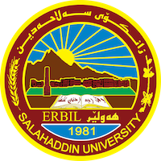
Academic Curriculum Vitae

Personal Information:
Full Name: Daria Soorkew Shareef
Academic Title: Assistant Lecturer
Email: daria.shareef@su.edu.krd
Mobile: 07504814224

Education:
- MA English Literature (Salahaddin University, Erbil – 2008)
- BA English Language (Salahaddin University, Erbil – 2005)

Employment:
- 2008 held the post of head of registry at Erbil Medical Institute.
- 2009 started teaching English literature at college of Languages, English Department
- 2022 started teaching English language at Language and Translation Centre
Qualifications
- University Teachers Certificate

Teaching experience:
- 2009-2010: Assistant Lecturer of English Literature, College of Languages Evening Classes – Salahaddin University, Erbil.
- 2010 – 2022: Assistant Lecturer of English Literature (English Department, College of Languages Salahaddin University.
- 2022-ongoing : Assistant lecturer at Language and Translation Centre.

