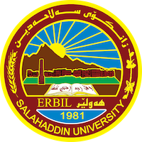
Academic Curriculum Vitae
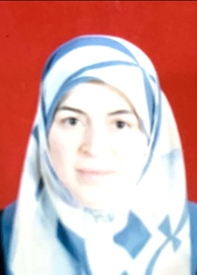
Personal Information:
Full Name: Daristan Jamal Ghareb
Academic Title: Assistant Professor
Email: daristan.ghareb@su.edu.krd
Mobile: +9647504849710

Education:
- B.Sc. in Biology / Salaheddin-Erbil University – College of science 1988
- M.Sc. in Medical Bacteriology / Salaheddin-Erbil University – College of science 1994

Employment:
- Assistant in Department of Biology / College of Science / Salaheddin-Erbil University 1988-1994
- Assistant Lecturer in Department of Biology / College of Science / Salaheddin-Erbil University 1994-2010
- Lecturer in Department of Biology / College of Science / Salaheddin-Erbil University 2010-2013
- Assistant Professor in Department of Biology / College of Science / Salaheddin-Erbil University 2013-Present

Qualifications
- Teaching Training
- Medical Lab Training
- Microsoft Office teaching course

Teaching experience:
- 29 years of teaching theoretical and practical sessions to undergraduate students of Biology (Medical bacteriology, Microbial physiology, Food microbiology)
- 4 years of Postgraduate teaching in medical bacteriology
- Supervision of 1 M.Sc. student.
- 29 years of lab supervision to undergraduate students

Research and publications
- 6 research papers published in Zanco Journal

Professional memberships
- Member of Kurdistan Syndicate of Biology

Professional Social Network Accounts:

- List your profile links of ReserchGate, LinkedIn, etc.

