Fermentation
Fermentation means the breakdown of carbohydrate material by micro-organisms (or enzymes) under anaerobic conditions, in common usage, the term FERMENTATION refers to both the anaerobic and aerobic breakdowns of carbohydrates and carbohydrate-like materials, to alcohols and carbon dioxide or organic acids by yeasts, bacteria, or combination of them, under anaerobic conditions.

Bread Fermentation
Fermentation is normally considered as that time between mixing and makeup of the dough.
- During Fermentation yeast undergoes anaerobic metabolism, producing Co₂ gas , which aerates the dough.
- It also imparts flavor to the baked product.
- About 40% of total carbon dioxide gas produced by yeast fermentation retains in the proofed dough.
- The remaining 60% is lost during punching, molding, and proofing the dough.
- The increase in dough volume during baking (oven) primarily is attributed to the vaporization in ethanol, with a small amount contributed by water vaporization.
- The PH –value of the dough decreases and the acids have a softening and mellowing effect on the gluten.
- The temperature during fermentation is around 27°C and relative humidity should be 75 % to 80 %.

The function of yeast
- It acts as a leavening agent in the dough (CO₂ –production)
- It has to develop flavors (from alcohols, esters and flavor production)
- It has to develop the dough (dough ripening).

About Yeast
• Single celled, microscopic plant.
• When you add sugar to yeast, it reacts to the bacteria and creates carbon dioxide. This leavens the baked product.
• Water mixed with yeast MUST be between 43 and 50 degrees in order to keep the yeast alive.
• Available in three forms:
- Active dry (what we use)
- Compressed (very perishable)
- Fast rising yeast (rises twice as fast)

Types of Yeast
Commercially available:
    - Cream yeast
Used directly, highly perishable
    - Cake yeast
• Yeast cream through filtration press or vac. filter
• Refrigeration required, shelf life a few weeks
• Metabolically active, quick fermentation
    - Dry active yeast
• Home bread making, small business operation
• Last 6 months or longer
• Require hydration, not as active S. cerevisiae, or bakers’ yeast

Factors affecting fermentation
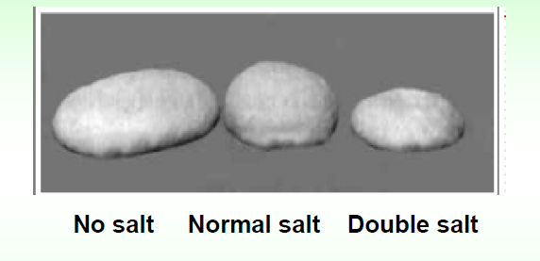
- Too much salt inhibits yeast activity, reducing the amount of carbon dioxide gas produced and decreasing the volume of the loaf.
- The temperature has a great influence on the development of the yeast. Above 45 °C yeast cells are destroyed.

Over fermentation
• Gluten stretches, becomes weak and can collapse
• Coarse grain & sour odor due to excess acid production
• Less color in baked crust.

Measurement of carbon dioxide (CO₂).
for measurement of Gassing Power by the Pressuremeter method to measure the gas production by baker’s yeast and with (flour, sugar and ….) Flour slurry used instead of dough for compatible with our instrument experiment design.
Procedure
- 2.5 g of flour (weighed on 14% mb).
- Mix with 20ml of distilled water followed by 0.075g dry yeast, in a dry and clean 250ml Pyrex bottle, the mixture vortex for 15Sec. move to 30°C regulated water path, then read the pressure meter on (Sphygmomanometer 0-300mm.Hg), and let for fermentation for 5 hours with reading the gas pressure an 1 hour intervals.

Table 1: Fermentation gassing power (mm Hg) values of flour

Samples | Sugar | 1 Hour | 2 Hour | 3 Hour | 4 Hour | 5 Hour
Wheat flour | 0
 | 1g
 | 2g
 | 3 g

