Salahaddin University - Erbil
College of Agricultural Sciences Engineering
Food Technology Department
Third year
F.P.E. (Practical)
2021-2022
3 Hours
Mrs. Darwin Mohammed

Lecture 2 \ Heat Transfer in Food Processing

Heat transfer:
Heat transfer means the movement of thermal energy from one side or medium to another. It occurs repeatedly in food industry while cooking, baking drying, … etc. Hence, it is necessary to understand heat transfer so as to understand a significant side of food processing. Thermal energy can be transferred in three ways: conduction, convection, and radiation.
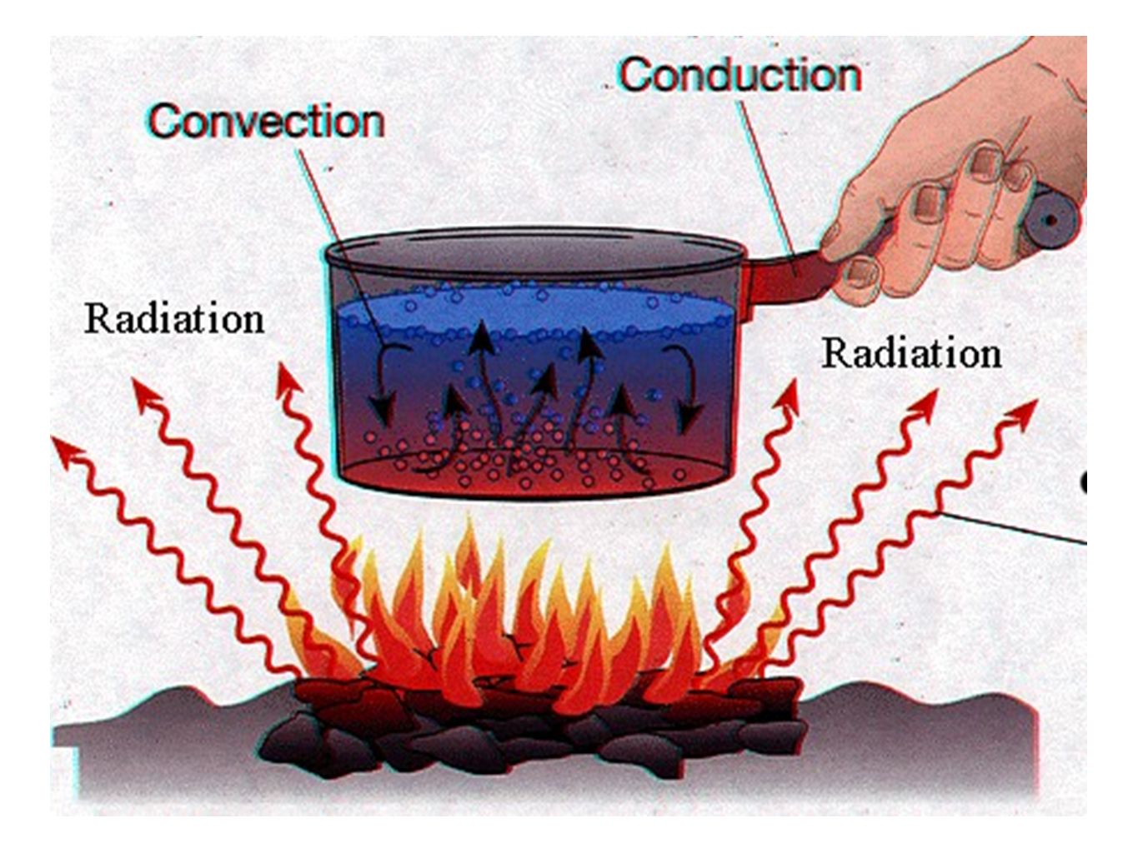
The temperature difference between the source of heat and the receiver is the active factor of heat transfer. Then, increasing the temperature difference strengthens the active factor; then the heat transfer increases. During this operation the heat passes through a medium in which a resistance appears against the heat transfer. Therefore, the resistance becomes the second effective factor in heat transfer operation. Eventually, the equation becomes:
Rate of heat transfer= temperature difference/medium resistance
Generally, the equation of transferred heat is:
Q = m * c * ∆T Joule
Problem: A pan has a mass of 3.5 and a specific heat of 0.8, the initial temperature is 278 and the goal is to heat it 320 more degrees. Determine the transferred heat.
Q: Transferred Heat
m: Mass
c: Specific Heat
∆T: Temperature Difference

. Conductive heat transferring:
It is the method in which the thermal energy is transferred by direct contact, it is used widely overall the world in food industry especially in baking.
It is easy to find the temperature difference by subtracting the receiver’s temperature from the source’s temperature:
∆T = T₁ – T₂
Transferred heat by conduction can be calculated by the equation:
Q = $(\frac{ҡA\left(T\text{hot} - T\text{cold}\right)}{ⅾ})$ Watt
ҡ: thermal conductivity
A: area of the surface
T_{hot}: hot temperature
T_{cold}: cold temperature
d: the thickness of the material
Problem: A chef uses a rectangle pan (w: 30cm, l: 40cm) to make an omelet, the stove is 450º kelvin, and temperature of the pan and the contents is 275º kelvin. The pan’s thickness is 5mm. The room’s temperature is 27º C. Determine the heat transfer. (thermal conductivity= 200 $\frac{W}{m.k}$)

- Convective heat transferring:
It is the method in which the thermal energy is transferred from the source to the receiver without direct contact through a fluid medium. This method is used in boiling food.
Transferred heat via convection can be calculated by the following equation:
Q = H_{C} A (T_{hot}−T_{cold}) Watt
H_{C}: Heat transfer coefficient
Problem: 1529.6 KJ of thermal energy was transferred in a process of frying French fries by an aluminum frying pan. The pan before heating was 290º kelvin, it was placed on a stove until it reached 450º kelvin. Determine the heat transfer coefficient of the pan when you know that the area of the pan is 400cm².

- Radiative heat transfer:
It is the method in which the thermal energy is transferred by electromagnetic waves. It is used while in electrically baked food.
Transferred heat by radiation can be calculated as following:
Q= σ (T_{hot}−T_{cold}) A Watt
σ : Stefan Boltzmann Constant: 5.67e-8 W.m⁻².K⁻⁴

nzifst.org.nz. (n.d.). Unit Operations in Food Processing - R. L. Earle. [online] Available at: https://nzifst.org.nz/resources/unitoperations/httrtheory1.html
ibid
Toppr-guides. (2019). Heat Transfer Formula: Definition, Concepts and Examples. [online] Available at: https://www.toppr.com/guides/physics-formulas/heat-transfer-formula/.
Ibid
Ibid

