Salahaddin University - Erbil
College of Agricultural Sciences Engineering
Food Technology Department
Third year
F.P.E. (Practical)
2021-2022
3 Hours
Mrs. Darwin Mohammed

Lecture 3 \ Heat Exchanger

Heat exchanger:
An equipment that transfers thermal energy from a hot fluid to a colder one(s), with minimum cost and maximum result.

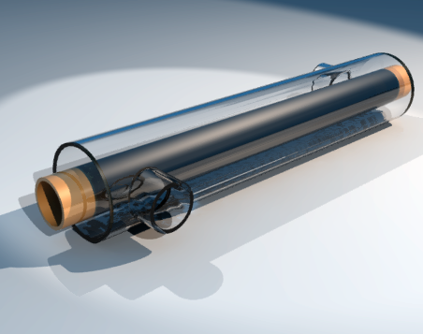

The fluids are separated by the solid walls of the carrier tube so as not to be mixed or being in direct contact.
The exchanged heat in the tubes can be calculated by the following equation:
Q (watt) = U$(\frac{watt}{m2*kelvin})$ * A(m²) * ∆T_{LM} (kelvin)
Log mean temperature difference is an equation that shows the logarithmic average of the heat difference between the hot and the cold fluids in a heat exchanger.
Q: Transferred Thermal Energy
U: Heat transfer coefficient
A: surface area of the tube or pipe
∆T_{LM}: Log mean temperature Difference

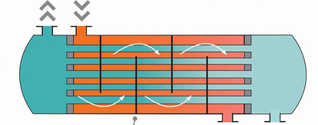
B
A

The larger log mean temperature difference, the more heat is transferred. The equation for log mean temperature difference is:
∆T_{LM} = $\left(\frac{∆T\text{A}-∆T\text{B}}{\ln\left(\frac{∆T\text{A}}{∆T\text{B}}\right)}\right)$
∆T_{LM}: Log mean temperature difference
∆T_{A}: temperature difference at side A
∆T_{B}: temperature difference at side B

Problem: A heat exchanger system used to cool down a fluid from 425º Kelvin to 320º Kelvin, using another fluid which enters the system with a temperature of 180º Kelvin and leaves with a temperature of 230º Kelvin. Calculate the transferred thermal energy when you know that the heat transfer surface area is 2.50 m². Assume the heat transfer coefficient is 4000 $\frac{W}{m2.K}$ .

Types of Heat Exchangers:
Heat exchangers can be classified according to several properties, characteristics, and designs, they are classified according the following points:
- Nature of heat exchanging process, into:
  - Direct contact heat exchangers (open heat exchangers).
  - Indirect contact heat exchangers.

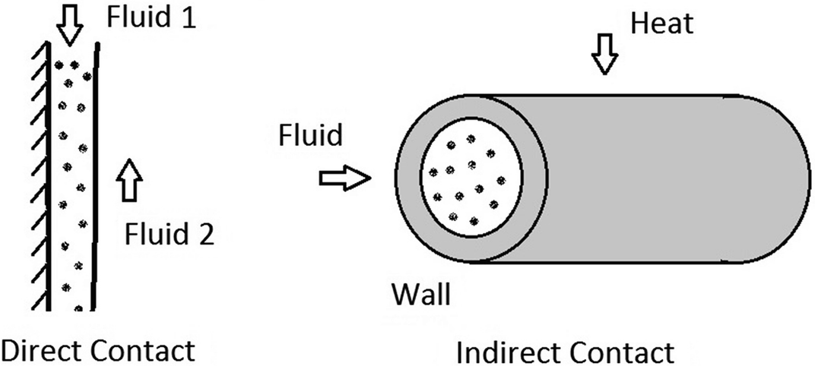

- Direction of the current flow, into:
  - Co-current flow (parallel flow).
  - Countercurrent flow.
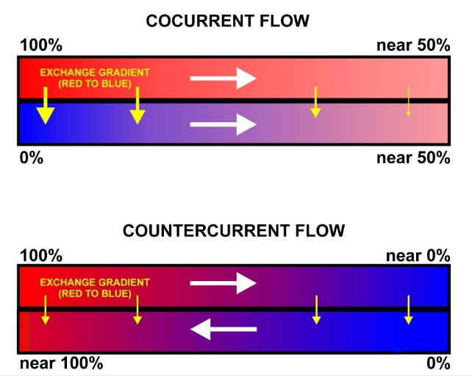

  - Cross Flow.

- Design and construction, into:
  - Double pipe exchangers.
  - Shell and tube exchangers.
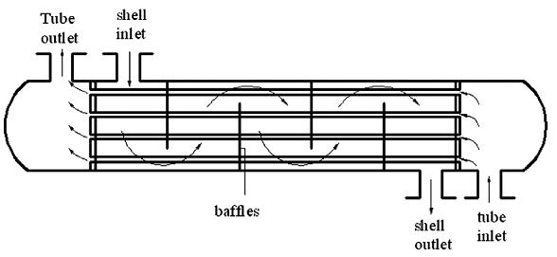
  - Plate heat exchangers.
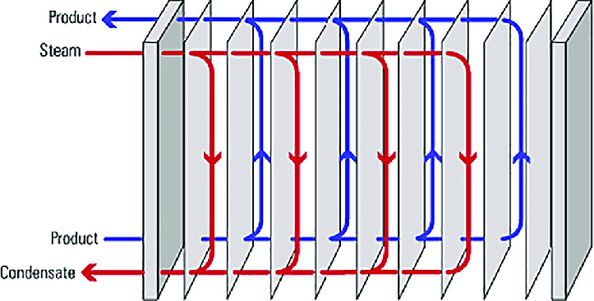

- Physical state of fluids:
  - Condensers.
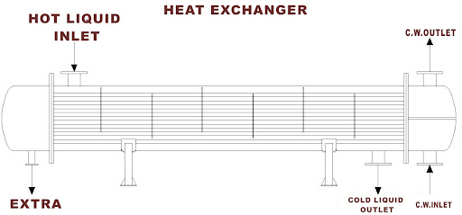
  - Evaporators.
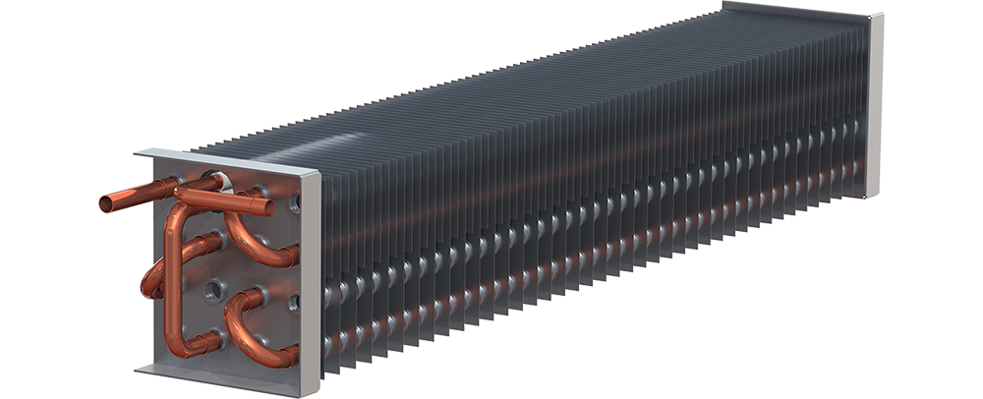

Al-Sammarraie, A.; Vafai, K. (2017) Heat transfer augmentation through convergence angles in a pipe, Numerical Heat Transfer, Part A: Applications. 72 (3): 197–214
Kakaç, S., Liu, H. (2002) Heat Exchangers: Selection, Rating and Thermal Design, (2nd ed.), CRC Press
Perry, R., Green, D. (1984). Perry's Chemical Engineers' Handbook (6th ed.). McGraw-Hill

