Salahaddin University - Erbil
College of Agricultural Sciences Engineering
Food Technology Department
Third year
Cereal Technology (Practical)
2021-2022
Lab 5
Pearling and Milling Grains
Milling process
The first part of the milling process is cleaning the grains. The methods or machines that are used vary from plant to plant. The idea is to remove foreign material, straw, stones etc. A scourer is a cleaning device that removes dust, sand, and soil. As well as, it reduces the bacterial count. In the scourer, the grains are rubbed against either each other and emery surface or through a metal plate. The dirt that loosens is removed by an attached aspiration channel. Additionally, polishing could be used on wheat or barley and is part of the cleaning steps in the milling process. Debranning is relatively new pre-treatment for gains.
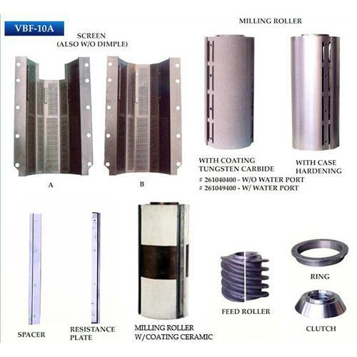
Figure 1: Rice debranning machine
After cleaning, the grains are subjected to tempering, in which the grains rest in water for some time to make sure that the entire gain absorbs water. Tempering is done in order to toughen the bran parts and soften endosperm. This makes the endosperm easier to grind; while the bran will be kept in larger fragments so that they can be separated later by sieving. Conditioning happens when both water and heat is used to weaken the endosperm. The water uptake is higher at higher temperatures but temperature should not exceed 50 ⁰C because the gluten can be damaged.
Prior to Debranning the bran holds together better and the grains can be exposed to a higher force without breaking them. One disadvantage is that it will use more energy to remove the bran because the machine has a lower capacity when using wet kernels. If the grains are not conditioned the bran will be harder to remove and it will be more of a polishing effect.
Peeling is a gentle process where the grains are rubbed against each other and an interaction between the rotor and the screen jacket removes the peripheral layers (pericarp) of the grain. Before the grains go in to the peeler, they are once again damped. By using a peeler, the contamination of microorganisms and heavy metals is reduced, the bacterial count can be decreased by 40- 50% due to the efficiency of the peeler. So that, the peeler is essential to make grains suitable for producing whole grain products.
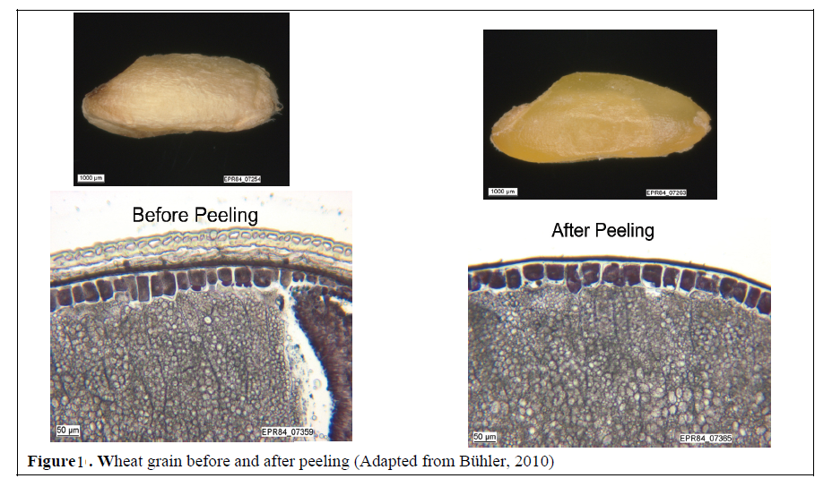
Figure 2: Wheat grain before and after peeling
Pearling is done by rubbing the grains against abrasive stones and air pressure is used to remove the pearling. this process will remove up to 18% of grain which would correspond to a removal of the entire bran. The degree of removal can be regulated by controlling the time for pearling and by adjusting the space between the abrasive stones and the screen. removing approximately 4% with pearling will decrease the microbial contamination with approximately 90%. Pearling is a good pre-treatment for durum wheat milling in order to get the best semolina fraction, but it is also suitable to refine other types of grains. The outer layers are removed prior to grinding and this will in durum wheat milling give speck –free and more yellow semolina.

Ash as a flour evaluation parameter
While the function components of flour for baking, i.e., starch and gluten, can be found in the inner endosperm. Meanwhile, most of the vitamins and minerals are located in the outer parts of the wheat kernel. The mineral content termed “ash” of wheat or the mill product determined by incinerating the sample and expressing the residue as a percentage of the original sample weight. An alternative method for ash determination based on conductivity. The ash content gradient in the wheat kernel increases from the center to the outer layers of the endosperm. The ash content of endosperm varies from one wheat lot to another depending on variety, soil, and growing conditions. Sometime, defining the quality of white flour is a low ash value. As well as, to suggest using a flour ash –wheat ash ratio that indicates the efficiency of separation between bran and endosperm and is not related to the inherent ash content of a specific kernel endosperm.
Where ash is considered a grading factor for flour, the flours are designated types 405, 550, 630, 812m and 1,050. for example, flour could be considered to be type 550 when the flour’s ash content is between 0.490 and 0.580% (dry basis).
The flour ash depends on wheat kernel variables such as hardness, ash, whiteness, size, bran thickness, and its physical state after the conditioning process. Wheat moisture content and temperature before the first break could also affect the flour ash content. Under temperature between 20 and 250 ºC, the bran tends to split; and below 200 ºC, the bran tears and affects the ash content of flour.

Bran Content in Mill End Products
Basically, it is impossible to produce flour completely free of bran by the dry milling process unless extraction in very low. Theoretically, the bran content could be determined based on ash content of the product compared with a minimal endosperm content of 0.30%. The percentage of bran powder in the stock can be calculated by the following equation:
Bran Powder% = $\frac{\text{Ash\% in the sample}-0.30}{0.057}$

Marconi, E., Graziano, M. and Cubadda, R., 2000. Composition and utilization of barley pearling by‐products for making functional pastas rich in dietary fiber and β‐glucans. Cereal Chemistry, 77(2), pp.133-139.

