Salahaddin University - Erbil
College of Agricultural Sciences Engineering
Food Technology Department
Third year
Cereal Technology (Practical)
2021-2022

Lecture 1

Introduction and Objectives
- What is a Cereal?
- What is a Grain (seed)?
- The Major Cereal Crops
- The structure of grains

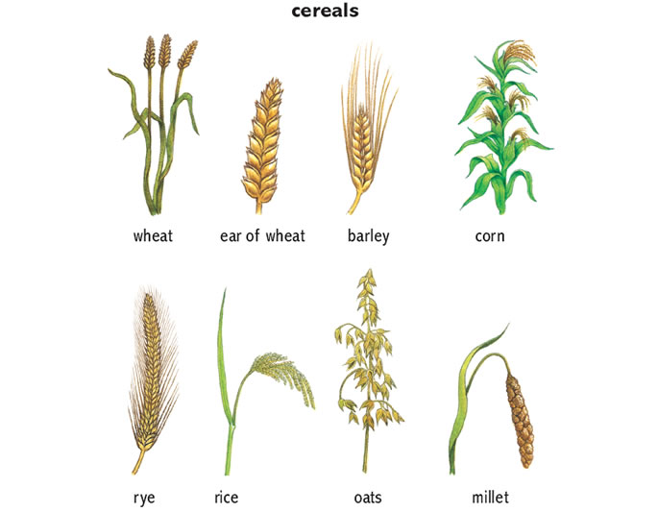

Definition
Cereal is any grass (family Poaceae) yielding starchy seeds suitable for food. Most grains have similar dietary properties; they are rich in carbohydrates but comparatively low in protein and naturally deficient in calcium and vitamin A.
Botanically, cereal a type of fruit called a caryopsis or covered caryopsis), composed of the endosperm, germ, and bran. Cereal grains are grown in greater quantities and provide more food energy worldwide than any other type of crops therefore they are staple crops.
Each caryopsis has a:
  - Protective outer husk
  - Bran covering
  - Starchy endosperm
  - Germ

Cereal: edible grains produced by annual grasses.
Grain: seeds or seed-like fruits of plants, particularly grasses.

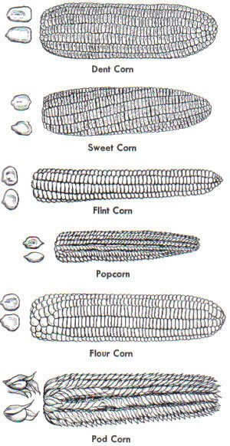
Major Cereal Crops

The grains of primary importance in the world now in descending order are:
  - Wheat Triticum (T.aestivum, T.monococcum, T.durum)
  - Rice Oryza sativa
  - Corn Zea mays
  - Barley Hordeum vulgare
  - Millet Eleusine coracana, Pennisetum glaucum, etc.
  - Sorghum Sorghum bicolor
  - Oats Avena sativa
  - Rye Secale cereal

Types of Wheat
- Durum (tetraploid) “hard” wheat – used for macaroni
- Bread Wheat (hexaploid) “soft” wheat - bread flour
There are eight classes of wheat: durum, hard red spring,
hard red winter, soft red winter, hard white, soft white,
unclassed, and mixed.
“Mixed wheat” is the class designation for shipments that
contain less than 90 percent of one wheat class and more
than ten percent of one or more other classes. “Unclassed
wheat” is the class designation for any variety that cannot be
classed under criteria of the official U.S. wheat standards.

Forms of Rice
White, Converted, Instant, Brown, Specialty, Wild.

Encyclopedia Britannica
Shibuya NA, Nakane RE, Yasui AK, Tanaka KE, Iwasaki TE. Comparative studies on cell wall preparations from rice bran, germ, and endosperm. Cereal Chem. 1985 Jan 1;62(4):252-8.
Accum, F.C., 1821. A Treatise on the Art of Making Good and Wholesome Bread of Wheat, Oats, Rye, Barley, and Other Farinaceous Grain, T. Boys.
Manickavasagan, A., Jayas, D.S., White, N.D.G. and Paliwal, J., 2010. Wheat class identification using thermal imaging. Food and Bioprocess Technology, 3(3), pp.450-460.
Kaláb, M., 2018. A bowl of rice and SEM. Infocus Magazine-Proceedings of the Royal Microscopical Society in the UK, 1(51), pp.13-36.

