Salahaddin University - Erbil
College of Agricultural Sciences Engineering
Food Technology Department
Third year
Cereal Technology (Practical)
2021-2022

Lab 6
Gluten Washing:
Gluten washing is simply the process of using excess water to mechanically remove the starch and most other non-gluten components of the wheat flour.
This can be done either by hand or with the aid of instrumentation. The end of washing time is determined when all visible signs of starch have been removed. The gluten is weighed, and the percent of wet gluten is calculated based on the starting flour weight. The gluten sample can then be dried, either in an oven or on a special hot press, and the dry gluten weight and percentage are recorded.
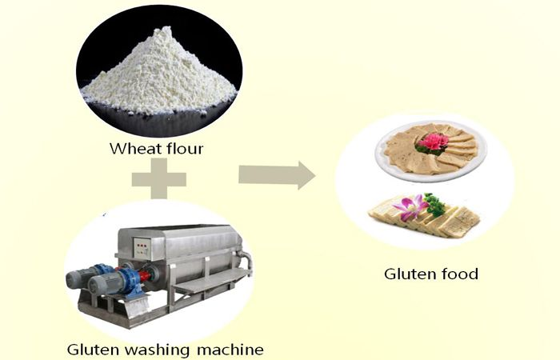

Method:
- A 10-gram sample of flour or ground wheat is weighed and placed into the Glutomatic washing chamber on top of the polyester screen.
- The sample is mixed and washed with a 2% salt solution for 5 minutes.
- The wet gluten is removed from the washing chamber, placed in the centrifuge holder, and centrifuged.
- The residue retained on top of the screen and through the screen is weighed.

Results:
- Wet gluten content is determined by washing the flour or ground wheat sample with a salt solution to remove the starch and any other soluble from the sample. The residue remaining after washing is the wet gluten.
- During centrifugation, the gluten is forced through a sieve. The percentage of gluten remaining on the sieve is defined as the Gluten Index, which is an indication of gluten strength. A high gluten index indicates strong gluten.
- Wet gluten content results are expressed as a percentage on a 14% moisture basis; for example, 35 percent for high protein, strong gluten wheat or 23 percent for low protein, weak gluten wheat.

Q/ Why is gluten test important?
A/ The wet gluten test provides information on the quantity and estimates the quality of gluten in wheat or flour samples. Gluten is responsible for the elasticity and extensibility characteristics of flour dough. Wet gluten reflects protein content and is a common flour specification required by end-users in the food industry.

The Pelshenke Test
The aims of this test that found by German scientist Paul Pelshenke to determine the dough gluten’s strength, as well the ability of production carbon dioxide (CO₂) by yeast and the ability of dough to kept it, for this reason this test called (Wheat meal fermentation time test).
Pelshenke test is widely used in many countries for predicting the breadmaking quality of gluten. A dough ball is made up from the whole wheat meal with a yeast suspension, and these are immersed in water at a constant temperature. The dough balls fall apart after a given time, and the elapsed time between immersion and start of disintegration is called the Pelshenke test number. The reason of breakdown of dough ball due to liberate of CO_{2.} The fermentation time compute since the ball immersed in water even breakdown of ball. The strength of dough gluten according to fermentation time classification is as the following:

Fermentation time (min) | Gluten strength
0-60 | Very weak
66-120 | Weak
121- 200 | Medium strong
201-300 | Strong
301- 400 | Very strong
>400 | extremely strong

Method and materials:
- Beaker (150 ml)
- Glass Rod.
- Yeast.
- Distilled water.
- Timer.

Procedure:
- Mix 5g of wet yeast or 1.5g of dry yeast with 100ml distilled water and mixed until homogenize.
- Weigh 3 gram of selected flour in glass pot (200ml) then add 1.8 ml of yeast suspend that prepared before, and make dough ball by hand.
- Immerse the dough balls into glass pot or beaker where contain 150ml of water at constant temperature around 30C^{0,} record the time of immersing ball into water which the ball falls to the bottom of container, after period time the ball will be floats to the top by CO_{2,} and then the ball will be disintegrate and then
fall down, and finishing the fermentation time.

Sedimentation test for flour:
Sedimentation testing techniques are used widely in the United States, Europe and the United Kingdom as a means of measuring gluten strength. These sedimentation techniques involve hydration of a small flour sample in a lactic acid solution containing either the detergent sodium dodecyl sulphate (SDS sedimentation) or isopropyl alcohol (Zeleny sedimentation). The presence of lactic acid in solution causes the hydrated flour particles to sink in the form of a sediment, the level of which, indicates the strength of the gluten. High sedimentation volume indicates strong gluten while low sedimentation volume indicates weaker gluten.
Q/ Why is sedimentation test important?
A/ The sedimentation test provides information on the protein quantity and the quality of ground wheat and flour samples. Positive correlations were observed between sedimentation volume and gluten strength or loaf volume attributes. The sedimentation test is used as a screening tool in wheat breeding as well as in milling applications.
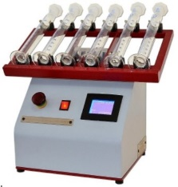

Adapted from Method 56-61A, Approved Methods of the American Association of Cereal Chemists, 10th Edition. 2000. St. Paul, MN.

