Salahaddin University - Erbil
College of Agricultural Sciences Engineering
Food Technology Department
Third year
Cereal Technology (Practical)
2021-2022

Lab 3

Physical properties of bulk grain and grain products
It is important to study these properties to
- Minimize post-harvest losses.
- Improve grain quality
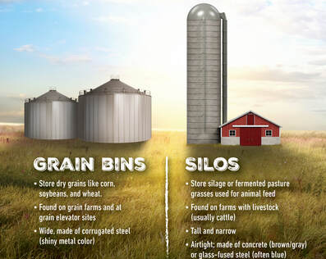

- Flow property of grain (flowability)
When grain is poured into bin, it’s an angle from the horizontal axis that is called ‘angle of repose’ with most grain this angle is about 0-90º. Damp grain or very small grain gives as slightly flatter slope. The outflow hopper at the bottom of a bin must be cone-shaped and have a slope greater than the angle of repose, or the grain will not flow out. Smaller bins requite a steeper slope because of the greater friction on the sides of the hopper.

- The freedom of grain flow depends on
- Geometrical shape
- Grain size
- Degree of grain surface softness
- Moisture content
- Degree of foreign and dockage materials (impurities)

The procedure
- Put the hectoliter funnel in a fixed distance from the table surface.
- Weight 1kg of cereal grain and put in the funnel
- After leaving the grain to flow and rest on the table.
- Measure the distance of spreading (the radius of the circle base made.
- Measure the height of the flower seeds vertically.
- Then draw the triangle to be enabling you measuring the angle of repose which differ from grain to grain and depend some time to moisture content and impurities content.

- Inter-granular space:
It depends on geometrical shape of grain. During storage these spaces will be filled with air the inter-granular spacing is estimated as percentage (%) of total grain volumes.
The composition of this air affected the physical and physiological properties of grain during storage. This space is estimated to be between 38-45% of total volume of wheat grains. Meanwhile, for rice and oat it ranges from 55-75 %.

Procedure
Put certain amount of grains into cylinders, and then fill with kerosene until grain height level in cylinders. Measure of the kerosene volume in cylinder’s which represent the spacing between the grains.

- Absorption and desorption
The ability of grains to absorbs or desorbs vapor, gases or water is due to inter-granular spacing between grains from one side and the porosities property of the tissues making the grain body.
This property causes the grain to absorb nasty odors or losing (desorbs) these odors depending on its equilibrium vapor state within 48 hours these will be on equilibrium between grain moisture and the humidity of the air.

Procedure
- Weight 100 gram of purity grain
- Input into desiccator (dry storage cabinet) Desiccant
Substances of a hygroscopic nature, capable of absorbing moisture and therefore used as drying agents. e.g. Anhydrous sodium sulphate, anhydrous calcium chloride, or the mostly popular SILICA GEL and ZEOLITES.
- Weight 100 gram of purity grain
- Input into wet storage cabinet (water)
Weight 100 gram of purity grain
Input into storage cabinet (without water or desiccant)
After 48 hours or next week weight the grains to calculate the difference between two weights of grains.
- Thermal conductivity of grain bulk
Thermal conductivity index of cereal grain ranged between 0.1-0.2 Kcal/m/hr./degree. This property is not a good in grains due to the organic compounds from which the grains are made of (starch, protein, cellulose and lipids) and air spacing.
This is why the liberated heat due to respiration, insects and microorganisms will accumulate in grain bulk and cause quality deterioration.

